ESS - Personal Information – Address and Contact Information
- Address and Contact Information - The Address and Contact Information screen under Personal Information allows employees to view their Permanent Address and any other address on file with PASSHE. The Address and Contact Information screen also provides employees the ability to view/maintain their primary contact number(s), emergency contact address and phone number(s), campus address and phone number(s), as well as the ability to end any current mailing address.

  - To begin, select the Address and Contact Information link from the Personal Information menu in ESS.
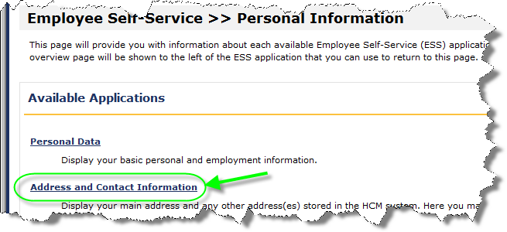
  - The employee’s current Permanent Address, Emergency Contact, Campus Address, and Mailing Address information on file with PASSHE will automatically be displayed.
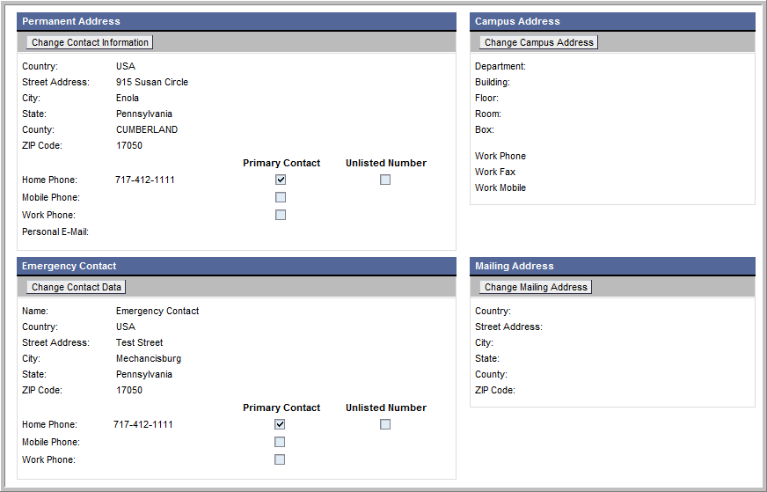

Permanent Address Maintenance
- Under Permanent Address, employees have the option to update the following:
- Home Phone (Option to make number unlisted)
- Mobile Phone (Optional and can be the same as Home Phone)
- Work Phone (Optional)
- Primary Contact (Required)
- Personal E-Mail (Optional)
NOTE: ESS does not allow employees to update their permanent address. Employees must contact the Human Resource Office in order to update their permanent address. The Permanent Address on file will be used for sending mail to the employee. If a different address is to be used for mailings, employees must visit their Human Resource Office as well in order to provide a Mailing Address.
- To begin making changes under Permanent Address, click Change Contact Information.
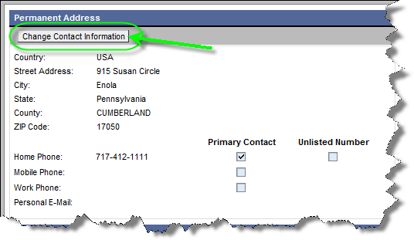
- The Update Contact Information window will appear allowing employees to make changes.
- The following guidelines should be used for entering data. (NOTE: If data is entered in an erroneous format, additional guidance will be provided on screen when Save Changes is attempted.)
- At least one phone number must be provided.
- Only one number can be chosen as the primary contact number.
- Phone numbers must be in the format of 123-456-7890.
- Employees may choose to make the Home Phone an Unlisted Number.
- Home Phone and Mobile Phone can be the same number.
- Mobile Phone, Work Phone, and Personal E-Mail are optional.

- From the Update Contact Information window, the Home Phone and the Work Phone along with ext. can be entered directly in the spaces provided.
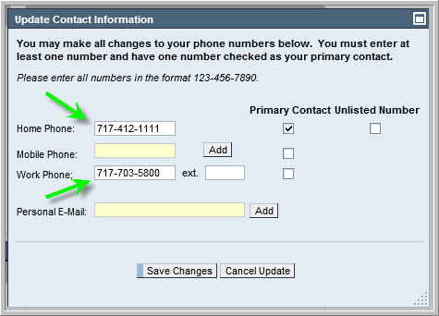
  - In order to enter a Mobile Phone, select the Add button.
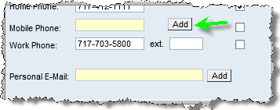
  - The Add Mobile Number screen will appear. Enter the New Mobile Phone, select the Mobile Carrier from the drop-down box, and select Add Mobile Number
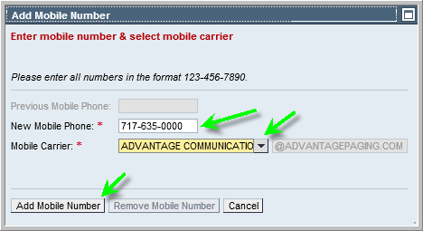

    - The Update Contact Information screen will appear again. The Mobile Phone field will be populated with ***-***-****. Select the Save Changes button.
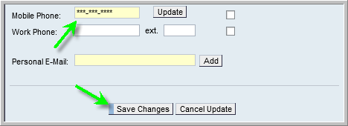
    - The following message will appear confirming changes have been saved.
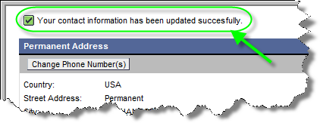
    - To update or remove a previously entered Mobile Phone, return to the Update Contact Information screen and select the Update button.
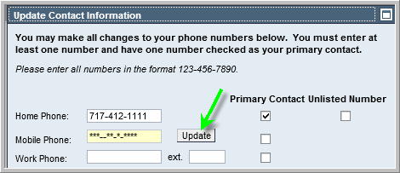

    - Before making any updates, users will be required to enter the Previous Mobile Phone.
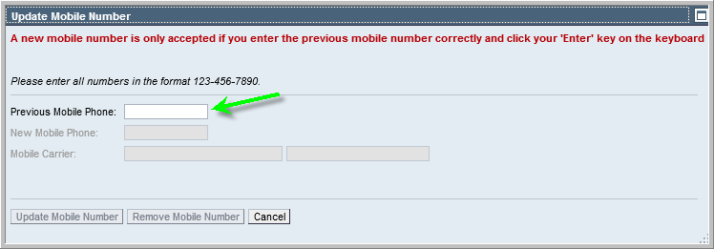
    - Once the Previous Mobile Phone field has been completed, select the Enter key on the keyboard.
      - To remove a mobile phone completely, select the Remove Mobile Number button.
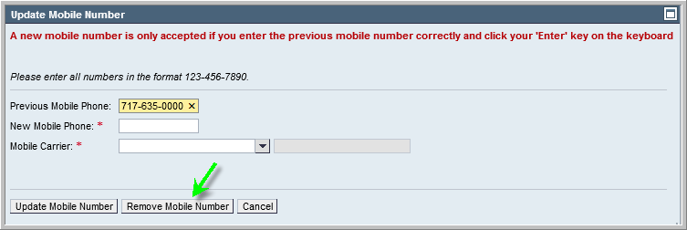
      - To change the mobile phone, enter the new number in the New Mobile Phone field, select the Mobile Carrier from the drop-down box, and select Update Mobile Number.
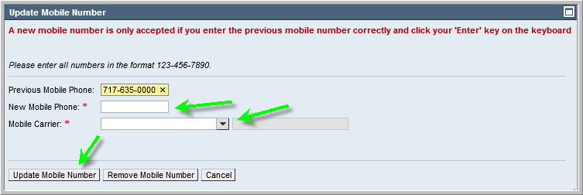

      - The Update Contact Information screen will appear. To commit to the changes, select the Save Button.
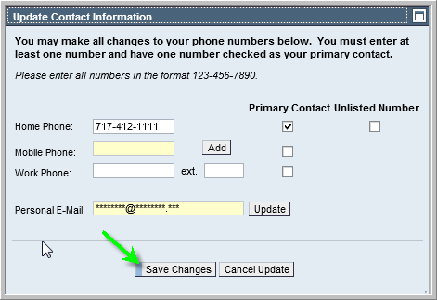
      - The following message will appear confirming changes have been saved.
  - In order to enter a Personal E-Mail, select the Add button.
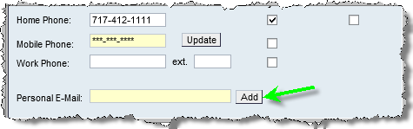

    - The Add Personal Email screen will appear.
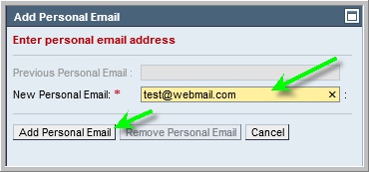
    - The Update Contact Information screen will appear again. The Personal E-Mail field will be populated with *******@*****.***. Select the Save Changes button.
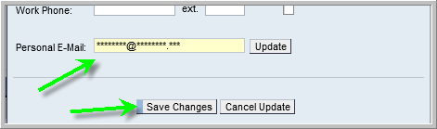
    - The following message will appear confirming changes have been saved.

  - To make changes to or remove a previously entered Personal E-Mail, follow these steps:
    - Select Change Contact Information from the Permanent Address section.
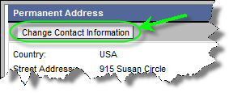
    - Select the Update button next to the Personal E-Mail field.
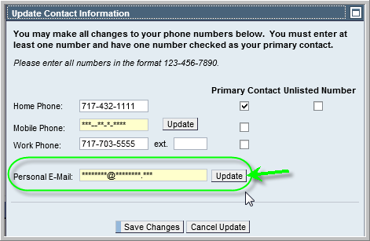
    - The Personal E-Mail pop-up window will appear. Enter the personal email address that is currently on file into the Previous Personal Email field and click the ‘Enter’ key on the keyboard. This will unlock the New Personal Email Address field as well as the Update Personal Email and Remove Personal Email buttons.
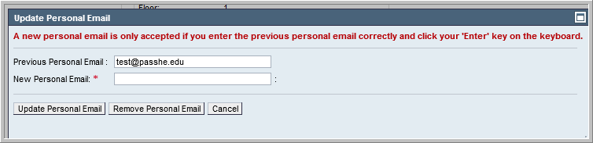

      - If updating the personal email address on file, enter the new email address into the New Personal Email field and select Update Personal Email.
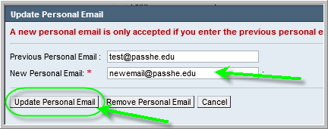
      - If completely removing the personal email address on file, select Remove Personal Email.
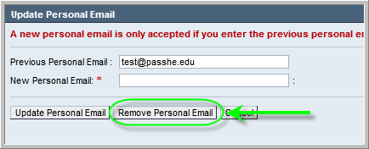
    - The following message will appear to indicate changes have been made successfully.

Emergency Contact Maintenance
- Under Emergency Contact, employees have the option to update the following:
- Emergency contact name
- Emergency contact address
- Emergency contact home phone (Option to make number unlisted)
- Emergency contact mobile phone
- Emergency contact work phone
- Emergency contact primary contact number
- To begin making changes under Emergency Contact, click Change Contact Data.
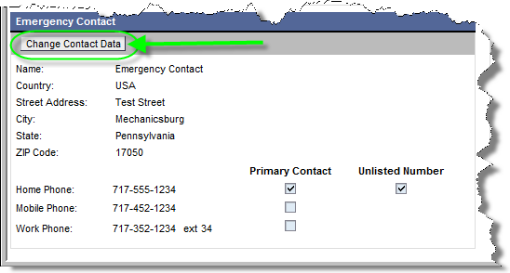
- The Update Emergency Contact Information window will appear allowing employees to make changes.
- The following guidelines should be used for entering data. (NOTE: If data is entered by the user in an erroneous format, additional guidance will be provided on screen when Save Changes is attempted.)
- All address fields are required.
- At least one phone number must be provided.
- Only one number can be chosen as the primary contact number.
- Phone numbers must be in the format of 123-456-7890.
- Employees may choose to make the Home Phone an Unlisted Number.
- Home Phone and Mobile Phone can be the same number

  - When finished making updates, click Save Changes.
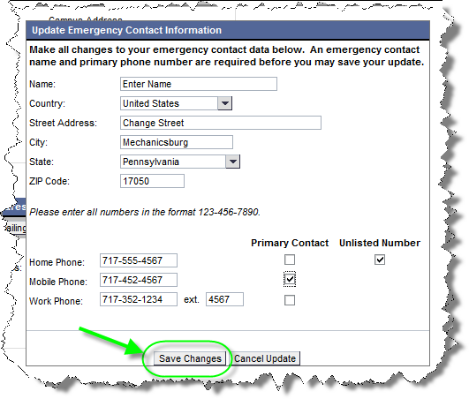
NOTE: To cancel updates, click on Cancel Update and changes will be discarded.

- The following message will appear confirming changes have been saved.
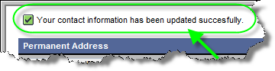

Campus Address Maintenance
- Under Campus Address, employees have the option to update the following:
- Department (required)
- Building (required)
- Floor
- Room number
- Box
- Work phone
- Work fax
- Work mobile
- To add a new campus address or to begin making changes to a pre-existing campus address, select Change Campus Address.
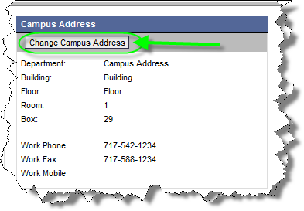
- The Update Campus Address window will appear allowing employees to make changes.
- The following guidelines should be used for entering data. (NOTE: If data is entered by the user in an erroneous format, additional guidance will be provided on screen when Save Changes is attempted.)
- The Department field will default from the employee’s organizational assignment and cannot be modified.
- The Building field is required to be completed. Employees will be provided a drop-down list of buildings to choose from depending on the university at which they are employed.
- Floor, Room Number, Box, Work Phone, ext., Work Fax, and Work Mobile are optional fields.
- If phone numbers are provided, they must be in the format of 123-456-7890.

  - When finished making changes, click Save Changes.
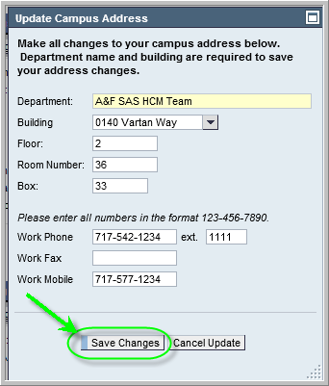
NOTE: To cancel updates, click on Cancel Update and changes will be discarded.

- The following message will appear confirming changes have been saved.
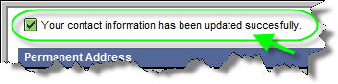

Mailing Address Maintenance
- Under Mailing Address, employees have the option of ending the validity of their mailing address if one is already on file. If no Mailing Address exists and an employee attempts to access the Change Mailing Address button as in the example below, a message will appear indicating that adding a mailing address must be done by visiting the HR office. To exit, select the Cancel Update button.
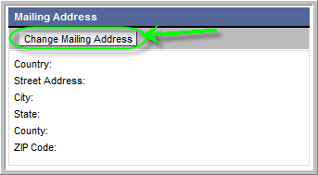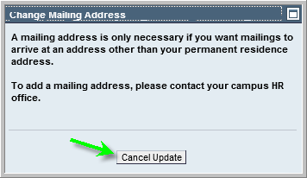
NOTE: The Permanent Address on file will be used for sending mail to the employee. Mailing Address should only be provided by the employee if they desire mail to be sent to an address other than Permanent Address.

- For employees who already have a mailing address on file but no longer wish to receive mail at that particular address, the Change Mailing Address feature can be used to end the validity of the mailing address. To begin, select Change Mailing Address.
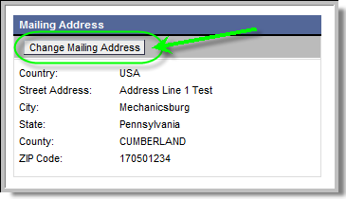

- The Change Mailing Address window will appear. Select Remove Mailing Address.
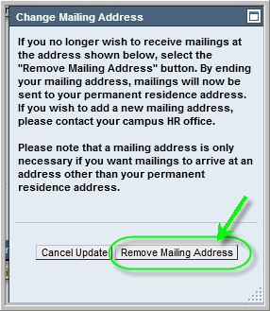
NOTE: To cancel updates, click on Cancel Update and the process will be abandoned.
- The following message will appear confirming the Mailing Address has been ended.
(NOTE: The Mailing Address will now be blank reflecting the address has been removed.)
