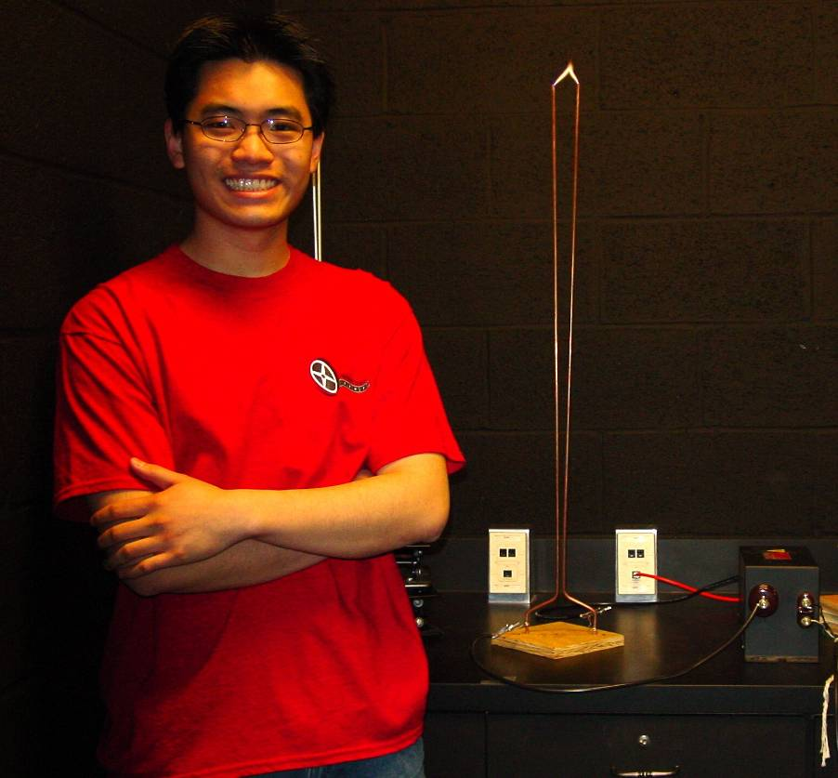

Analysis of a Jacob’s Ladder Apparatus
By Jeremy Low
Advisor: Dr. Tariq Gilani

The Jacob’s Ladder is an impressive tool that demonstrates the ionization of air. Furthermore, it can also be used for an educational tool to help in better understanding the world around us. The Jacob’s Ladder is comprised of two rods and a high voltage transformer. When a high voltage is applied across the rods, it ionizes the air between the rods and a rising electric arc is formed. I found that the minimum sparking voltage for a 6mm gap was about 13,000 VRMS or about 25,000 V/cm. Using high speed video I found that the arc jumped back and forth 60 times per second. It accelerated upwards at a rate of 1.021 ± .051 m/s².

