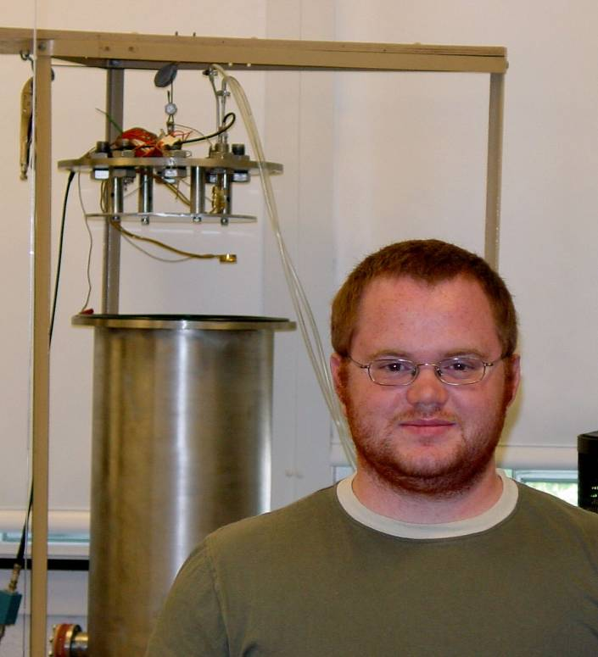
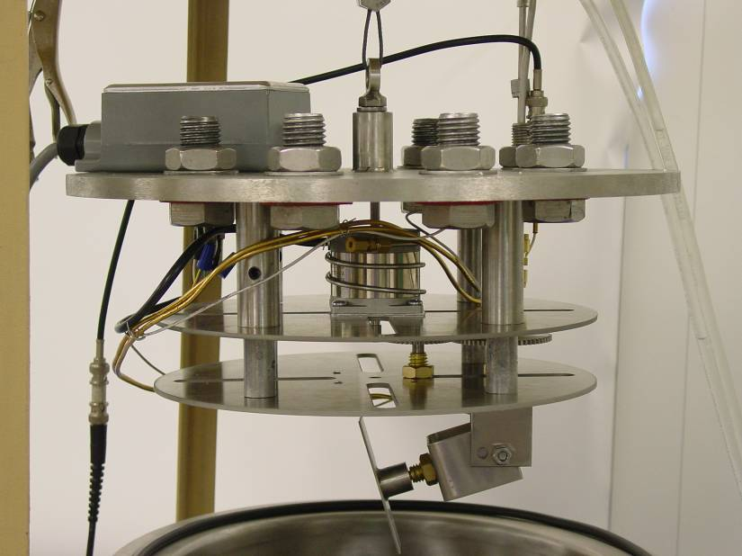

Fabrication of Nano-Engineered thin films by Thermal Evaporation
By Drew Pulsifer
Advisor: Dr. Tariq Gilani

The concept behind the process of creating sculptured thin films by evaporation is relatively simple. Given the appropriate conditions and deposition material, columnar growth is a natural occurrence that does not require a great deal of effort to produce. These non-uniform growths are an obstacle to producing uniform optical coatings, but like many other seemingly burdensome occurrences they have unique properties that are interesting if not potentially useful in their own right. The process behind intentionally producing such films is the subject of my research. The process is known as Glancing Angle Deposition (GLAD). I have been researching and designing a system that uses GLAD to produce sculptured films in a controllable manner. This has included the design and fabrication of: a new vacuum chamber, substrate mounting and rotation system and control, and installing all of the necessary deposition monitoring hardware. The project is currently in a state where an attempt at producing films can be carried out. Inevitably there will be a phase of debugging the system and developing an appropriate operating procedure that time has not allowed me to develop. This would be the next phase of work in this area.

