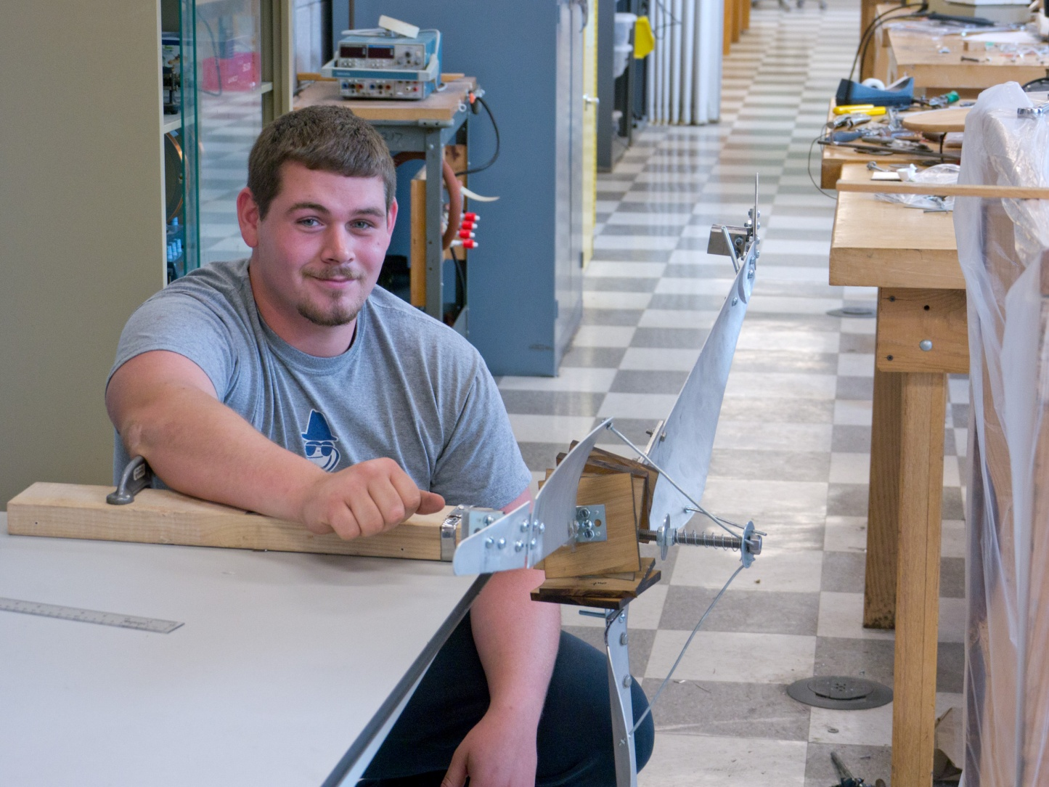
Study and Development of a Sweep Area Mechanism for a Small Scale Wind Turbine
By: Jason Beisel
Advisor: Dr. Mehmet Goksu
The objective for this research project was to study wind turbines and then develop a mechanism, mechanical or electrical, that would automatically adjust the sweep area of the blades of a small-scale wind turbine. By adjusting and controlling the sweep area of the blades the turbine would theoretically be able to run more efficiently and at higher wind speeds than other turbines.

