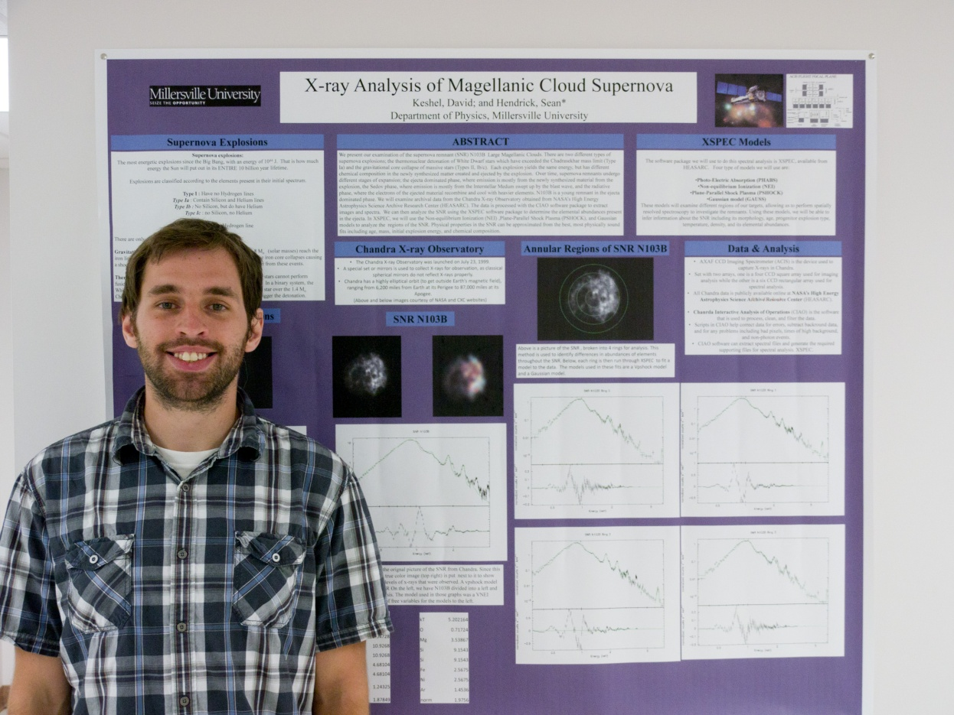
X-ray Analysis of Young LMC SNR N103B
David Keshel
Advisor: Dr. Sean P. Hendrick
We present our examination of supernova remnant (SNR) N103B in the Large Magellanic Cloud (LMC). There are two different types of supernova explosions; the thermonuclear detonation of White Dwarf stars which have exceeded the Chadrasekhar mass limit (Type Ia) and the gravitational core collapse of massive stars (Types II, Ib/c). Each explosion yields the same energy, but has different chemical composition in the newly synthesized matter created and ejected by the explosion. Over time, supernova remnants undergo different stages of expansion; the ejecta dominated phase, the Sedov phase, and the radiative phase. We will examine archival data from the Chandra X-ray Observatory obtained from NASA’s High Energy Astrophysics Science Archive Research Center (HEASARC). The data is processed with the CIAO software package to extract images and spectra. We can then analyze the SNRs using the XSPEC software package to determine the elemental abundances present in the ejecta. N103B is a young remnant in the ejecta dominated phase. In XSPEC, we will use the Non-equilibrium Ionization (NEI) and Plane-Parallel Shock Plasma (PSHOCK) models to analyze the ejecta regions as well as Gaussian models to analyze sharp peaks. Physical properties in the SNRs can be approximated from the best, most physically sound, fits including age, mass, initial explosion energy, and chemical composition.

