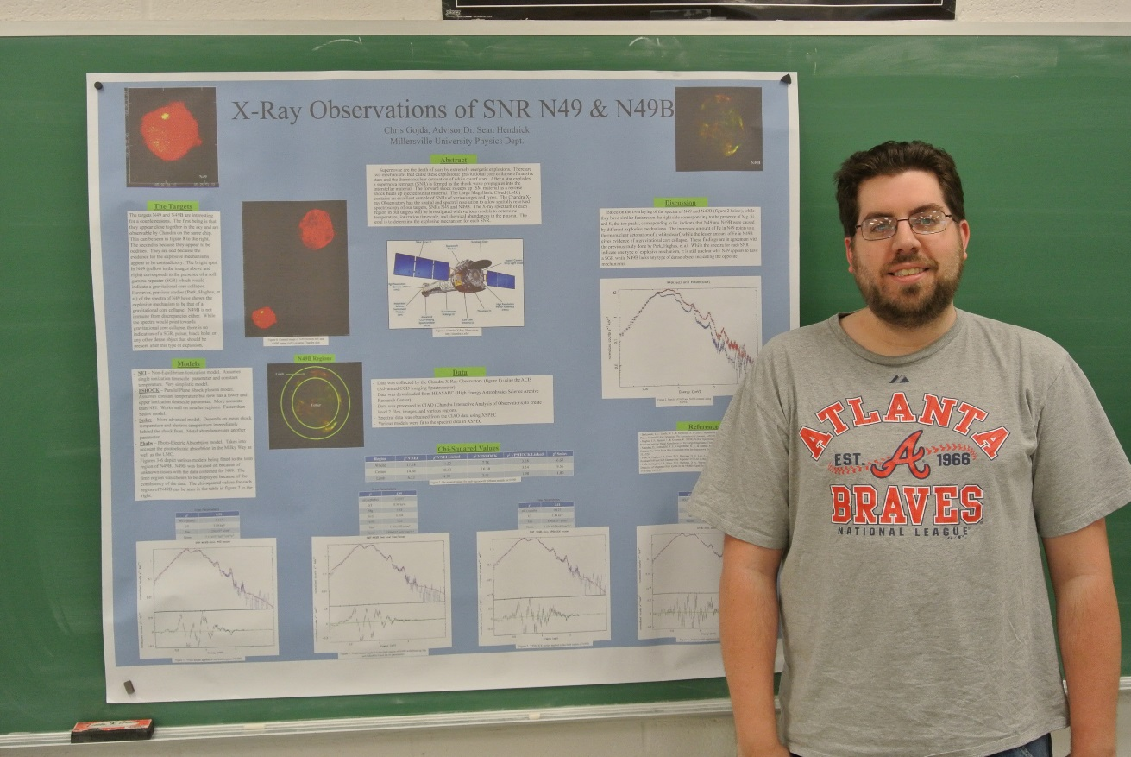

X-Ray Observations of LMC SNR N49 & N49B
By: Chris Gojda
Advisor: Dr. Sean Hendrick

Abstract

Supernovae are the death of stars by extremely energetic explosions. There are two mechanisms that cause these explosions: gravitational core collapse of massive stars and the thermonuclear detonation of white dwarf stars. After a star explodes, a supernova remnant (SNR) is formed as the shock wave propagates into the interstellar material. The forward shock sweeps up ISM material as a reverse shock heats up ejected stellar material. The Large Magellanic Cloud (LMC) contains an excellent sample of SNRs of various ages and types. The Chandra X-ray Observatory has the spatial and spectral resolution to allow spatially resolved spectroscopy of our targets, SNRs N49 and N49B. The X-ray spectrum of each region in our targets will be investigated with various models to determine temperature, ionization timescale, and chemical abundances in the plasma. The goal is to determine the explosive mechanism for each SNR.

