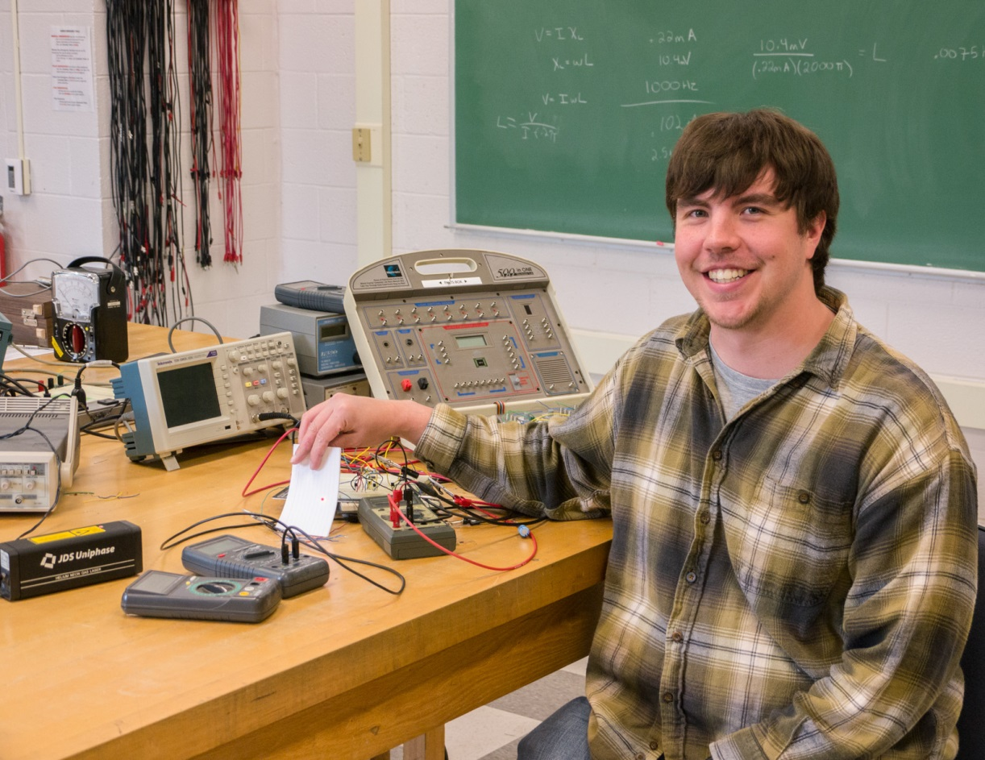
Laser Harp (2013)
John Savastinuk
Advisor: Dr. Tariq Gilani
Invented by Bernard Szajner in 1981, the laser harp uses the breaking of light beams to elicit musical tones. By using a photodiode in photoconductive mode and an inverter, the lack of the laser hitting the photodiode triggers the circuit. The inverter uses a PNP transistor with a Sziklai pair. An RLC oscillator is attached to produce a musical pitch at a certain frequency.

