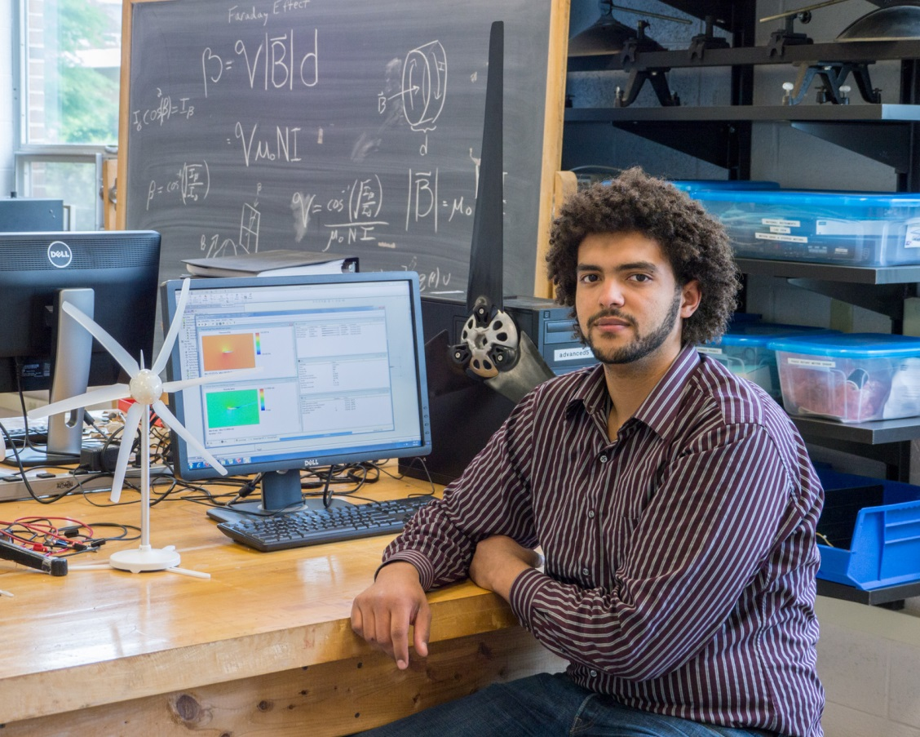
Computational Fluid Dynamics
Simulations of Wind Turbines (2013)
Joshua Dyer
Advisor: Dr. Mehmet Göksu
As scientists try to find new ways to satisfy the energy needs of the world, many new technologies emerge in an effort to reduce the amount of petroleum-based energy we consume. Few methods have been used to capture and use energy as long as those which extract energy from the wind. Much research and many trials have been done to make wind-energy a viable source to partially fulfill our energy needs; designs have become very sophisticated, vast improvements from the crude wind machines that were once used to mill grains. Despite all of the efforts put towards the study of wind power, we are not using this source to its potential. The theoretical maximum efficiency of a wind turbine, as understood by accepted laws of physics, is about 60%, however most modern wind turbine designs are nowhere near this number, with the best being about 45% efficient^{[1][5]}. The purpose of this research project is to gain a better understanding of the physical interactions involved with a wind turbine, in an effort to design more efficient blades, which in turn will make wind power a more cost-effective alternative to burning fossil fuels.

