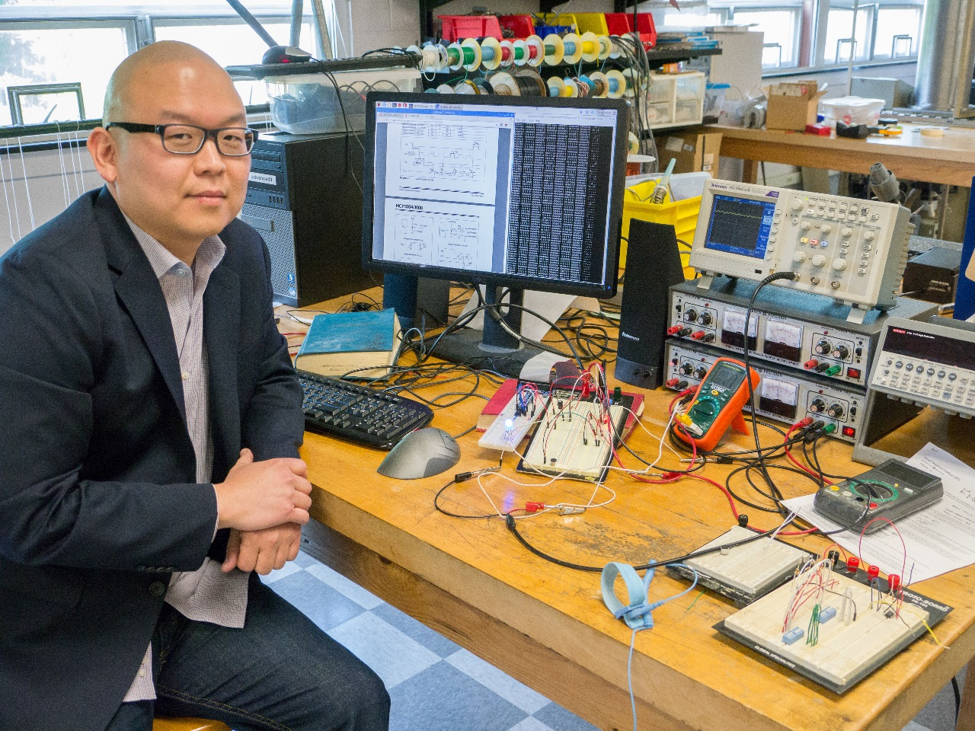
Digital-Analog Conversion from First Principles
Julius O
Advisor: Dr. Tariq Gilani
Digital-to-Analog (D/A) and Analog-to-Digital (A/D) conversion of electrical signals are essential processes for electronic devices to interface with the physical world. High fidelity audio, wireless communications, and digital photography serve as prime examples for the practical application of these processes. Continuous phenomenon such as light and sound can be represented as a discretized stream of binary digits that can be stored and transmitted to other electronic devices and communication networks without any loss of information, to an arbitrary resolution. Increasing a converter’s resolution introduces technical challenges to its performance that can be addressed through processing, filtering, and using higher tolerance components to reduce output variability. D/A and A/D converters were constructed from primitive electronic components, and their experimental characteristics are discussed and compared to predicted values.

