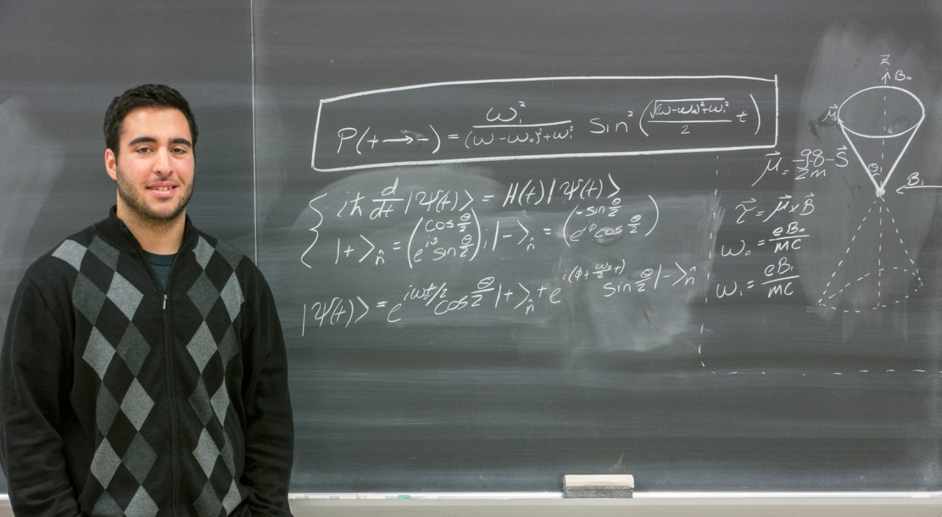
Rabi Oscillations (2013)
William Kassis
Advisor: Dr. Zenaida Uy
The discussion of Rabi Oscillations is intimately related to the phenomenon of Nu-
clear Magnetic Moments, which can be analyzed by spin arguments. To begin our
discussion of spin, we should start at the beginning. In 1922, Otto Stern and Walther Gerlach, in attempts to test the quantization of the direction of angular momentum of silver atoms, discovered an intrinsic angular momentum that is now known as spin. This spin is closely analogous to the dynamics of a classically spinning object, but it has been shown that the values of intrinsic angular momentum are quantized at the quantum level.

