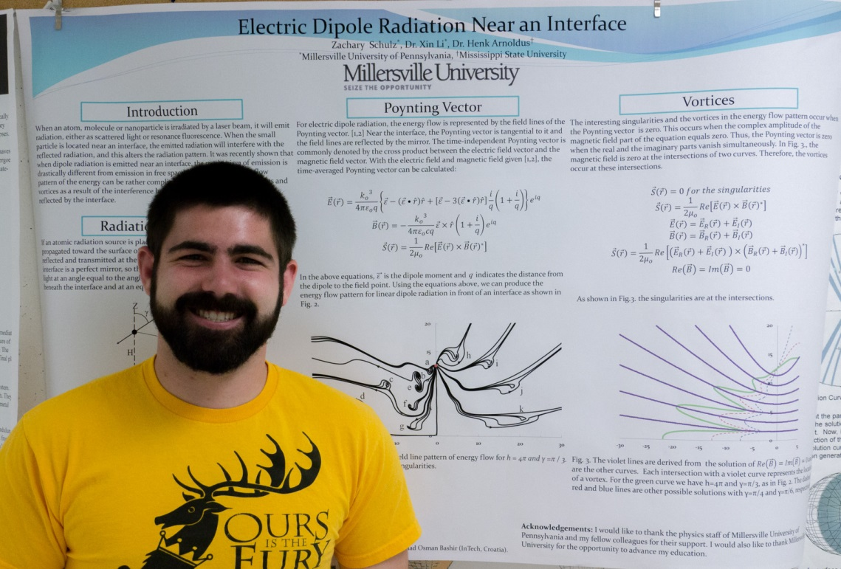
Electric Dipole Radiation Near an Interface
Zachary Schulz
Advisor: Dr. Xin Li
When an atom, molecule or nanoparticle is irradiated by a laser beam, it will emit radiation, either as scattered light or resonance fluorescence. When the small particle is located near an interface, the emitted radiation will interfere with the reflected radiation, and this alters the radiation pattern. This problem was already studied by Sommerfeld in the 1950’s, when he considered the effect of the Earth on the radiation pattern of dipole radiation emitted by an antenna. Many experimental and theoretical efforts have been devoted to this problem since, including quantum effects leading to alterations of the lifetime of atomic levels due to the presence of the interface. With the rapid progress of nanophotonics, where phenomena on the scale of an optical wavelength or less are of interest, this area of research has attracted renewed attention. It was recently shown that when dipole radiation is emitted near an interface, the mechanism of emission is drastically different from emission in free space. In addition, the flow pattern of the energy can be rather complicated, and it contains singularities and vortices as a result of the interference between the emitted light and the light reflected by the interface.

