COOP 18-19 survey
Cooperating Teacher Survey
May 23rd 2019, 9:42 am MDT
Q1 - Are you a Millersville Graduate?

# | Field | Minimum | Maximum | Mean | Std Deviation | Variance | Count
1 | Are you a Millersville Graduate? | 1.00 | 2.00 | 1.49 | 0.50 | 0.25 | 240

# | Answer | % | Count
1 | Yes | 51.25% | 123
2 | No | 48.75% | 117
 | Total | 100% | 240

Q4 - How many Millersville student teachers have you mentored over the course of your teaching career (including this semester, spring 2019)?

# | Answer | % | Count
1 | 1 | 25.42% | 61
2 | 2 - 3 | 25.42% | 61
3 | more than 3 | 49.17% | 118
 | Total | 100% | 240

Q5 - How many student teachers have you mentored from other universities in the past two years?

# | Field | Minimum | Maximum | Mean | Std Deviation | Variance | Count
1 | How many student teachers have you mentored from other universities in the past two years? | 1.00 | 4.00 | 1.54 | 0.80 | 0.64 | 240

# | Answer | % | Count
1 | None | 63.33% | 152
2 | One | 21.25% | 51
3 | 2 - 3 | 13.33% | 32
4 | More than 3 | 2.08% | 5
 | Total | 100% | 240

Q6 - How many Millersville students have you worked with for field/clinical experiences from September 2018 until May 2019?

# | Field | Minimum | Maximum | Mean | Std Deviation | Variance | Count
1 | How many Millersville students have you worked with for field/clinical experiences from September 2018 until May 2019? | 1.00 | 4.00 | 2.16 | 0.90 | 0.82 | 240

# | Answer | % | Count
1 | None | 24.58% | 59
2 | One | 44.58% | 107
3 | 2 - 3 | 21.25% | 51
4 | More than 3 | 9.58% | 23
 | Total | 100% | 240

Q11 - Write detailed lesson plans.

# | Field | Minimum | Maximum | Mean | Std Deviation | Variance | Count
1 | Write detailed lesson plans. | 1.00 | 5.00 | 1.65 | 0.92 | 0.84 | 236

# | Answer | % | Count
1 | Strongly agree | 54.24% | 128
2 | Somewhat agree | 36.02% | 85
3 | Neither agree nor disagree | 2.54% | 6
4 | Somewhat disagree | 5.08% | 12
5 | Strongly disagree | 2.12% | 5
 | Total | 100% | 236

Q12 - Integrate the use of technology in planning and instruction.

# | Field | Minimum | Maximum | Mean | Std Deviation | Variance | Count
1 | Integrate the use of technology in planning and instruction. | 1.00 | 5.00 | 1.85 | 0.94 | 0.89 | 236

# | Answer | % | Count
1 | Strongly agree | 41.53% | 98
2 | Somewhat agree | 42.80% | 101
3 | Neither agree nor disagree | 6.36% | 15
4 | Somewhat disagree | 8.05% | 19
5 | Strongly disagree | 1.27% | 3
 | Total | 100% | 236

Q13 - Self-reflection guides modification of instructional practices

# | Field | Minimum | Maximum | Mean | Std Deviation | Variance | Count
1 | Self-reflection guides modification of instructional practices | 1.00 | 7.00 | 1.85 | 1.11 | 1.24 | 236

# | Answer | % | Count
1 | Strongly agree | 47.03% | 111
2 | Agree | 34.32% | 81
3 | Somewhat agree | 12.29% | 29
4 | Neither agree nor disagree | 2.12% | 5
5 | Somewhat disagree | 2.97% | 7
6 | Disagree | 0.00% | 0
7 | Strongly disagree | 1.27% | 3
 | Total | 100% | 236

Q14 - Demonstrate knowledge of content-related pedagogy
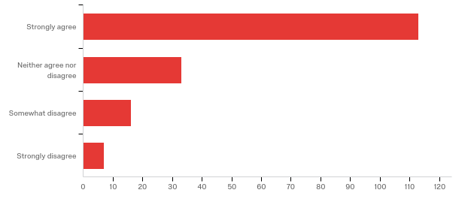

# | Field | Minimum | Maximum | Mean | Std Deviation | Variance | Count
1 | Demonstrate knowledge of content-related pedagogy | 1.00 | 5.00 | 1.88 | 1.07 | 1.15 | 234

# | Answer | % | Count
1 | Strongly agree | 66.86% | 113
3 | Neither agree nor disagree | 19.53% | 33
4 | Somewhat disagree | 9.47% | 16
5 | Strongly disagree | 4.14% | 7
 | Total | 100% | 169

Q15 - Lesson planning provides concrete ways the candidate provides instruction that meets the needs of all learners.

# | Field | Minimum | Maximum | Mean | Std Deviation | Variance | Count
1 | Lesson planning provides concrete ways the candidate provides instruction that meets the needs of all learners. | 1.00 | 9.00 | 3.45 | 2.64 | 6.96 | 235

# | Answer | % | Count
6 | Strongly Agree | 40.79% | 31
7 | Neither Agree or disagree | 21.05% | 16
8 | Somewhat agree | 32.89% | 25
9 | Strongly disagree | 5.26% | 4
 | Total | 100% | 76

Q23 - Formative data driven assessment data is used to monitor instruction.
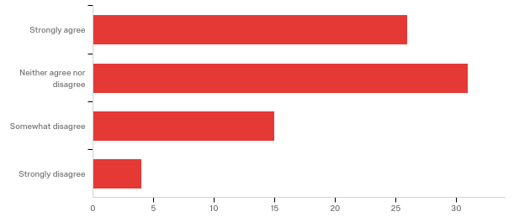

# | Field | Minimum | Maximum | Mean | Std Deviation | Variance | Count
1 | Formative data driven assessment data is used to monitor instruction. | 11.00 | 15.00 | 12.62 | 1.28 | 1.63 | 76

# | Answer | % | Count
11 | Strongly agree | 34.21% | 26
13 | Neither agree nor disagree | 40.79% | 31
14 | Somewhat disagree | 19.74% | 15
15 | Strongly disagree | 5.26% | 4
 | Total | 100% | 76

Q16 - Plans assessments aligned with performance outcomes of learner.
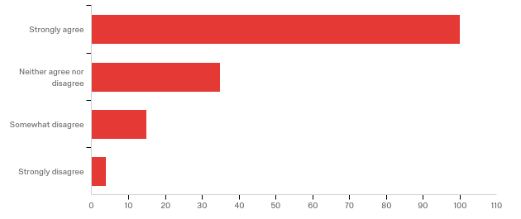

# | Field | Minimum | Maximum | Mean | Std Deviation | Variance | Count
1 | Plans assessments aligned with performance outcomes of learner. | 1.00 | 5.00 | 1.90 | 0.99 | 0.97 | 235

# | Answer | % | Count
1 | Strongly agree | 64.94% | 100
3 | Neither agree nor disagree | 22.73% | 35
4 | Somewhat disagree | 9.74% | 15
5 | Strongly disagree | 2.60% | 4
 | Total | 100% | 154

Q24 - Candidates can assist in design or assessments that are aligned with performance outcomes.
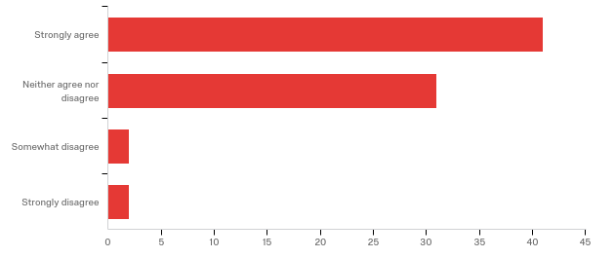

# | Field | Minimum | Maximum | Mean | Std Deviation | Variance | Count
1 | Candidates can assist in design or assessments that are aligned with performance outcomes. | 11.00 | 15.00 | 12.00 | 1.14 | 1.29 | 76

# | Answer | % | Count
11 | Strongly agree | 53.95% | 41
13 | Neither agree nor disagree | 40.79% | 31
14 | Somewhat disagree | 2.63% | 2
15 | Strongly disagree | 2.63% | 2
 | Total | 100% | 76

Q17 - Utilize technology for tracking data for use in monitoring all learners’ progress instruction.
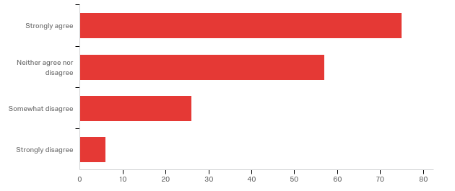

# | Field | Minimum | Maximum | Mean | Std Deviation | Variance | Count
1 | Utilize technology for tracking data for use in monitoring all learners' progress instruction. | 1.00 | 5.00 | 2.22 | 1.09 | 1.19 | 235

# | Answer | % | Count
1 | Strongly agree | 45.73% | 75
3 | Neither agree nor disagree | 34.76% | 57
4 | Somewhat disagree | 15.85% | 26
5 | Strongly disagree | 3.66% | 6
 | Total | 100% | 164

Q18 - Utilize technology to differentiate and extend learning.
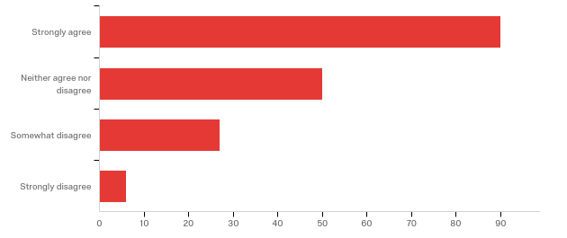

# | Field | Minimum | Maximum | Mean | Std Deviation | Variance | Count
1 | Utilize technology to differentiate and extend learning. | 1.00 | 5.00 | 2.14 | 1.12 | 1.26 | 236

# | Answer | % | Count
1 | Strongly agree | 52.02% | 90
3 | Neither agree nor disagree | 28.90% | 50
4 | Somewhat disagree | 15.61% | 27
5 | Strongly disagree | 3.47% | 6
 | Total | 100% | 173

Q20 - Do you feel you were provided enough information about your role as cooperating teacher?
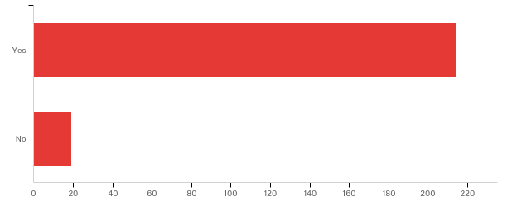

# | Field | Minimum | Maximum | Mean | Std Deviation | Variance | Count
1 | Do you feel you were provided enough information about your role as cooperating teacher? | 1.00 | 2.00 | 1.08 | 0.27 | 0.07 | 233

# | Answer | % | Count
1 | Yes | 91.85% | 214
2 | No | 8.15% | 19
 | Total | 100% | 233

Q21 - Would a brief training session have been helpful to you? Please indicate which modality you would prefer.

Would a brief training session have been helpful to you? Please indicate which modality you would prefer.
I prefer emails and written information.
No- the student teaching supervisors have been able to answer any and all questions I have had, and I haven't had many. The documentation provided is enough.
No trainings.
Training is always refreshing to assist in understanding roles.
I don't think there was enough information at the beginning of the expectations of the student teacher and that made it difficult to know how much was expected of them. Mainly in terms of lesson planning. I think even just a more detailed write-up would have helped.
No, meeting with supervisor was sufficient
I think it would be very helpful. I think a sit down session of expectations would be great.
Online option for updates and review of procedure would be nice.
I feel comfortable with the quality of teachers that Millersville keeps sending me. I love the full year program. Much better than the traditional junior block then semester student teaching experience.
It would be extremely helpful to be able to meet with the candidate prior to the first day of their experience. This meeting could be used to discuss expectations (arrival time, dress code, and schedule) rather than bombarding the student teacher on the first day.
Not necessary.
I am familiar with Dr. Gates and her pedagogy so I felt comfortable with accepting one of her student teachers. For other teachers not familiar with Millersville's expectations and/or Dr. Gates, a informational training may be helpful.
I do not need more training. The dept. chair is very supportive and helpful.
No need.
Yes, preferably online.
No thank you
no
The information provided is detailed. I have been involved in this process for a while, but perhaps new cooperating teachers would benefit from a truing session. However, i do feel that the information provided is detailed and the supervisors are available and willing to provide support.
Yes, but it wouldn't need to be face to face. I think an FAQ style tutorial would have been helpful.
I believe it would be. I think an in-person training/expectations session would be a good idea for cooperating teachers to provide an opportunity to ask questions and be better prepared to work with a candidate.
No
No, but I wish the program change of having PDS students in the fall Wednesday-Friday would have been communicated better. I was only expecting my student teacher to be here in the fall on Fridays.
I've been working with student teachers for over 25 years. I don't think there is anything new to be brought to the table.
no
Yes- Something that is face to face with both the student teacher and the cooperating teachers to go over the expectations. Each year I felt like our student teachers (through no fault of their own) didn't have a clear picture of the expectations until the last minute.
Yes, a beginning of semester meeting would have been nice with outlined expectations for both the cooperating teacher AND the student teacher. I especially feel that this is necessary with the post-bac student teachers, since their requirements were different than a traditional student teacher.
Not necessarily
Yes. Virtual
Not necessary.
No
I have done this for so many years, that a training session would not be helpful. However, if you held one, online would be best.
I think making something available online (checklist or referral guide) would be beneficial for mentors to use to make sure their interns are on track with that the University requires.
No, I believe the current system worked well enough for me.
Maybe - but I don't believe it should an idealistic view of being a cooperating teacher. I feel that a lot of the instruction I was given was based on ideal situations.
No
I do not believe a training session is necessary
Because it was my first time, I would have benefited from a brief training. An online module would have been sufficient.
Yes, a training would be helpful. It could be face to face, video conference, or online workshop.
It might help to touch base every year and hear about any updated expectations, etc. of the student teaching program. It might help for this to just be some form of electronic communication.
It would have been helpful to receive information, from Millersville, about my student teacher. This was done in the past through a questionnaire the teacher candidate completed prior to student teaching.
I have had overall good experiences with Millersville student teachers, but this year, I was not given any background information on the student I would be mentoring. I find this helpful in making a decision about if I am the best equip mentor for the candidate. This year, I worked with a student who had a diagnosed learning disability and that information was not released to me. I spent 8 weeks struggling to understand why this individual was not capable of meeting the basic needs of a classroom teacher. Had I know that accommodations were necessary for this student's success, I would have approached this placement differently.
Mrs. R is an awesome supervisor. She has surpassed the other supervisors I have had experience with from Millersville.
No, not really.
face to face or online
no
No, thank you.
No, the supervisor this semester was extremely helpful. Supervisors in the past have not been and training would have been helpful then.
Yes. Meeting with the supervisor before we began would have been helpful.
I have attended an in-person training in the past. Future training available on-line would be easiest for me.
Email
Email communication was sufficient. Any questions were promptly answered.
No. I understand what I am asked to do.
The provided paperwork makes it very clear the expectations and requirements.
Yes! Peg Brown was great!
no
I would just like to be kept abreast of any changes to expectations.
I believe knowing exactly what is expected in this ever changing education world would be beneficial for the comfort level of both teachers. I think an online session would work well.
A training session would have been very helpful. A Google Hangout, Skype Session, or face to face presentation would have been very helpful. The communication that I received came from the student teacher rather than the supervisor.
Yes. I do feel like I was learning about things that were happening as they were happening. My student teacher is a PDS intern and there was no information given regarding her action research project. An in-person training session or virtual training videos would have both been very helpful to ensure that I knew all of her requirements ahead of time.
No. I am an auditory learner.
The reason I said no this time was because the student teacher supervisor never contacted me. I knew the expectations of the student teacher because I have been a coop before. We had one meeting the second week of her student teaching. I know my student teacher had questions and her supervisor didn't get back to her or returned her emails days after the initial email. The student teacher that I had (Lindsey Boarman) was wonderful! She did an excellent job, but her supervisor was a great disappointment.
No - the format works just as it is.
Training would definitely be helpful. Online or in person would be best.
I do not feel training is needed, but I would have preferred that the university supervisor had come right at the very start of my student teacher's time with me.
I think a brief session would be useful. Though I have supervised a number of student teachers, I feel like the expectations are ever changing, to flow with the trends of education. Knowing what's expected of them would help me to facilitate better. An online resource, that could be referenced as needed, would be helpful. Perhaps even a video that could be viewed on our own time.
I found that meeting with my student teacher's supervisor was sufficient in preparing both of us for the experience.
The information I found on the website was informative and helpful.
Yes- an online or in-person training session would be beneficial. I responded the same way after my last student teacher but was not provided with a training opportunity following that placement.
No
Training not needed.
Yes, other universities I have worked with have a meet and greet session where all expectations are explained. There is a presentation and refreshments. There is the opportunity to meet with the college supervisor and opportunity to ask questions.
yes on-line or in person
No I felt I was prepared based on info I received
No. There are ample documents outlining our responsibilities. We also have a collaboration meeting about our duties in the first week of student teaching. Millersville professors hold meetings to discuss progress and goals as well.
N/A
No--I think the information you provide is helpful as long as cooperating teachers decide to use it.
I actually received a number of training sessions when MU began to offer the year long format for teacher candidates. I found these sessions helpful, but I do not feel I need further training sessions at this time. MU sent presenters to our district, and we met with our teacher candidates at a designated place and time within the district. This was a great way to get the information and ensure our teacher candidates had the same information we received as cooperating teachers.
No. The information provided on paper and through emails has been more than adequate to help me navigate the experience.
NO
I think it would have been great to have a short session regarding the changes in the special education requirements for student teachers - either online or in person.
Having had three student teachers in the last 4 years I feel pretty comfortable. Training isn't bad, but I think a formal time is difficult as we all have our district responsibilities as well as home and community involvement. I think if it were an online self-paced seminar. Prerecord some video segments. Have it broken down like a FAQ page that we could look up info or segments for review or clarifications.
I thought the communication was very clear so I would not have needed a brief training session.
Yes I would have appreciated this. This is the first time that I have had a 3 day a week in the fall and 15 week in the spring PDS student. While my student teacher was wonderful it was hard to get a grasp on what the expectations of her were, how much I should be putting on her plate and how soon etc. This was even more difficult because at this time, April 1, 2019, her supervisor from Millersville, Dr. Burke, has only been in the classroom twice and really has had little to no dialogue with me. Fortunately Melissa is a capable and responsible student. I think just a training in general to review and clarify the expectations as well as where to find and how to use all the online resources.
No, not necessary.
no
not needed
No, however, if the requirements would change, it would be good to have a training session.
no
No
I was fine with the amount of information given.
No really don't feel an in-service on how to mentor a student teacher would benefit anyone.
A brief training would be helpful. Either an in-person meeting or a webinar format would be beneficial.
Yes a brief training would have been helpful in laying out the desired schedule of teaching for a student teacher in the PDS program since it is fairly new and spans for such a long time.
No. I had enough information.
Because I've had multiple student teachers, I do not feel I need a training session.
Any training session that is meaningful would be helpful. I truly think a self-paced online training would be fine. We are all so busy, so don't ask me to show up somewhere on a particular date.
no
no
I think for myself I know what to do with and for student teachers both in their pre-service observations and in their actual student teaching. However I do believe that newer mentor teachers should have some sort of training to complete.
I believe when I had a student teacher from Millersville for the first time, there was an orientation meeting option for us. As a Millersville graduate, I understand the expectations and still know and work with the professors in the department. So a training doesn't seem necessary for me, but I can see how cooperating teachers that graduated from a different school, or have a student teacher from Millersville for the first time could benefit from such a training.
A memo with all the dates listed would be helpful.
video or Youtube.
Not really
Maybe online
no
not needed for me
N/A
Email, Computer
No thanks...
If I were new to student teaching a training session would help, but having had extensive involvement with student teachers in the past it would not benefit me.
Yes. Online
Yes. A recorded Zoom session.
No
I don't know if I would need a training session, but I would have liked more communication on expectations of mentors and due dates for evaluations. As a former Millersville grad, I also saw differences between the expectations I had 5 years ago with my supervisor and my student teacher's supervisor. I think consistency between supervisors would help.
This would be beneficial. Another suggestion would be to create a folder will expectations, calendar of events with due dates, examples of lesson plan format to be used.
Some new cooperating teachers have said that this training would be helpful. However, those that have had numerous student teachers did not want this added obligation.
No
I don't really have a suggestion here.
no
No, the supervisor was fantastic!
I felt like I received enough information.
I have had over 10 student teachers during my career. I do not need a training session as a cooperating teacher.
Yes a training session would have been helpful- either in an online module or in person.
Yes, it would be helpful. The best method would be a webinar.
no
The session we attended to discuss in the fall of 2018 was very helpful.
No
I am not sure if it is necessary. If it will help to provide Millersville students and University with better experience, feedback, and services, then I have no problem with some training. I hope that evenings are best since I tutor after school.
I have had many student teachers in the past, so possibly if this were the first time hosting, but not for me personally.
Not necessary.
I think it would be beneficial for teachers who have not had a student teacher before. I have had many student teachers but I am still learning with each student teacher. I think training sessions would help for a general overview, but each student teacher is different so it may not help with specific concerns.
Meeting with the supervisor of the cooperating teacher early in the placement is generally enough support. They are easy to contact through email and quick to reply should any needs arise.
I have worked with Millersville in the past and the information is sent out in a timely fashion and everything needed is online and easy to use. I didn't have any questions or problems with the requirements or evaluations.
No training is necessary for me. If there is new information it would be easiest to share it electronically.
I do not feel a training is needed. I think the supervisors I have worked with have done a wonderful keeping me informed of what is required of me.
No, I've had many student teachers.
I felt sufficiently informed and prepared for the student teacher.
The information I've been provided has prepared me to support the needs of a student teacher.
No
I think before my first student teacher, yes, this would have been helpful. A video session would have been helpful so we can do it as we find time.
No, I feel that I was prepared enough.
Not at this time. If the student teaching philosophy changes, then a training session would be helpful (such as when it changed from cooperating teachers leave the room during the full week, now we stay and aide the student teacher).
NO
Yes, a brief training would be nice. Something to watch online would be helpful. I was unsure how soon to get my student teacher started and for how long the expectation was for her to teach full time.
No, the emails and electronic correspondence is preferred. If a training session is required, it would inhibit my future commitment to taking student teachers.
I think it would be more helpful to meet with the supervisor and student teacher before the assignment begins or shortly after. I did not meet the supervisor for weeks.
no
No I feel adequately prepared, but if one was available it would be best to have it be available on line. Like a Webinar.
I don't feel a training is necessary.
I feel the information provided was adequate and I would not need a brief training. However, if one was given, I would prefer it as an online training.
I do not feel a training session is necessary for me and am fine with email correspondence and/or meeting with supervisors/advisors.
I attended a brief training before my first student teacher at Millersville. I thought this was very helpful as it prepared me for my role as cooperating teacher and outlined my expectations.
No, I don't think a training is necessary.
Not needed
I do not think this is necessary since we meet with the student teachers supervisor.
No, I felt prepared.

Q22 - Were the online student teacher evaluation forms generally easy to understand?
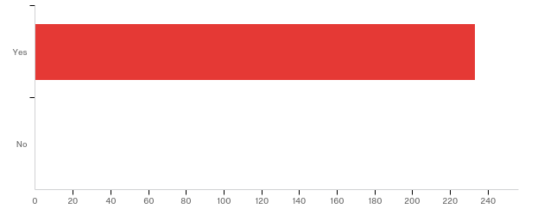

# | Field | Minimum | Maximum | Mean | Std Deviation | Variance | Count
1 | Were the online student teacher evaluation forms generally easy to understand? | 1.00 | 1.00 | 1.00 | 0.00 | 0.00 | 233

# | Answer | % | Count
1 | Yes | 100.00% | 233
2 | No | 0.00% | 0
 | Total | 100% | 233

Q23 - Did the categories on the forms allow for a good picture of the student teacher’s skills?
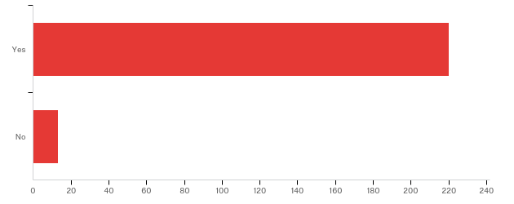

# | Field | Minimum | Maximum | Mean | Std Deviation | Variance | Count
1 | Did the categories on the forms allow for a good picture of the student teacher’s skills? | 1.00 | 2.00 | 1.06 | 0.23 | 0.05 | 233

# | Answer | % | Count
1 | Yes | 94.42% | 220
2 | No | 5.58% | 13
 | Total | 100% | 233

Q24 - Did the observations/evaluations seem to work as tools for the improvement of teaching?
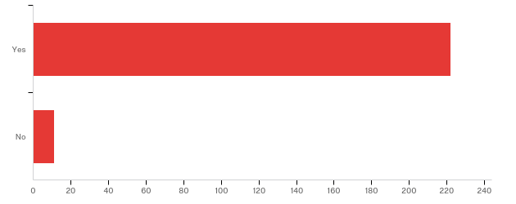

# | Field | Minimum | Maximum | Mean | Std Deviation | Variance | Count
1 | Did the observations/evaluations seem to work as tools for the improvement of teaching? | 1.00 | 2.00 | 1.05 | 0.21 | 0.04 | 233

# | Answer | % | Count
1 | Yes | 95.28% | 222
2 | No | 4.72% | 11
 | Total | 100% | 233

