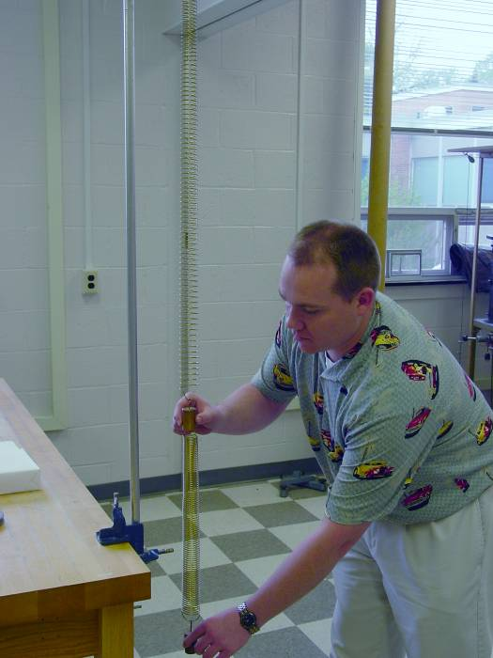

A Study of Coupled Oscillators
Stan K. Kulikowski, Jr.
Advisor, Dr. C.W. Price
Fall 2004

Abstract

For systems with two degrees of freedom, Lagrangian Mechanics are sufficient to develop the equations of motion. Additional degrees of freedom add complications that make the equations of motion difficult to derive using Lagrangian Mechanics. The project focused on two systems of coupled oscillators. The first system consisted of two springs and two bobs suspended and allowed to oscillate vertically. The second system consisted of three coupled pendulums. Both were analyzed to find the normal mode frequencies. The oscillations were measured using VideoPoint to collect data. The Excel Fourier transform function was required to extract the frequencies because the systems did not oscillate in pure modes. The results for the spring system were complicated by the spring mass, but the ratio of the two calculated frequencies matched the ratio of the measured frequencies within 1%. For the pendulum, the calculated angular frequencies were 5.08, 7.78, and 15.40 radians/sec. The measured frequencies were 5.15, 7.73, and 15.46 radians/sec.

