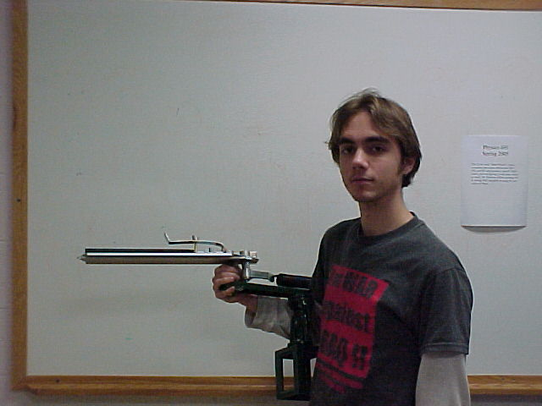

A Qualitative, Macroscopic Exposition of the Physics of Stone Skipping

Tony Robalik

Advisor: Dr. Cooney

Fall 2004

Abstract:

Some observations are made relating shape and mass of the “stone,” and its velocity, maximum height between skips, distance between skips and arc number (skip number). Using clay pigeons launched from a trap, it was shown experimentally that if the object is not flat, it is better for the center to curve into the water than to curve out of the water. The maximum height decreased monotonically with arc number, as did the length between skips. The horizontal component of velocity decreased in a nearly linear fashion with arc number, losing about 30% of its velocity with each skip.

