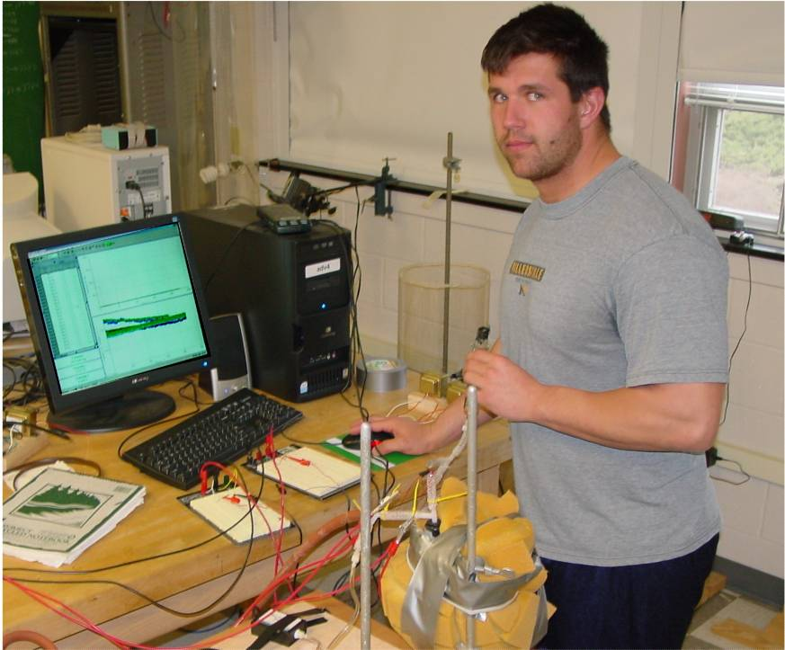

Refrigeration by Continuous-Cycle Absorption
by James Knox
Advisor: Dr. John W. Dooley

A continuous cycle heat-driven refrigerator works as follows: The system heats a mixture of ammonia and water in which bubbles of ammonia gas are produced. The ammonia gas rises through a chimney in which water vapor is removed. The pure ammonia gas passes through a condenser in which the ammonia gas is cooled to room temperature and liquefies (at elevated pressure. In the evaporator hydrogen gas flows over the pure liquid ammonia. The moving hydrogen keeps the ammonia vapor pressure low so that the liquid ammonia continues to evaporate. In the process the ammonia cools and in turn cools the refrigerator compartment. The ammonia gas is then absorbed back into a mixture of ammonia and water and the process starts over.
In my first experiment I showed that by compressing air it heats up and by decompressing it, it cools down. I was able to change the temperature of the gas by approximately 2 degrees Celsius compared to room temperature. The second experiment I created a vacuum system in which I obtained the vapor pressure of water, which I found to be approximately 16.62 ±.61 mmHg at 19.3 ± .26 Celsius and a leak rate of about 0.003054 mmHg/sec. In this system I also was able to create a very simple refrigerator in which I achieved a temperature drop of approximately 5 ± .26 Celsius.

