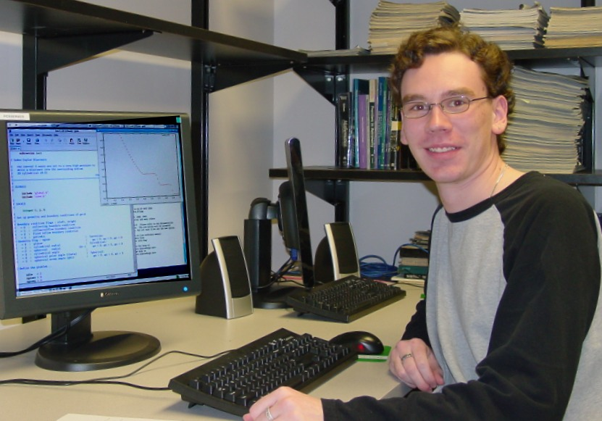

Computer Simulations of Type Ia Supernovae
Michael Palmer
Advisor: Dr. Sean P. Hendrick

Several mechanisms by which type Ia Supernovae could occur in a white dwarf were examined. The first mechanism is detonation, which is a supersonic shock wave that consumes the entire star. The second mechanism is deflagration, which is a subsonic flame wave traveling around the star. Other mechanisms involve a transition from deflagration to detonation, called a Detonation-Deflagration Transition (DDT), caused by the buildup of pressure behind a deflagration wave. The first DDT model is delayed detonation, in which part of the star is consumed by the flame wave before the detonation consumes the remainder. A second model is the pulsational delayed detonation model, in which the deflagration wave propagates throughout the star until the materials are dispersed enough to quell the flame, and a detonation is triggered upon recollapse of the materials.
The hydrodynamic software Virginia Hydrodynamics-One was explored. Several tests have been run with this program, and the results matched expected results based on other people’s calculations. Finally, the Sedov-Taylor expansion has been applied to the simulation as way to simulate a type Ia Supernova.

