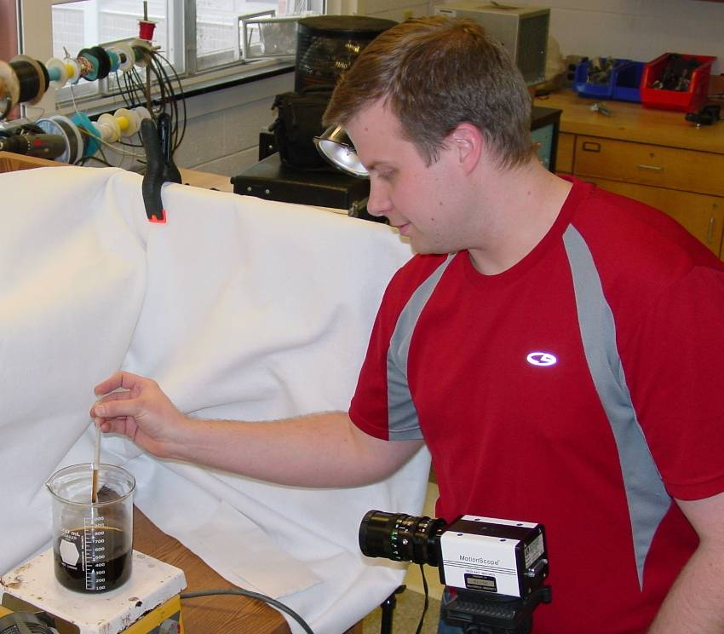

Noncoalescence in Liquids of Similar Temperatures
Arzie W. Yeater III
Advisor: Dr. P.J. Cooney

While brewing coffee drops can be noticed skating along the surface of the liquid instead of falling in. We made a movie to capture the events and later progressed to a high speed video to investigate the physics of these noncoalescing drops more closely. The drops formed, moved, and perished in a consistent pattern, lasting about one second. We used Vernier’s LoggerPro® software for video analysis and their LabPro® data logger for temperature readings. The mechanism behind the noncoalescence involves surface tension and vapor pressure gradient. The two properties are oppositely dependant on temperature; vapor pressure exponentially builds and surface tension linearly declines with rising temperature. Middle temperatures around 60ºC are the most likely place to form drops that do not coalesce. Surface tension reflects intermolecular forces that hold drops together, with small diameter drops held together more strongly. Smaller drops are less likely to become part of the bulk liquid and vapor pressure gradient creates a force that helps to keep the drops from the liquid. The coffee evidently acts as a surfactant, forming a slight “scum” on the surface increasing the barrier between drop and base coffee.

