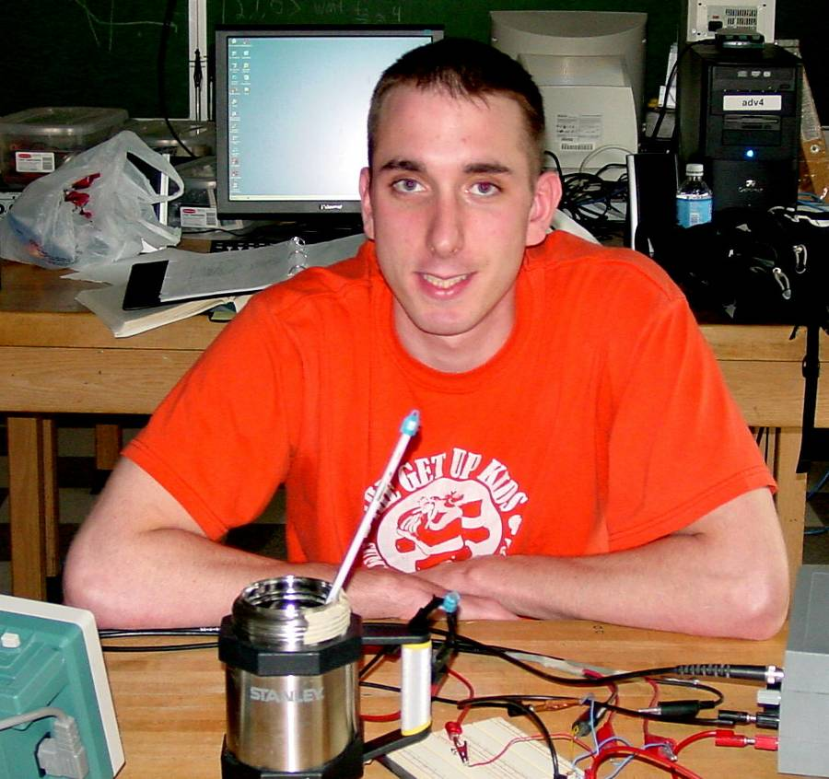

Dielectric Relaxation in Electrolytic Capacitors
By Edward Tangradi
Advisor: Dr. John Dooley

Dielectric relaxation can cause an increase in capacitance with increasing duration of the voltage applied to the capacitor. A simple model of the dielectric material uses rigid electric dipoles which rotate in a viscous medium. For longer duration electric fields, the dipoles rotate more completely in line with the applied field. Using both the real and imaginary parts of the measured dielectric constant, plotted as function of frequency, we can determine a relaxation time of about 0.4 ms in a 220µF, 35V, electrolytic capacitor. Measurements at higher and lower capacitors temperature can confirm, respectfully, lower and higher relaxation time constants. Unfortunately, in an attempt to cool and heat the capacitor, a shift in a relaxation time constant has yet to be identified

