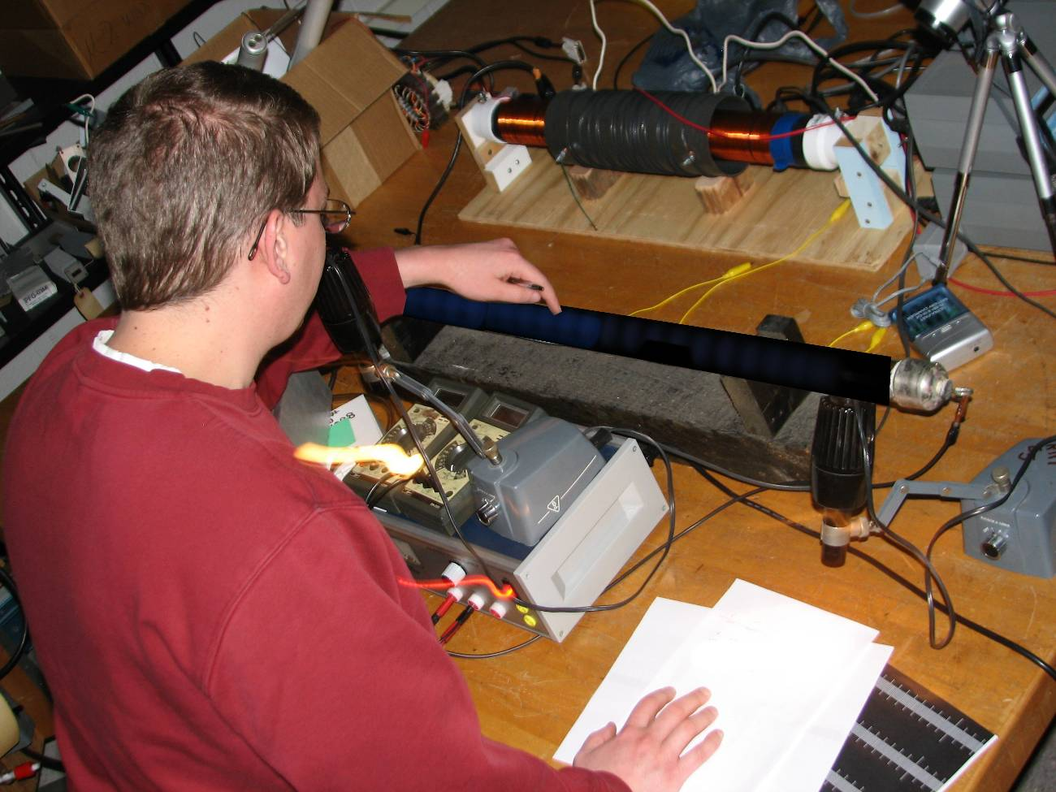

Striation Patterns in a Glow Discharge Tube

Philip Herd

Advisor: Dr. Tariq Gilani

ABSTRACT

The relationship between the striations in the positive column of the electric glow discharge in a vacuum tube and its pressure, voltage, and current, was experimentally investigated. It was found that the pressure plays the biggest role in determining the striations, while the voltage plays a part only at higher pressures.

