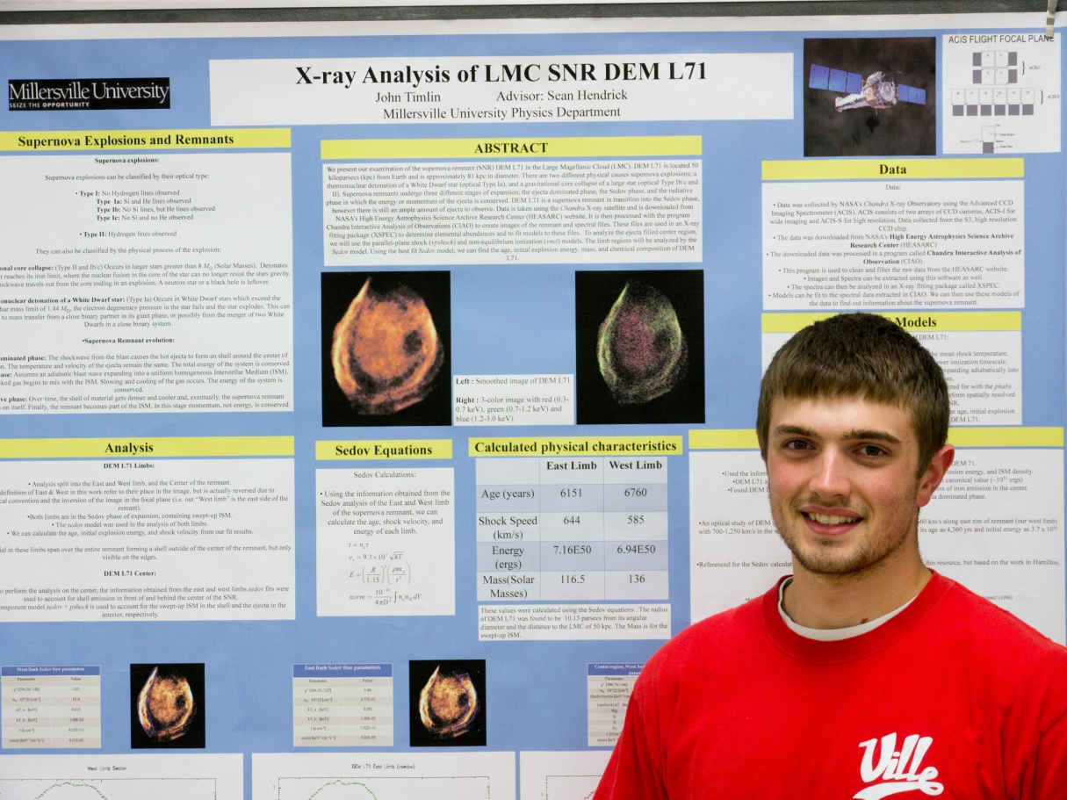
X-ray Analysis of Supernova Remnant DEM L71
John Timlin
Advisor: Dr. Sean Hendrick
We present our examination of the supernova remnant (SNR) DEM L71 in the Large Magellanic Cloud (LMC). DEM L71 is located 50 kiloparsecs (kpc) from Earth and is approximately 20.3 kpc in diameter. There are two different physical causes supernova explosions; a thermonuclear detonation of a White Dwarf star (optical Type Ia), and a gravitational core collapse of a large star (optical Type Ib/c and II). Supernova remnants undergo three different stages of expansion; the ejecta dominated phase, the Sedov phase, and the radiative phase in which the energy or momentum of the ejecta is conserved. DEM L71 is a supernova remnant in transition into the Sedov phase, however there is still an ample amount of ejecta to observe. Data from the Chandra X-ray observatory was downloaded from NASA’s High Energy Astrophysics Science Archive Research Center (HEASARC). It is then processed with the program Chandra Interactive Analysis of Observations (CIAO) to create images of the remnant and spectral files. Using an X-ray fitting package (XSPEC), we fit models our data and determined the elemental abundances present in the remnant. To analyze the ejecta filled center region, we will use the parallel-plane shock (pshock) and non-equilibrium ionization (nei) models. The limb regions will be analyzed by the Sedov model. Using the best fit Sedov model, we can find the age, initial explosion energy, mass, and chemical composition of DEM L71.

