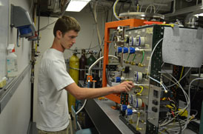

Properties of Electrically Conductive Polymers

Daniel. L. Gochnauer

Advisor: Dr. Tariq Gilani

The development of electrically conductive polymers maintains its worth as a valued field of materials science and solid state physics. The focus of this particular study is on synthesizable organic polymers with high electrical conductivity, and how this property can be tailored to meet certain criteria within various environs. In particular, doped polypyrrole will be synthesized and its conductivity will be analyzed, considering potential dependencies on dopant species, dopant concentration, imposed temperature, and imposed pressure. Extensive discussion on the conjugated polymeric model is presented in this review, which is used to predict the correlation between the conductivity of polypyrrole and each of the aforementioned independent variables. Special attention is given to the dependence of conductivity on temperature, as the relationship between these two variables is given succinctly by Mott’s variable range hopping model. The conductivity of 0.054 M PF6- doped polypyrrole at room temperature was experimentally determined to be 73±34 S/m. Based on the variable range hopping model, the average hopping distance at 298 K was calculated to be (3.38±0.06)x10-8 cm, the density of localized states at the Fermi level was calculated to be (1.5±0.1)x1023 cm-3 eV-1, and the hopping activation energy was calculated to be 0.040±0.003 eV.

