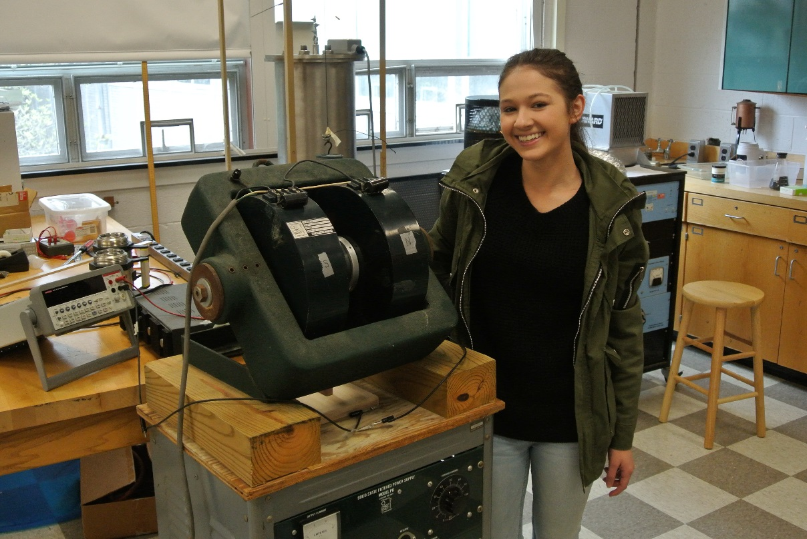

Mobility and Density of Charged Carriers in Thin Films

By: Diana Rabchuk
Advisor: Dr. Tariq Gilani
Spring 2016

The purpose of this experiment was to make Gold thin films using the vacuum evaporation
system and to find the temperature dependence of mobility and Hall coefficients and compare the
results to that of bulk materials. The Hall coefficient was found using an electromagnet setup.
The mobility was found by using the relationship between the density of the charge carriers and
resistivity. The four probe method was used to find the resistivity.

