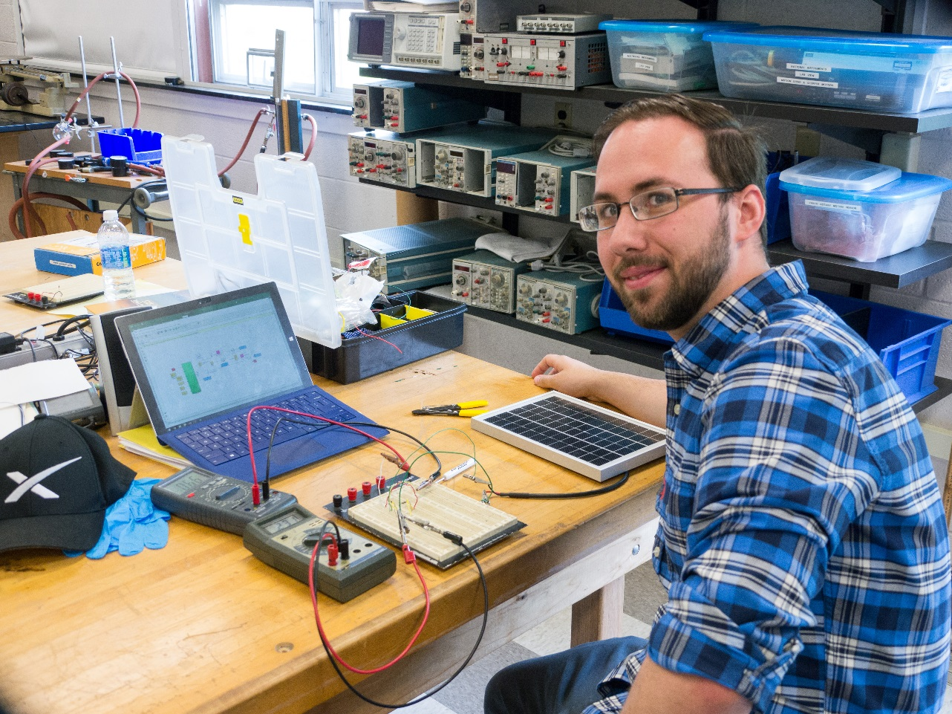
Modeling Photovoltaic Cells using MATLAB and Simulink
Jacob Celli
Advisor: Dr. Mehmet Goksu

Photovoltaic cells and solar energy are quickly becoming a major force in energy consumption in the United States and around the world. Accurately modeling these cells is essential in being able to make predictions on the ability of the cells. This research includes the modeling of single diode photovoltaic circuits. In the future, the model will be expanded to two and three diode circuits in being able to make predictions on the characteristics of photovoltaic modules, which consists of up to ten photovoltaic cells. This model will allow for the maximum power point of the circuit to be identified for specific conditions, including resistor values, ideality factors, temperature, and solar irradiance.

