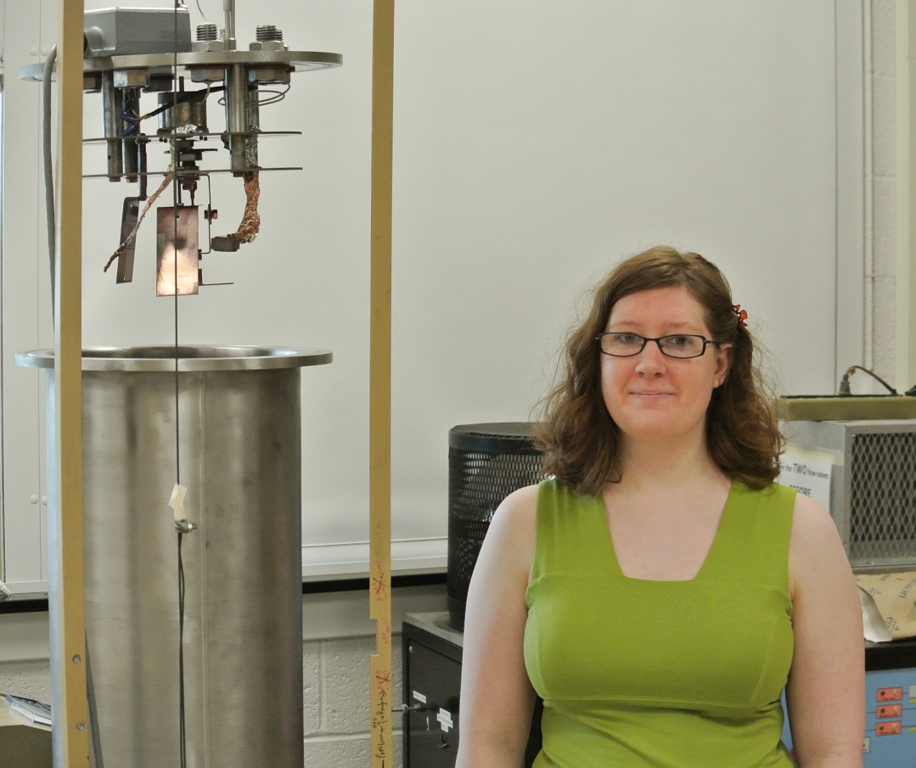
Optical Properties of Sculptured Thin Films

Katherine McClintock
Advisor: Dr. Tariq Gilani
Thin films can be produced from a variety of methods the most common is physical vapor deposition. Thin films can exhibit column like structures that can be altered during deposition by using oblique angle and glancing angle techniques. By changing the angle of the incident flux on the substrate sculptured thin films can be fabricated that exhibit different shapes such as zigzags or chevrons. Columns are formed from the effects of shadowing that occur during deposition and dictate how columns will grow. To produce defined columns shadowing effects must be enhanced and surface diffusion minimized. This is done by depositing at low pressures and maintaining a substrate temperature that is lower than the melting point of the material. Due to anisotropic nature, sculptured thin films exhibit a variety of optical properties. A sculptured thin film of a certain material can exhibit different transmission spectra than a bulk film of the same material. To investigate this property, columnar thin films of silver and copper were fabricated and FESEM images were taken to determine if they exhibited columnar growth. Fabricated silver films of thickness less than 100 nm exhibited an absorption spectrum similar to silver nanoparticles. The initial growth stages for the Volmer-Weber growth regime were observed for both films fabricated in this project.

