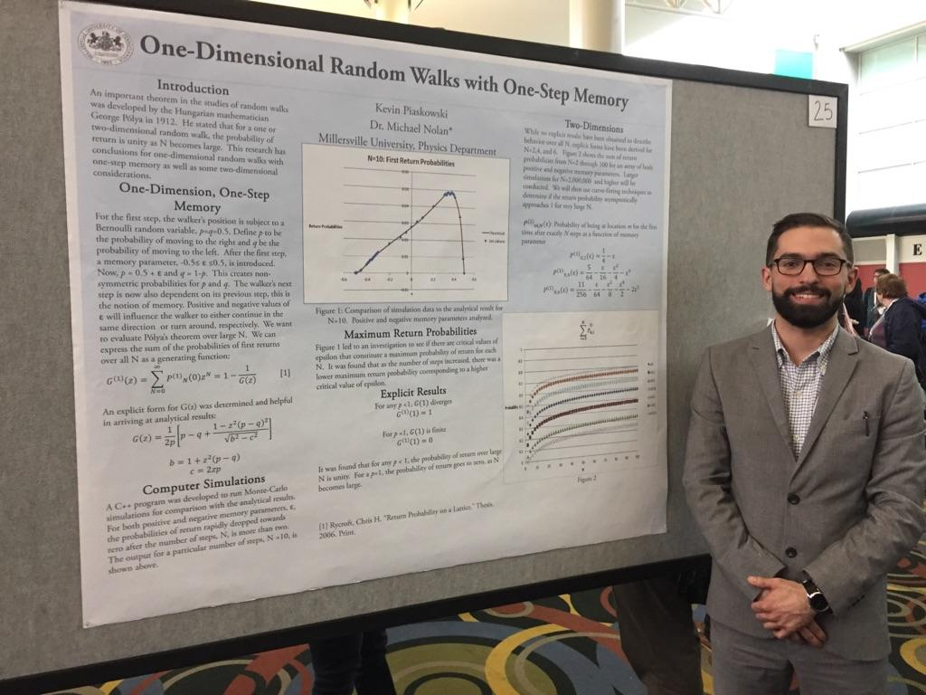
One and Two-Dimensional Random Walks with One-Step Memory
Kevin Piaskowski
Advisor:Dr. Michael Nolan*
Spring 2016

Abstract
Formalized studies of random walks have been conducted dating back to the early 20th century. Since then, well-defined conclusions have been drawn, specifically in the case of one and two dimensional random walks. A key theorem was formulated by George Pólya in 1912. He stated that for a one or two-dimensional lattice random walk in the limit of infinite number of steps, N, the probability that the walker will return to its point of origin is unity. However, for any higher dimensional lattice, the probability of a return is less than one. The following work explores Pólya’s theorem for one and two-dimensional random walks that are non-isotropic and have the property of one-step memory, i.e. the probability of moving in any direction is non-symmetric and dependent on the previous step. The memory can introduce a positive bias which creates a tendency to continue movement in the current direction of travel. Alternatively, a negative bias can be introduced which creates a tendency to reverse the direction of travel. Explicit theoretical formulation and numerical analysis have been explored for the one-dimensional case. Finite asymptotic results have been achieved for the two-dimensional case.

