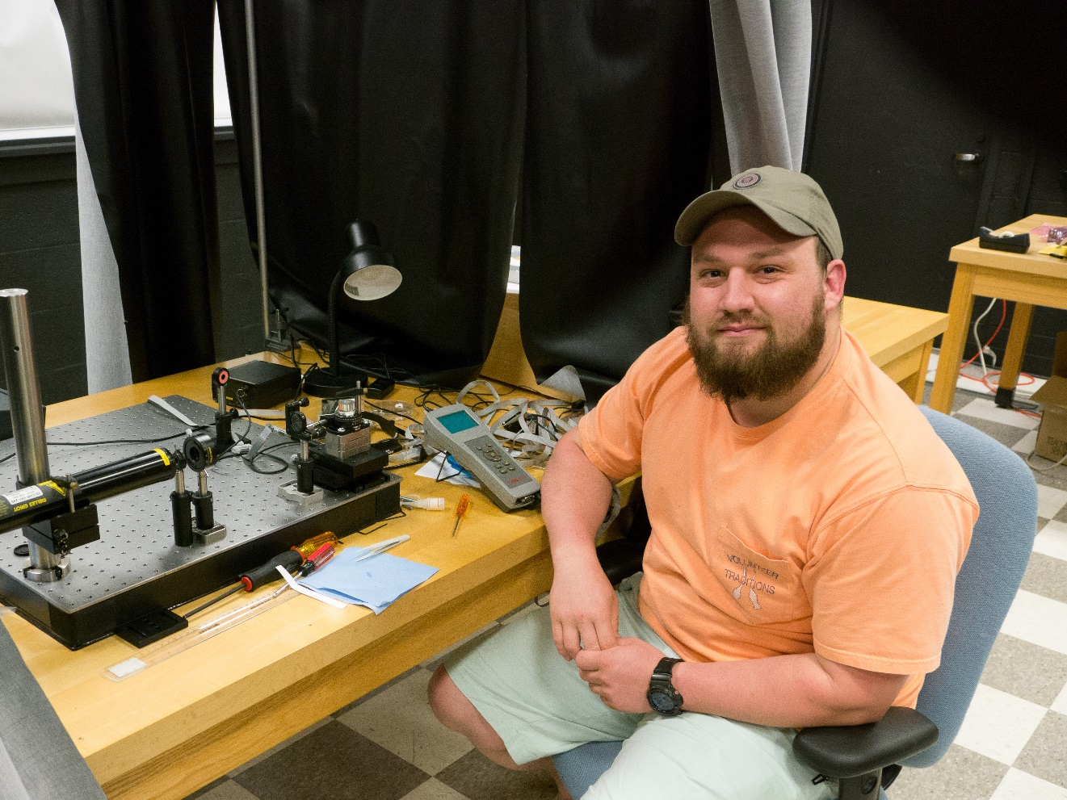
Automation of Surface Plasmon Resonance Measurements
Kyle Miller
Advisor: Dr. Natalia Dushkina

Automatizing surface plasmon resonance measurements has been done in several different ways, but this leads to a much easier way to take measurements. The known configurations hold the sample at the bottom or horizontally in the apparatus. This experiment aims to build an apparatus that places the sample at the top of the apparatus allowing for more applications in the bio-sensor field. Silver thin films will be used for this experiment because this metal has been widely tested in the realm of surface plasmon resonance. The Ag film is deposited on a microscope slide by vacuum evaporation; after that it is placed in optical contact with a cylindrical prism for total internal reflection. The results of the experimental trials are then compared to well-known theoretical models.

