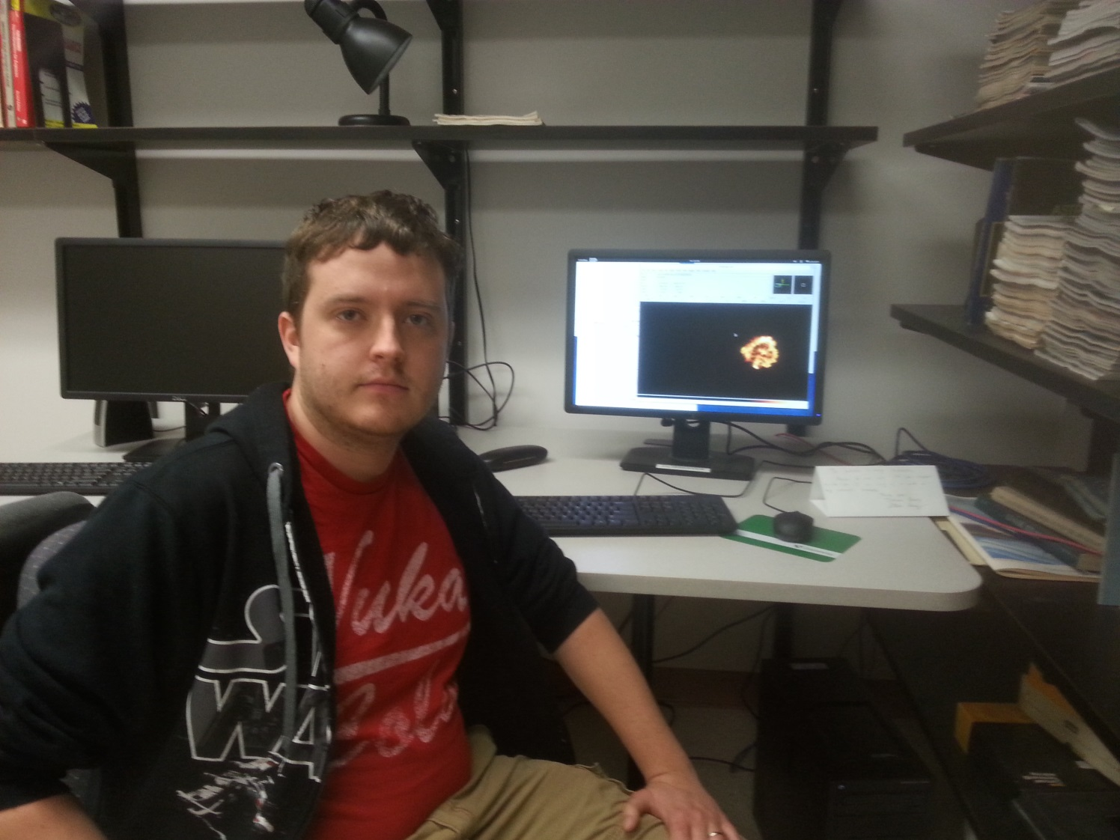

X-ray Spectroscopy of Supernova Remnant 0519-69.0

William Baldree
Advisor: Dr. Sean P. Hendrick

Supernova Remnant 0519-69.0 is one of the youngest and brightest remnants in the Large Magellanic Clouds. Archival data from the Chandra X-ray Observatory is analyzed in this project. The X-ray spectrum consists of several sharp and bright spectral lines that are difficult to fit with current models. Images of the remnant have been created at the energies corresponding to each line to examine the distribution of the elements in the remnant. Spatially-resolved spectroscopy has been used to examine and model the X-ray emission in various regions of the remnant.

