ESS – Personal Information– Direct Deposit/Bank Information
- Direct Deposit/Bank Information – Allows employees to view and maintain their Main Bank Account, which primarily controls direct deposit of pay. Employees may also add up to five Secondary Bank accounts to allow for additional customized distribution of direct deposit pay.

Setting up/Maintaining Main Bank Account
  - Select the Direct Deposit/Bank Information link from the Payroll menu in ESS.

  - In the example used here, the employee has not yet setup direct deposit with PASSHE as indicated by the saved Payment Method – Check.

  - Click Update Main bank Account to enter bank routing and account number information.

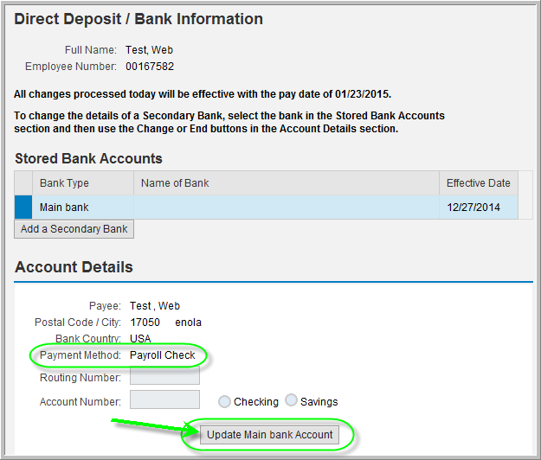

  - Enter the Routing Number, Account Number, choose whether the bank account type is Checking or Savings, and then to confirm the Account Number, complete Re-enter Account Num: When finished, click Save Changes.

NOTE: For help determining where to locate your bank ABA and bank account numbers, refer to the link at the bottom of the Direct Deposit/Bank Information screen Help Locating Routing/Account Numbers.
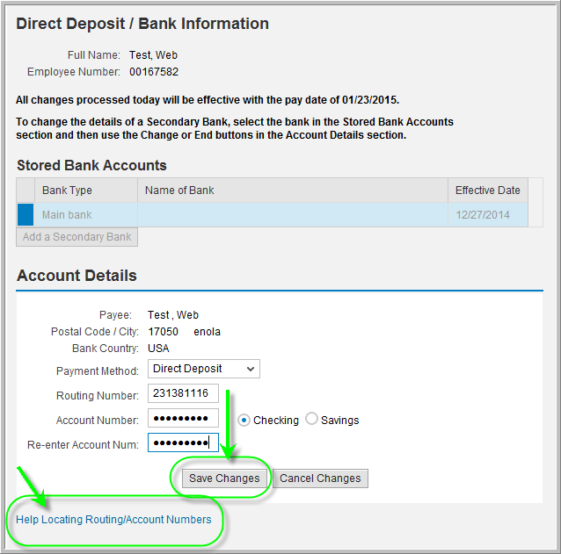

  - Main Bank Account information has been saved and the process of adding direct deposit information is complete. If adding one or more Secondary Bank accounts is not desired, 100% of the employee’s paycheck will be deposited to the Main bank. Continue with step 2 below if adding Secondary Bank accounts is desired.
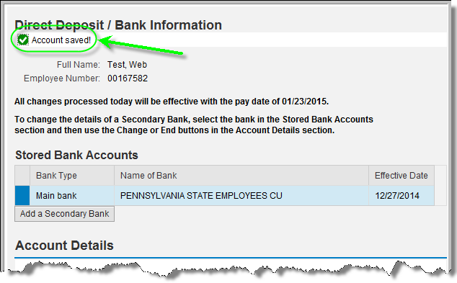
  - To modify details entered for Main Bank or to change the Main Bank on record to a completely new account, highlight the row for Main Bank, and then click Update Main bank Account.
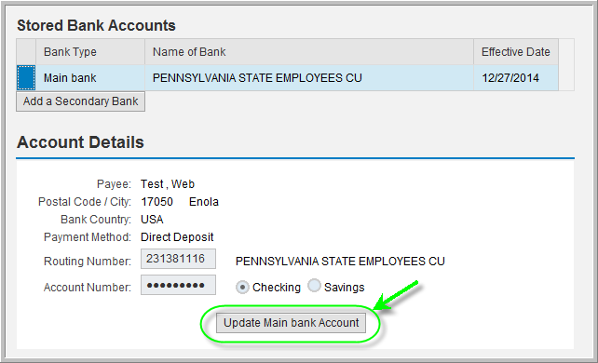

    - The Confirm Previous Account number pop-up window will appear. Enter the current associated Main Bank account number and select OK.
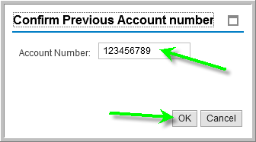
Adding a new Main Bank when there is a pre-existing Main Bank on record

    - If the intended change is to add a completely new Main Bank to be used for direct deposits, simply enter the new account Routing Number, Account Number, choose whether the bank account type is Checking or Savings, and then to confirm the Account Number, complete Re-enter Account Num: When finished, click Save Changes.

Modifying the pre-existing Main Bank on record

    - The process described here is to address situations where the employee only wants to change the type of account from checking to savings or vice versa on the pre-existing Main Bank account.
      - The Routing Number field should be left unmodified in order to ensure the same bank institution is being utilized for the deposits.
      - The Account Number must be entered exactly in order to match the account number that is currently on record.
      - The Re-enter Account Num. field must also match what was entered on the Account Number field in order to proceed with the update.
CAUTION! If maintaining the same bank account number is intended, it is extremely important to enter the Account Number exactly to match what is currently on record. If an incorrect/different Account Number is entered by mistake, a new Main Bank account will be created.

      - Select Save Changes. The following message will appear confirming the new Main Bank Account information has been saved.
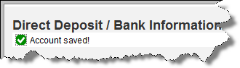

Setting up/Maintaining Secondary Bank Account
- For employees who wish to have a percentage or a specific dollar amount of their paycheck directly deposited to more than just their Main Bank, one or more Secondary Bank accounts may be added up to a maximum of five. Only the Secondary Bank account provides fields to indicate either the standard percentage or a standard value of an employee’s paycheck to be deposited. The Main Bank account does not provide these fields and will therefore retain the remaining percentage out of 100%. In the example used below, 70% of the employee’s paycheck will be deposited to the Main Bank account, while 30% will be deposited to the Secondary Bank account as indicated.
  - From the Direct Deposit/Bank Information screen, click Add a Secondary Bank.
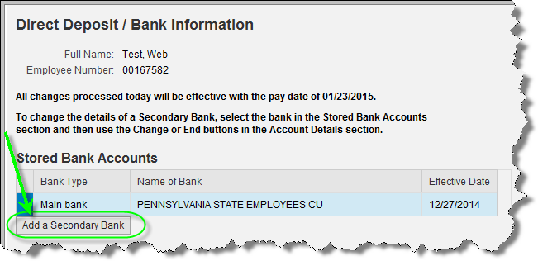

  - A pop-up window will appear asking to confirm the main bank account number for security purposes. Enter the account number associated with the Main Bank account and select the OK button to continue.
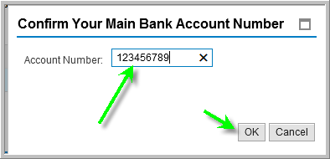
  - In the Account Details section, complete the Routing Number, Account Number, Re-enter Account Num:, and then complete either the Standard Value or Standard Percentage fields. The Standard Value field calls for a fixed dollar amount to be entered whereas the Standard Percentage calls for a fixed percentage out of 100 to be entered. However, only one of the two fields should be completed; otherwise, the system will display an error. Simply leave the field not being completed as blank, and upon clicking Save Changes, the system will default a zero value.
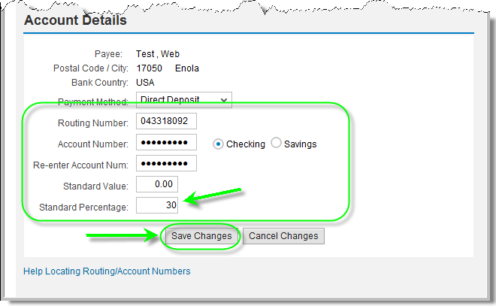

NOTE: This is an example of the error message displayed if both the Standard Value and Standard Percentage fields are completed with values and Save Changes is attempted:
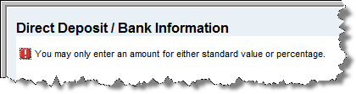
  - Secondary Bank account information has been saved.
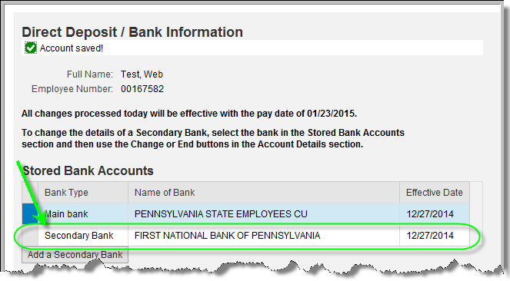
  - To add additional Secondary Bank accounts, repeat steps 2.1 through 2.3 above. Otherwise, the process of adding direct deposit information for the Secondary Bank account is complete.
If changing the amount, percentage, or type of bank account for Secondary Bank is desired, or to remove a Secondary Bank completely, continue to step 2.5.1 below.

    - To modify details entered for a Secondary Bank, highlight the row of the desired Secondary Bank for changes, and then click Change Amount or Percentage of Bank Account.
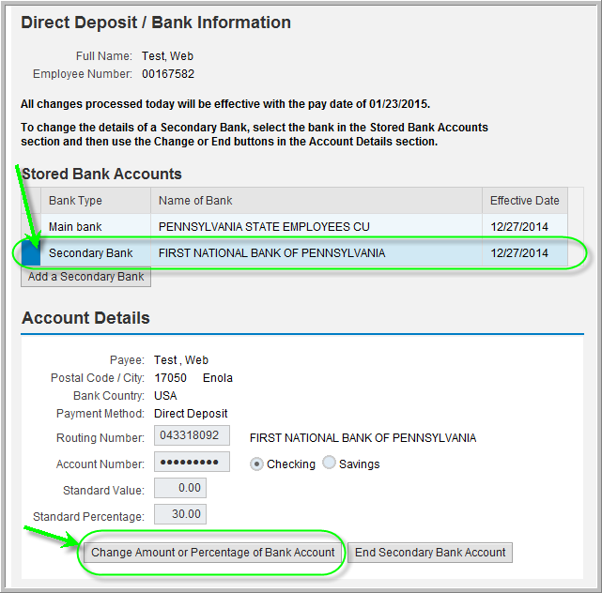

    - A pop-up window will appear asking for the user to Confirm Previous Account number. (NOTE: This message refers to the Secondary Bank Account number.) Once the account number has been entered, select the OK button to continue.
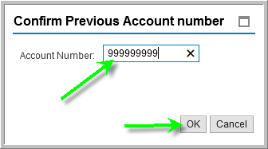
    - Make the desired changes and then select Save Changes.
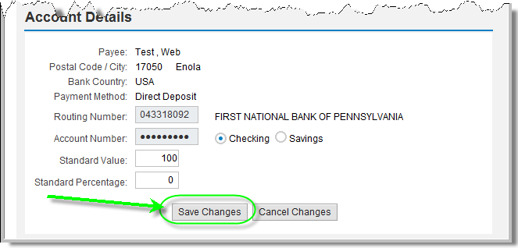
    - The Account saved message will appear at the top of the page.
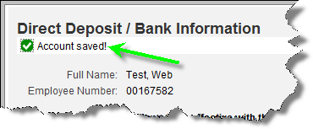

    - If completely removing/ending a Secondary Bank is desired, highlight the row of the desired Secondary Bank for changes, and then click End Secondary Bank Account.
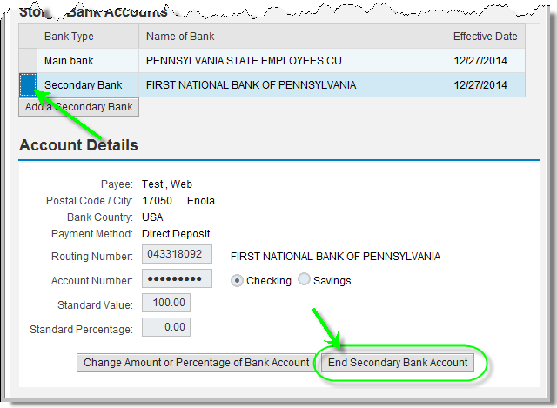
    - Depending on the timing of the change being made, one of the following confirmation messages will appear. If a deposit has never been made to the Secondary Bank, this message will display:

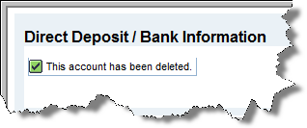

If a deposit has already been made to the Secondary Bank being removed/ended, a message similar to the following example will display stating the effective date of the last deposit to be made to the account.
