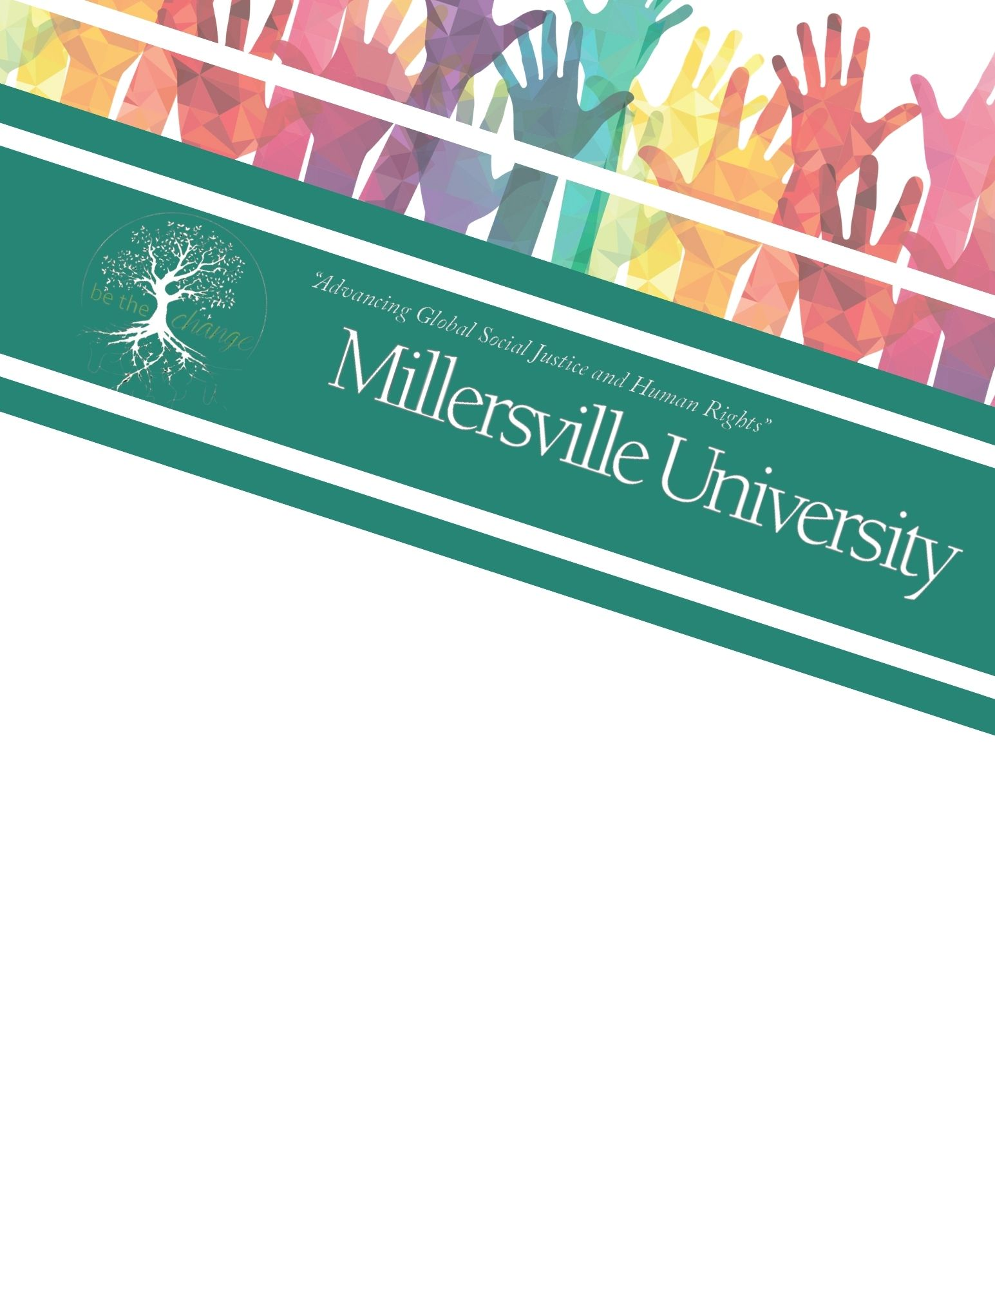

The Learning Institute’s 8th Annual
Global Well-Being and Social Change Conference

Global Citizenship: Acknowledging Interconnectedness and Cultivating Social Justice

April 14-16, 2021
Millersville University, Virtual Format, EST

Striving for social justice is the most valuable thing to do in life
– Albert Einstein

Table of Contents

Conference Planning Committee……………………………………………………3
General Conference Instructions…………………………………………………….4
Act 48 and CEU Instructions………………………………………………...5
Conference Schedule………………………………………….……………………..6
Special Event………………………………………………………………………...7
Keynote Speaker……………………………………………………………………..8
Plenary Speaker……………………………………………………………………...9
Concurrent Sessions……………………………………………………………...…10
Thursday April 15th ……………………………………………………...….10
Friday April 16th …………………………………………………………….12
Pre-Recorded Sessions……………………………………………………………...14
Event Supporters….………………………………………………………………...17

Conference Planning Committee

Jill Craven, Professor of English/Film Studies
Christine Filippone, Associate Professor of Art and Design
Jennifer Frank, Assistant Professor of Social Work
Heather Girvin, Associate Professor of Social Work
Mary Glazier, Sociology and Anthropology Department Chair, Director of Public Scholarship and Social Change
Duane Hagelgans, Associate Professor of Earth Sciences
Shayna Landis Bell, MSW Graduate Assistant
Jenny Monn, Assistant Professor of Nursing
Susan Moyer, Assistant Professor of Nursing
Wanja Ogongi, Assistant Professor of Social Work
A Nicole Pfannenstiel, Assistant Professor of English/Digital Media
Beth Powers, Assistant Professor of Early, Middle and Exceptional Education
Karen Rice, School of Social Work Chair, Associate Professor
Keishla Rivera-Lopez, Assistant Professor of Latinx Literatures and Cultures
Greg Seigworth, Professor of Communication and Theatre
Deborah Tamakloe, Associate Professor in Department of Early, Middle and Exceptional Education
Jas Whitlow, Director of Dr. Rita Smith Wade-El Intercultural Center for Student Engagement
Keishla Rivera-Lopez, Assistant Professor of Latinx Literatures and Cultures
Eden Willis, MSW Graduate Assistant
Miriam Witmer, Assistant Professor of Educational Foundations
Tiffany Wright, Associate Professor of Educational Foundations

Education is the most powerful weapon which you can use to change the world
– Nelson Mandela

General Conference Instructions

Welcome to our 8th Annual Global Well-Being and Social Change Conference! This is the second year we are hosting the conference virtually. We are pleased to offer a hybrid of live sessions and pre-recorded sessions this year. See instructions below on how to access all conference sessions. Additional information can be found on our conference page: https://blogs.millersville.edu/learninginstitute/

Accessing Live Sessions:
- See schedule on page on page 6. Session descriptions and zoom links can be found on pages 10-13. To join a session, open the corresponding zoom link.
- Sign-in Process: At the beginning on each session, type your name into the zoom chat. You can introduce yourself to all participants or you can send your name in a private chat to the Tech Support person. We will be using the chat to confirm attendance!
- While we recommend attending sessions live, we will be posting recording from zoom sessions by 10pm on Sunday, April 18th. Videos will be available to watch until Wednesday, April 21st for those who cannot attend a session at the live time.

Accessing Pre-Recorded Videos:
See list of videos on page 14. To watch these videos, click on the link next to the name on the program guide. Pre-recorded videos will be available from 12:00pm April 14th - 6:00pm April 21st and can be viewed at any time in that window.

You can also find the videos on our YouTube Channel, https://www.youtube.com/channel/UCBWX0t6HcVxHWTokiQGGzJw/ . Conference sessions will be found in the playlist entitled, 8th Annual Global Well-Being and Social Change Conference.
Note: Videos in other playlists will not count towards continuing education.

Zoom Etiquette:
- Remain muted when you are not speaking as this increased the sound quality for everyone else.
- Participant by adding to the conversation in the chat or speaking up when prompted by the presenter.
- If you are in a vehicle or moving around, please keep your camera off as this can be distracting to other participants.
- Send questions related to Zoom or technology to the tech support person; Shayna Landis Bell, Eden Willis, or Nina Galvez.
*Note: each live zoom session will be recorded and available until April 21st on Youtube for conference participants to watch. If you wish not to be recorded, please keep your camera turned off.
*Tip: The Zoom ID is the series of numbers found at the end of the Zoom link. See example below
Zoom link: https://millersville.zoom.us/j/91823793428
Zoom ID: 91823793428

Tips to make the most of a virtual conference:
- Plan it out: Look through the program and decide which sessions you would like to view. Next, create a tentative schedule to watch the live sessions/videos and keep yourself on track.
- Pick the right spot: It is helpful to find a set-up that allows you to be engaged and attentive while watching participating in the session. For example, if you typically like to take notes, try to find a tables or place where you can comfortably write.
- Document feedback as you go: Make sure you are keeping a record of which sessions you’ve completed. This will help you quickly finish the form for CE (continuing education) certificates. Be sure to also record comments for the sessions while it is fresh in your mind so you can provide feedback at the end. Use the “Session Feedback” document as resource.
- Engage deeper by adding comments: Even in a virtual format, there are many opportunities to engage in the session. Utilize the chat feature and speak up when prompted by the presenter. For pre-recorded videos, feel free to ask questions and engage by adding to the comments on the youtube video. You can also add knowledge for other participants by commenting about your own experience or expertise on a topic.
- Check your email: Continue to check your inbox throughout the conference as we will be sending out important details and updates.
- Reach out with questions: If you have any questions or concerns about the conference, please contact Shayna Landis Bell at learninginstitute@millersville.edu, (717) 723-9097. We want to make this the best experience it can be for you so please let us know how we can assist you throughout the virtual conference.
ACT 48 and CEU Instructions

For those who purchased ACT 48 & CEU credits, you must complete a post-conference
survey before receiving your CEU credit. In the survey you will need to properly document which sessions you attended or viewed entirely. In order to properly complete this survey, we recommend that you take notes for each session. Once the survey is complete, you can expect your certificate to be emailed to you within 10 business days.

Sign-in Instructions: In order to receive credit for a live Zoom session, you must sign in by sending your name in the chat to the tech support person.

Credits:
- If you attend every zoom session, you can receive up to 13.5 CEU credit hours.
- If you watch every pre-recorded video session, you can receive up to 3.5 CEU credit hours.
- If you attend the special documentary screening, you can receive up to 2.5 CEU credit hours
- Total possible CEU credit hours: 19.5 hours

Survey link: Will be emailed at the end of the conference

Note: As a university accredited by the Council on Social Work Education, Millersville University School of Social Work is approved by the State Board of Social Workers, Marriage and Family Therapists and Professional Counselors to provide Continuing Education Units (CEUs) to qualified participants.

Conference Schedule

Note: All times are EST

Wednesday, April 14, 2021

6:00- 8:30 p.m. Special Event: “A Place to Breathe”
Film screening and discussion with Dr. Kimberly Mahaffy

Thursday, April 15, 2021

9:00-9:30 a.m. Welcome and Opening Remarks: Dr. Rachel Finley Bowman
9:30-10:30 a.m. Keynote Speaker: Eric Hartman
10:50-11:50 a.m. Concurrent Sessions
11:50-1:10 p.m. Lunch Break
1:10-2:10 p.m. Concurrent Sessions
2:20-3:20 p.m. Concurrent Sessions
3:30-4:30 p.m. Concurrent Sessions
4:40-5:40 p.m. Concurrent Sessions

Friday, April 16, 2021

8:00-9:00 a.m. Concurrent Sessions
9:10-10:10 a.m. Concurrent Sessions
10:20-11:20 a.m. Concurrent Sessions
11:30-12:30 p.m. Plenary Session: Sergio Argueta
12:30-1:10 p.m. Lunch Break
1:10-2:10 p.m. Concurrent Sessions
2:20-3:20 p.m. Concurrent Sessions
3:30-4:30 p.m. Concurrent Sessions

Wednesday, April 14 at 12:00pm- Wednesday, April 21, 2021 at 6:00pm

Anytime Pre-Recorded Sessions will be available to watch

Special Event

Wednesday, April 16, 2021

6:00-8:30pm

Documentary Screening with Discussion
Tune in on ZOOM: https://millersville.zoom.us/j/91823793428

Conversation will be led by Dr. Kimberly Mahaffy, Professor and Coordinator of Latino Studies at Millersville University

“A Place to Breathe”
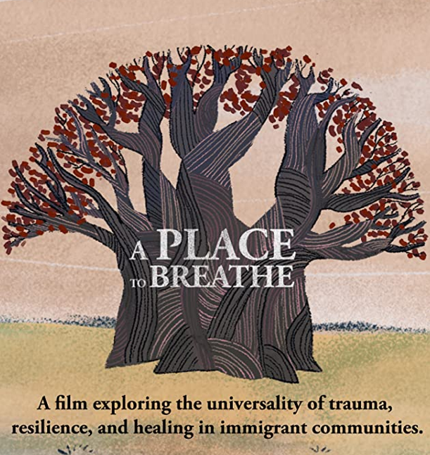
This film explores the universality of trauma and resilience through the eyes of immigrant and refugee healthcare practitioners and patients. This 86-minute documentary intertwines the personal journeys of those who are transcending their own obstacles by healing others. Combining cinema vérité and animation, the film highlights the creative strategies by which immigrant communities in the U.S. survive and thrive.

Rodrigue is a newly arrived refugee from war-torn Democratic Republic of Congo, who, along with his mother and six siblings, is struggling to adapt to life in Lowell, Massachusetts. Training to become a community health worker at the local clinic, he ultimately aspires to be a social worker to help his community heal from trauma. Socheat, a Cambodian immigrant, seeks tools to combat the stress of supporting her aging parents, teenage daughter, and disabled brother on a manicurist’s salary. The entire family experiences the benefits of meditation classes and culturally tailored wellness approaches at the health center. Sue, a nurse to both families, examines the continued impact of her own traumatic experiences, thriving in the U.S. after surviving the genocide in Cambodia and now supporting others to do the same.

Common ground and chance connection join these unique stories as the film humanizes those who have migrated here, sharing their wisdom and perspectives that enrich and strengthen our communities. This is more critical than ever with the devastating effects that COVID-19 is having on communities of color and immigrant populations. A PLACE TO BREATHE moves audiences to envision new understandings of wellness for all.

Keynote Speaker

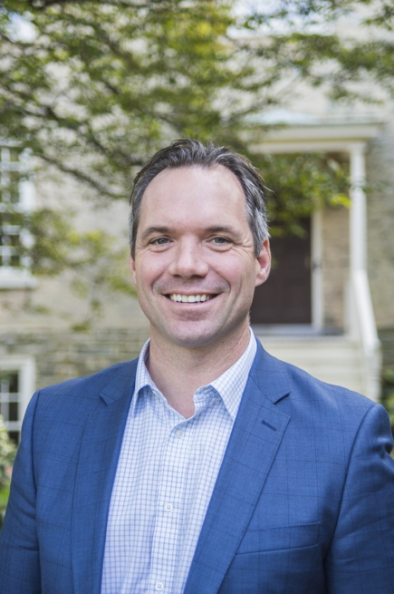
Keynote Speaker: Eric Hartman
Live Session: Thursday, April 15th , 9:00-10:30am,
Zoom: https://millersville.zoom.us/s/97622519063
Title: Advancing (Global) Inclusivity, Justice, and Sustainability

We are interdependent. Justice work takes place within hundreds of years of structural racism and systemic injustice. The truths of interdependence are undermined through most forms of civic education, which frequently emphasize local, national, and/or global citizenship as separate spaces of action and inquiry. In Pennsylvania and around the world, acknowledging and acting upon ethical interdependence requires shifting conceptual lenses, language, and practices.
Drawing on twenty years of scholarship and practice that emphasizes opportunities for critical inquiry and consequential action in communities all around the world, Dr. Eric Hartman will offer a civics of interdependence as an emergent space of opportunity. He will share specific, local examples from a growing interdependence action toolkit, and he will amplify local networks advancing justice, inclusivity, and sustainability. Participants will gain specific tools for action, along with examples of institutional changes that more deeply invest in community-based knowledge keepers, leaders, and students wherever they are.
He is also lead author of Community-Based Global Learning: The Theory and Practice of Ethical Engagement at Home and Abroad (2018) and has written for several peer reviewed and popular publications including The Stanford Social Innovation Review, International Educator, Tourism and Hospitality Research, and The Michigan Journal of Community Service-Learning. Eric served as executive director of a community-driven global nonprofit organization, Amizade, and taught human rights, transdisciplinary research methods, and globalization in global studies programs at a number of institutions before arriving at Haverford College. With a PhD in International Development from the University of Pittsburgh Graduate School of Public and International Affairs, Eric has worked in cross-cultural development practice and education in Bolivia, Ecuador, Ghana, Jamaica, Northern Ireland, Tanzania, and throughout the United States. He co-founded both The Community-based Global Learning Collaborative and the global engagement survey (GES), initiatives that advance ethical, critical, aspirationally decolonial community-based global learning. Eric serves as a Lecturer in the University of Pennsylvania Graduate School of Education, where he teaches Seeking Global Citizenship at Home and Abroad: The Role for Higher Education.

Plenary Speaker: Karen Foley and Todd Snovel
Plenary Speaker

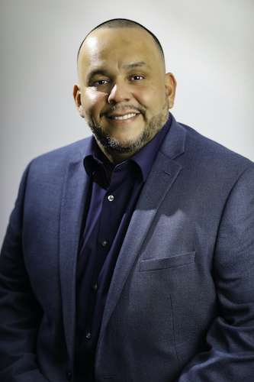
Keynote Speaker: Sergio Argueta
Live Session: Friday, April 16th , 11:30-12:30am
Zoom: https://millersville.zoom.us/s/99791285850
Title: Community Building Through Youth Empowerment
Sergio Argueta is among the most influential grassroots community activists on Long Island, and is the founder and Board Chair of S.T.R.O.N.G. Youth, Inc. (Struggling To Reunite Our New Generation). S.T.R.O.N.G. is a leading agency in the northeastern United States focused on providing alternatives to street organizations, focused on providing at-promise youth with services and supports that enable them to help heal their communities and meet their maximum potential.
He earned an associate's degree in Criminal Justice from Nassau Community College and a bachelor's degree in sociology with a minor in political science from Hofstra University. He was awarded the Turner Fellowship at Stony Brook University, where he earned a master's degree in social work. He earned two post-master’s certifications in K-12 school building and school district leadership at Stony Brook University.
Sergio served as the gang prevention and intervention specialist for the Nassau County Youth Board; and is currently one of the leading experts in the region on street organizations and youth violence. He served as the Director of the Baccalaureate Social Work Program at Adelphi University. In 2014, he became a high school social worker at Uniondale High School, rose to attendance coordinator, and is now the Dean of Academic Services and Discipline. He is involved in various community organizing initiatives, including serving as a Co-Convener of The Corridor Counts (T.C.C.), which advocates for equity within some of the most marginalized communities in Nassau County.
He has served as an adjunct criminal justice professor at Nassau Community College and St. Josephs College, an adjunct professor in the Schools of Social Work at Stony Brook University and Millersville University in Pennsylvania. He has also taught in both the Schools of Social Work and Education at Adelphi University.
He is a compelling speaker that transcends boundaries in reaching his audience. His powerful words give profound insight into a host of modern-day issues involving the intersectionality of race, class, gender, interpersonal violence, education, criminal justice reform, race. He is the proud son of Graciela Argueta, a fearless Salvadorian warrior. He is also the proud partner of Katiria Maldonado and two strong daughters, Lei-Lani and Gianna Argueta-Maldonado.
Concurrent Sessions
Thursday, April 15, 2021

9:00-10:30am
Welcome + Keynote Speaker: https://millersville.zoom.us/s/97622519063

10:50-11:50 am

The Art and Science of Resident-driven Community Engagement  https://millersville.zoom.us/j/95830806395  This workshop highlights the value of a collaborative partnership of artists and social workers to support resident-driven civic engagement. Facilitators will share their experiences in utilizing participatory research methods to design and implement an art and theatre-based model for community engagement on a neighborhood level.  Presenter(s): Mary Semerod Ph.D., LSW, Widener University and Lisa Jo Epstein, Ph.D. MA, Just Act | The Challenge of Cultural Competency  https://millersville.zoom.us/j/95880535502  Cultural competency refers to an ability to understand, communicate with, and effectively interact with people of different cultures, races and socio-economic backgrounds. This roundtable Presentation will explore conceptual frameworks and four components of Cultural competence: (a) Awareness of one's own cultural worldview, (b) Attitude towards cultural differences, (c) Knowledge of different cultural practices and worldviews, and (d) Cross-cultural skills. As in the words of Dr. Martin Luther King, Jr., - "Injustice anywhere is a threat to justice everywhere."  Presenter(s): Earl Bradford Smith Ph.D., LCSW, Carlow University
Who Is Human Enough and Who Gets to Decide?
https://millersville.zoom.us/j/92391276208

The workshop will discuss the barriers to interconnectedness transgender people experience and the strategies to eliminate them. I will examine the philosophical forces behind the reasons transgender people are prevented from having a chance at life, and I will present a model for social work to take initiatives for change.

Presenter(s): Gaben Cetrola LCSW, University of Utah

1:10-2:10 pm
Tackling poverty afflicting women in Nigeria and community-oriented social work  https://millersville.zoom.us/j/95830806395  Globally, poverty is a human rights issue. Women constitute about 60% or 52 million of the people living in extreme poverty in Nigeria. The aim of this paper is to emphasize the need for practitioners in Nigeria to embrace community-oriented social work in their fight against poverty afflicting women.  Presenter(s): Sumaina Yesufu Ph.D., University of Benin | Predictors of State-Level COVID-19 Case Reporting Time Frame  https://millersville.zoom.us/j/95880535502  A regression analysis was performed to determine which demographic characteristics predicted COVID-19 case reporting time frame. Percent of White Only residents and the percent of disabled residents under the age of 65 predicted later reporting time, while percentages of Asian Only and Black/African American Only residents predicted earlier reporting time.  Presenter(s): Donna Dopwell, Ph.D., M.S.S.W., and Tanya Gonzalez, Middle Tennessee State University
2:20-3:20 pm
Rooted in Racism: the Housing Industry and Racial Inequality  https://millersville.zoom.us/j/95830806395  Keywords: racial inequality, housing, redlining, low-income families, cost burden, discrimination.  • Unfair Housing for Black and Brown People  • Economic Hardship with Lack of Help  • Eviction ad Foreclosure rates higher in urban communities  Presenter(s): Shantayah Hayes and Thomas Jarrett, West Chester University | Climate Refugees  https://millersville.zoom.us/j/95880535502  The term “climate refugees” has only surfaced in the last few years as we tackle the challenges of global warming. Global warming has created a host of consequences that spans from impacting global politics, economies, health, and availability of resources. Understanding and tackling the complex consequences of global warming requires an interdisciplinary approach.  Presenter(s): Valentina Hollinger, MSW, LSW, Wellspan Philhaven
3:30-4:30 pm

The Macro Implications of Micro-Aggressions: Experiences of Minoritized Individuals Applying to Ph.D. Programs  https://millersville.zoom.us/j/95830806395  This session focuses on previous research data exploring micro-aggressions and their macro implications related to higher educational attainment and representation within academia, particularly for Black students and educators. This session will also use a case study of black graduate students' experience in applying to Ph.D. programs to explore this topic further.  Presenter(s): Channel Lowery, Millersville University | “Mindful Travel Mentor”- An Intercultural Social and Economic Justice Experience in Finland  https://millersville.zoom.us/j/95880535502  The “Mindful Travel Mentor” trip engaged social work students, alumni, professionals, and faculty in an intercultural group experience. While exploring social and economic justice issues, reflection tools were used as a strategy for self-discovery, developing cultural competencies as well as learning what it means to be a global citizen.  Presenter(s): Hope Horowitz, LSW, Donna Acerra, MA, and Susan McDonald, Ph.D., Northampton Community College
4:40-5:40 pm

Reshaping Macro Social Work for a Post COVID-19 World  https://millersville.zoom.us/j/95830806395  The Pandemic highlighted major changes in society, including a global information economy and an environmental crisis. These trends can affect the efficacy of macro practice. This paper considers how social workers can revisit and create macro practice theory for the future and proposes a system for developing practice theory.  Presenter(s): John McNutt, Ph.D., MSW, University of Delaware | Using Letter Writing as a Research Methodology: Addressing Social Isolation in a Time of Social Distance  https://millersville.zoom.us/j/95880535502  Undergraduate social work students in a freshman seminar course were paired with participants of a local agency to engage in a letter writing exchange about life experiences. This presentation will discuss the use of letter writing as a qualitative research methodology to understand social isolation, human connection, and rural poverty.  Presenter(s): Jen Frank, Ph.D., Laura Brierton Granruth, Ph.D., Heather Girvin, Ph.D., Brittany Leffler, and Rachel Presibisch, Millersville University
Friday, April 16, 2021

8:00-9:00 am

Addressing the Issue of Child Sexual Abuse in Pakistan: A Conceptual Analysis  https://millersville.zoom.us/j/95830806395  This paper addresses context, causes and incidents of child sexual abuse in Pakistan, reporting of child sexual abuse, lack of effective structures to protect children in Pakistan, public education, the example of Punjab province in Pakistan and its approach to dealing with child sexual abuse, and solutions to the problem.  Presenter(s): Steven Granich DSW, Lockhaven University, Sonia Omer Ph.D., Tahira Jabeen Ph.D., and Muhammad Arshad, University of Punjab | The Social Work Identity & Global Citizenship  https://millersville.zoom.us/j/99088837025  This workshop is designed to focus on social work identity by identifying your mission and vision as a social work practitioner (or student) through a human rights approach. Topics incorporated in this workshop will provide a learning space to revisit our potential as social workers to make positive social change with a focus on global citizenship.  Presenter(s): Sylvia Bekele, DSW, School District of Lancaster and Virginia Commonwealth University
9:10-10:10 am

Embracing Ubuntu in our work and social policy  https://millersville.zoom.us/j/95830806395  The 2021 World Social Work Day theme is Ubuntu: I am because you are. We will discuss the meaning and inspiration of Ubuntu and how to deepend this in our profession, particularly with US social policy (i.e. reparations, universal basic income, etc.).  Presenter(s): Lynn Goerdt, EdD, MSW, University of Wisconsin-Superior | Law Enforcement & Persons with Mental Illness: Best Practice Responses  https://millersville.zoom.us/j/99088837025  Based on a comprehensive review of the existing literature, this presentation will discuss law enforcement agency best practice models (ex., Crisis Intervention Teams) and other evidence-informed techniques that may be utilized to reduce the risk of harmful and fatal outcomes in police interactions with people with mental illness.  Presenter(s): Alexander Rohrer, MA, CBGS
10:20-11:20 am

A Pedagogical Approach to Activate the Global Readiness of Today’s Students  https://millersville.zoom.us/j/95830806395  Our workshop explores empirically-based pedagogy to introduce students to the global interconnectedness of human rights through contemporary literature, exposing them not only to information but to the depths of the human experience. Students read narrative nonfiction and fiction about people enduring injustices, including refugee status, poverty, and climate disasters.  Presenter(s): Yolanda C. Padilla PhD, MSSW, Quynh Nhu Bui La Frinere-Sandoval, MSW, University of Texas at Austin and Nadia Kalman MA, M.Ed, Words Without Borders | Humanizing Athletes (Workshop) A Qualitative case study  https://millersville.zoom.us/j/95444386124  This session will focus on research data that explores mental health with various athletes. This qualitative study will explore the barriers athletes face when looking for help. It will also explore how sports teams are hiring social workers and therapist to help their athletes.  Presenter(s): Baron Jackson, Millersville University
11:30-12:30pm
Plenary Speaker: https://millersville.zoom.us/s/99791285850

1:10-2:10 pm

Native American gender identities: Are we recognizing them in current U.S. identities?  https://millersville.zoom.us/j/95830806395  Pre-colonized Native American tribes/nations had diverse concepts for gender identity. The current term of “two-spirit" has been used for identity and dialogue. This workshop will explore two-spirit identities and how current U.S. gender and sexual identities might be informed from Native American tribes/nations.  Presenter(s): Curtis Proctor, MSW, Ph.D., Millersville University | Approaching Teaching through a Lens of Pedagogy of Care: Cultivating Social Justice  https://millersville.zoom.us/j/95444386124  Empowering citizens is an educational goal shared broadly, K-12 and beyond. With educational space as a starting point for promoting lifelong learning to cultivate social justice, this roundtable discusses Pedagogy of Care as an approach to learning space design, especially when the learning space includes digital tools and mediated communication.  Presenter(s): A. Nicole Pfannenstiel, Ph.D., Michele Santamaria MFA, MLIS, Kaitlin Mondello Ph.D., Millersville University
2:20-3:20 pm

Pandemic of Mental Health, Public Health, and Racism  https://millersville.zoom.us/j/95830806395  The 2020 Global Pandemic of mental health, public health, and racism took a toll on the World on a global level. We will explore how mental health, public health, and racism exposed that we have an interconnected and global systemic problem on a Macro level and how as practitioners we need to tailor our practices to problem-solve, empower, and heal these global issues.  Presenter(s): Andrea Imafidon LCSW, Tuskegee University | “In someone else’s shoes”: Exploring the role of targeted, narrative-based, social work curricula to address poverty perceptions  https://millersville.zoom.us/j/95444386124  Building upon past research, this presentation will share the results of two studies on a targeted poverty curriculum to affect attitudes about poverty among first-semester college students. The quantitative data demonstrated a change toward empathy and the qualitative data provided insight into how this shift transpired.  Presenter(s): Jen Frank Ph.D., Laura Brierton Granruth Ph.D., Karen Rice Ph.D., LSW, ACSW, Kathleen Walsh Ph.D., LCSW, and Dawn Watson, Millersville University
3:30-4:30pm
The Trauma of Dyslexia and Its Impact in PA  https://millersville.zoom.us/j/95830806395  In comparison to other states, Pennsylvania lags behind in addressing the learning difference of dyslexia. As a result, children experience various in-school traumas that lead to negative long-term consequences both for the student and for society. This roundtable will discuss the traumas associated with dyslexia and ways PA can move forward to address it.  Presenter(s): Jill Craven Ph.D., Sara Page Stinchcomb, Millersville University, and Kevin Ghaffari MPS, School District of Lancaster | Tackling Food Insecurity in Nigeria: The Social Work Option  https://millersville.zoom.us/j/95444386124  Food insecurity is on the increase worldwide. The paper explores how social work as a profession can help tackle the problem of food insecurity in Nigeria. The novelty of the study is that it will fill the gaps in knowledge relating to how to effectively address food insecurity in Nigeria.  Presenters: Sumaina Yesufu Ph.D., University of Benin

Pre-Recorded Sessions
Instructions: To watch these videos, click on the link next to the name on the program guide. Pre-recorded videos will be available from 12:00pm April 14th - 6:00pm April 21st and can be viewed at any time in that window. You can also find the videos on our YouTube Channel, https://www.youtube.com/channel/UCBWX0t6HcVxHWTokiQGGzJw/ . Conference sessions will be found in the playlist entitled, 8th Annual Global Well-Being and Social Change Conference.
Note: Videos in other playlists will not count towards continuing education.

Advocating for Public Policy Change
(45:13)
Link: https://youtu.be/6n-13l8gvLw
Social Workers face social and human rights injustices around them in their daily work. Sometimes the level of advocacy needed falls into the realm of public policy. But how do we get started advocating at this level? This workshop will cover advocacy at the county and state level of Pennsylvania for social workers. (.75 CEU credit hours)

Presenter(s): Abigail Wilson LSW

Global Environmental Justice and Social Work Praxis
(14:27)
Link: https://youtu.be/-v_5nvZObk8
Environmental issues effect all aspects of social work practice. This presentation focuses on research outcomes from a global environmental project with social workers and environmental scientists in Eastern Europe and partnering universities; the findings inform and address the importance of interdisciplinarity in environmental social work, the interrelatedness between the individual, society, and world at large, areas to improve environment social work practice, and environmental social work curricula. (.25 CEU credit hours)

Presenter(s): Matthew Diner Ph.D., LCSW-R

Social Workers in Police Departments? Exploring Challenges and Solutions to this Emerging Trend
(35:18)
Link: https://youtu.be/js0a_Jzx6Js
Social justice movements call for “defunding” of the police. Recent police reform has resulted in surges of social workers being hired directly by police departments; however, its effectiveness is unknown. This workshop will detail the gaps in police reform and will also explore how the strengths and tensions of police social work can be worked through in order to best serve the community. (.50 CEU credit hours)

Presenter(s): Jasmin Collazo, LCSW

Intimate Partner Violence and Women with Disabilities: A Forgotten Population
(26:35)
Link: https://youtu.be/eY2vjk3IxN4
Women with disabilities are at an increased risk of violence throughout their lifecycle. From childhood abuse, to intimate partner violence, to caretaker abuse, women with disabilities are perceived to be more vulnerable and have reported to experience violence at rates higher than the nondisabled public—reverberating across the world. Women with disabilities are at an increased risk of violence throughout their lifecycle. From childhood abuse, to intimate partner violence, to caretaker abuse, women with disabilities are perceived to be more vulnerable and have reported to experience violence at rates higher than the nondisabled public—reverberating across the world. (.50 CEU credit hours)

Presenter(s): Alison Fedoris Leslie LSW, MSW, MSSP

The Wellbeing Club: Promoting Youth Wellbeing through Intentional Dialogue and Youth Leadership
(33:05)
Link: https://youtu.be/SdTZg1MNRI0
The Wellbeing Club is a freely available international curriculum that is being used in a variety of global and cultural contexts. The UC-San Diego team works in a co-design process that invites feedback and participation in all aspects of the curriculum from our global partners. Wellbeing Club youth learn about interconnectedness through dialogue circles and visual art, and explore social justice via youth participatory action. Emerging research has shown that the curriculum enhances identity awareness, promotes peer relationships and interconnectedness, reduces feelings of hopelessness, and promotes mindful awareness of positive wellbeing among youth (Bintliff, 2019). (.50 CEU credit hours)

Presenter(s): Amy Bintliff PhD, Rebecca Levine LICSW, Zaharah Namada, Christian Demesa
Esmeralda Salas

The Challenges, Barriers, and Implications to Unequal Access to Study Abroad for Students of Color within the United States
(8:16)
Link: https://youtu.be/RCi4xUVVB2k
The importance of study abroad experiences is recognized by many given the personal and professional benefits for the student. Despite the benefits, students of color are underrepresented in study abroad programs. The barriers and implications to unequal access will be discussed as well as recommendations for change. (.25 CEU credit hours)

Presenter(s): Karen Rice Ph.D., LSW, ACSW and Karlee Rice BA

The Lived Experience of Stigma Surrounding Mental Illness
(51:03)
Link: https://youtu.be/2eFwPX6Kfsg
It is the purpose of this workshop to highlight the complexities of stigma surrounding mental illness. A clearer understanding of the lived experience of stigma could more effectively support the “vision of recovery” and provide new insights to guide programs and participants to address and cope with this issue. (.75 CEU credit hours)

Presenter(s): Mary Semerod Ph.D., LSW, Melissa Jones MS/CPRP, Martina Buffington, Cindy Erickson, Sarah Hurst, Karen Retorick, and Melissa Steele

2021 Conference Supporters
2020 LEARNING INSTITUTE SPONSORS

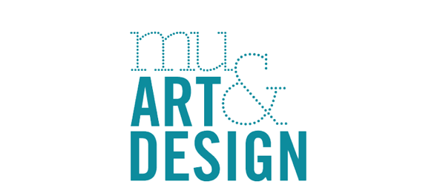
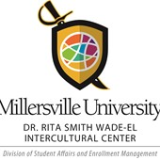
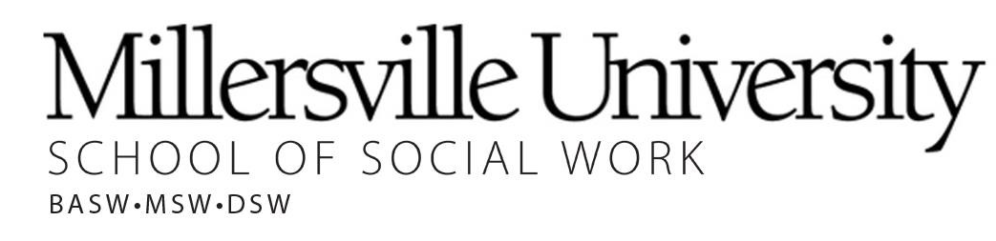
Educational Foundations
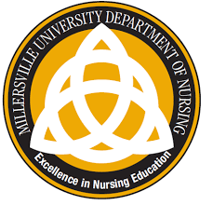
Criminology, Sociology, and Anthropology
Women & Gender Studies
Department of English

Department of Early, Middle, and
Exceptional Education

