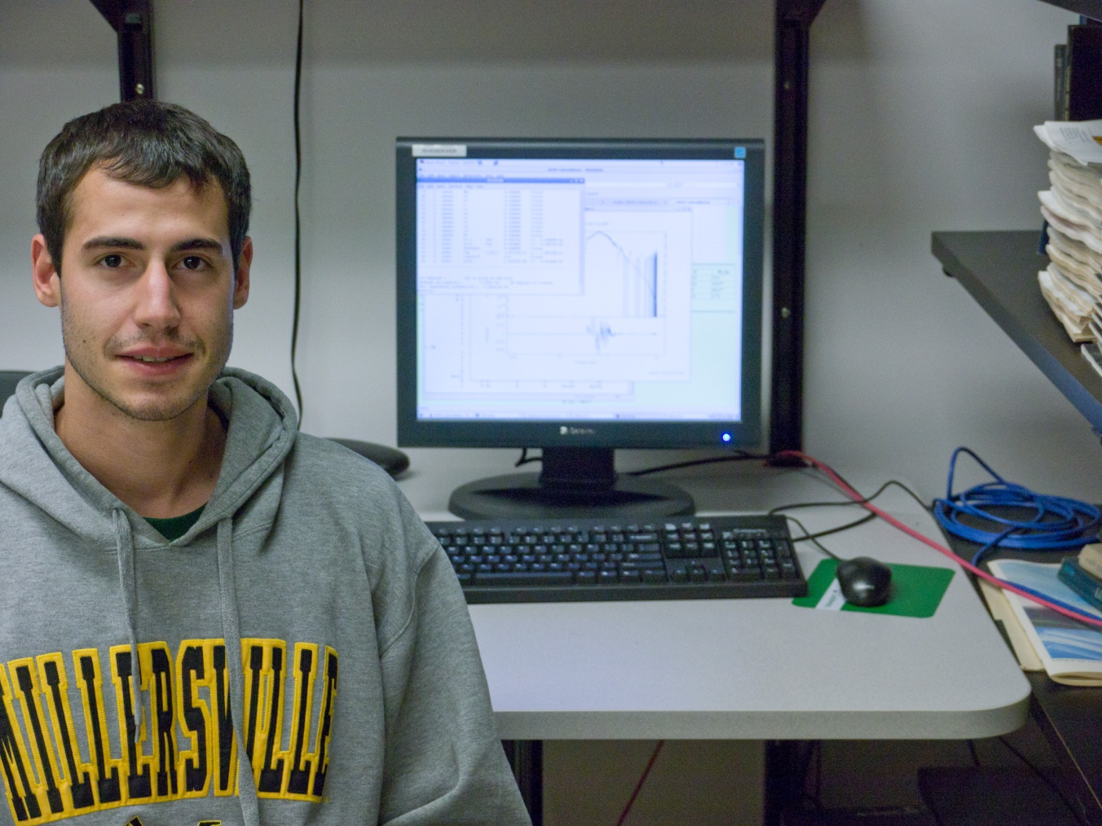
X-ray Observations of an SMC Supernova Remnant
SNR 0103 72.6

Adam D. Jacobs
Advisor: Dr. Sean Hendrick

X-ray data of a supernova remnant (SNR) transitioning from the ejecta dominated phase into the Sedov phase was downloaded, processed, and analyzed. The target, SNR 0103 72.6, is located in the Small Magellanic Cloud (SMC). The data was collected by the Chandra X-ray Observatory and downloaded from NASA’s High Energy Astrophysics Science Archive Research Center (HEASARC). Next, the data was then processed with the CIAO software package to extract images and spectra. This SNR data was then analyzed using the XSPEC software package to determine important characteristics present in the ejecta and Interstellar Medium (ISM) within the SNR area. Certain XSPEC models were used to analyze the central and limb regions. These models can help in approximating certain physical properties from the best, most physically sound fits including temperatures, ion timescales, mass, initial explosion energy, and chemical composition. The history and characteristics of supernovae in general are reviewed. Several findings from extracted spectra and XSPEC model runs of SNR 0103 72.6 data are discussed. These results are compared to other recent studies on this SNR.

