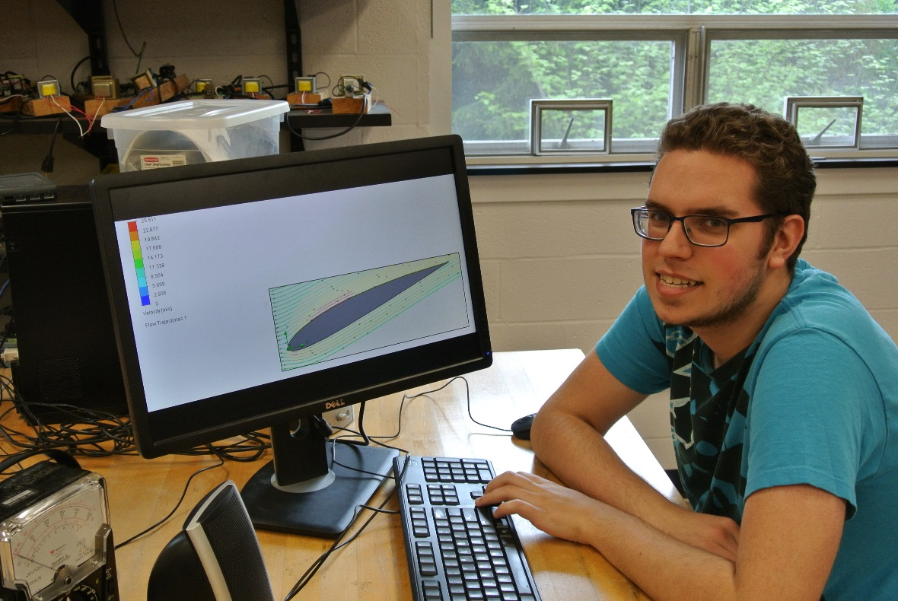
The Optimization of Wind Turbines
Jonathon Gojda
Faculty Advisor: Mehmet Goksu, Ph. D.
Spring 2016

Abstract
The goal of this research project was to create a more efficient wind turbine. So far, we have created three-dimensional model based on real world turbines. We simulated these turbines to ensure that the power harvested from the wind is consistent with real world data. We obtained optimal conditions to get maximum power from the wind turbine using the SolidWorks program. Based on our simulation, we will make necessary changes in the original design in order to improve its efficiency.

