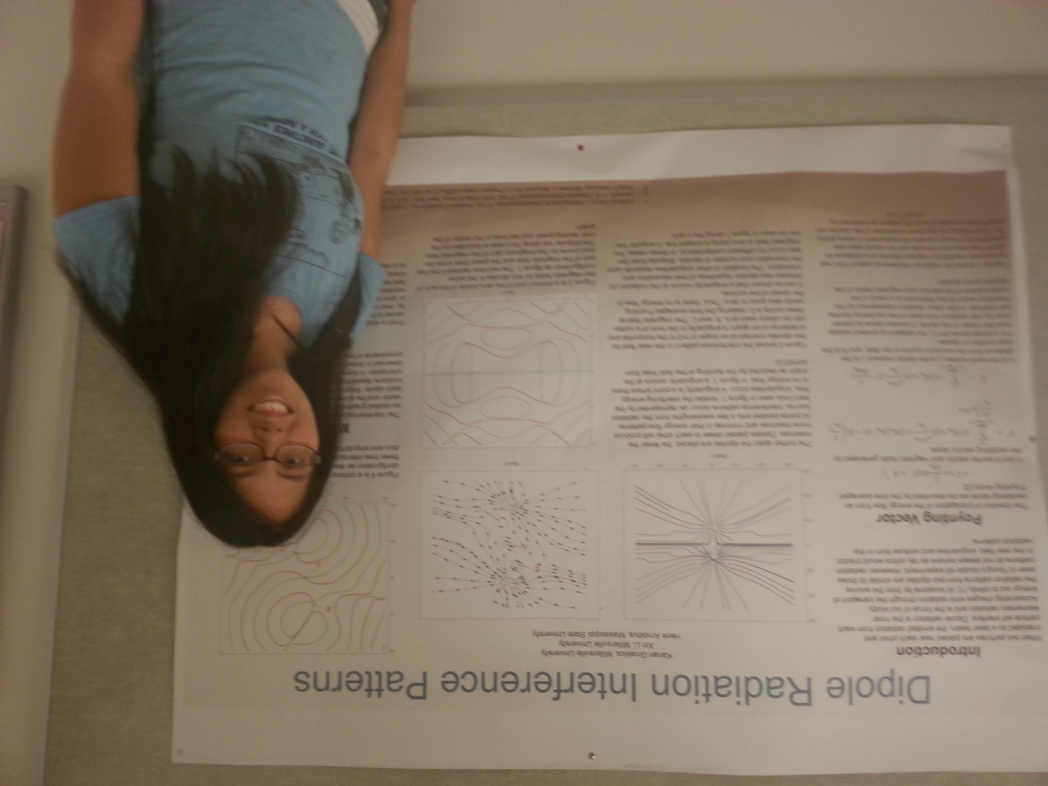

Dipole Radiation Interference Patterns

Kanan Grosklos
Advisor: Dr. Xin Li

When two small particles are placed near each other and irradiated by a laser beam, the emitted radiation from each particle will interfere. Electric dipole radiation is the most elementary radiation and is the focus of our study. We studied the interference patterns of multiple linear dipoles, at different separations and phase angels in the near and far fields. In particular, the energy flow pattern in the near field between the dipoles can be complicated and contain singularities and vortices.

