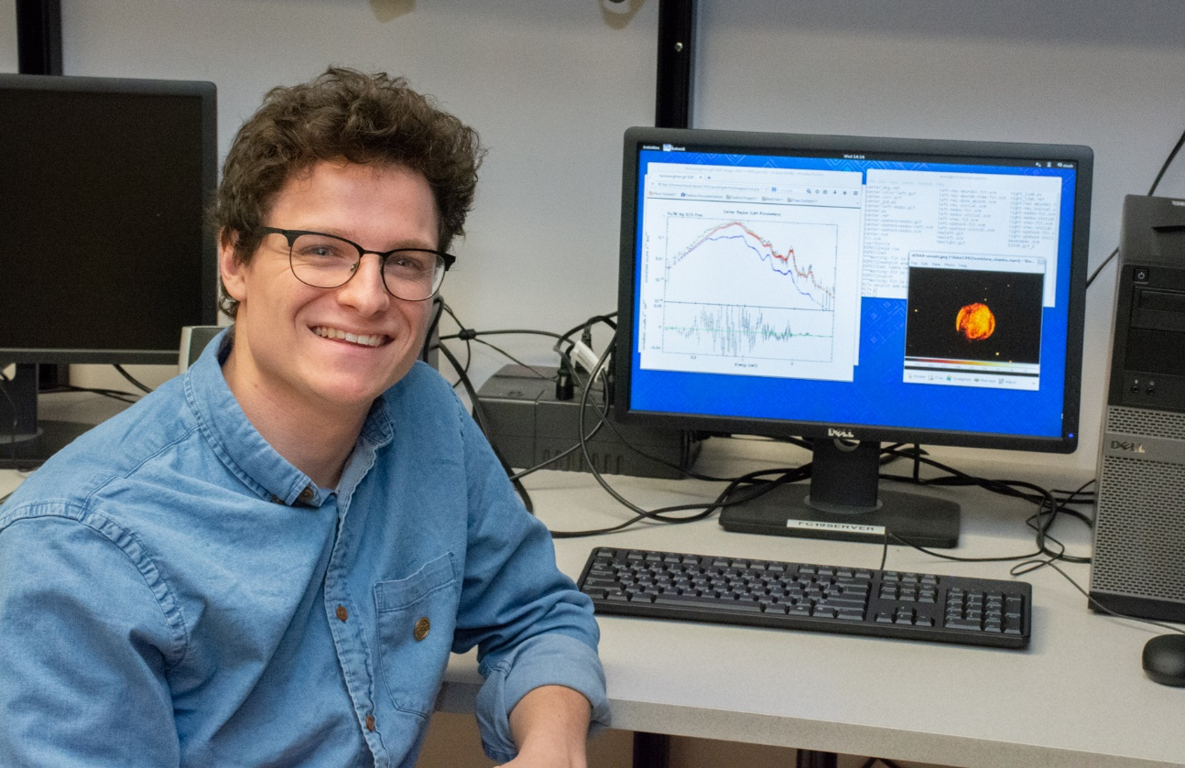

X-ray Analysis of LMC SNR 0548-70.4
Lucas Staub
Advisor: Dr. Sean Hendrick
Supernovae (SN) mark the death of stars. There are two known causes of a supernova explosion; a thermonuclear detonation of a white dwarf, which produces a Type Ia SN, and a gravitational core collapse, which produces Type Ib, Ic, and II SN. Looking at the chemical abundances in the SN allows us to determine which type of explosion created the remnant. When the star explodes, a shockwave is sent from the core outward. As the shockwave crashes into the rest of the star, it sweeps up that material and synthesizes new elements. This creates a shell of stellar ejecta around the remnant. We conduct an X-Ray analysis on the supernova remnant (SNR) 0548-70.4 using data from the Chandra X-Ray satellite. Chandra allows us to perform spatially resolved spectroscopy. When looking at the remnant, it can be separated into several regions. SNR 0548-70.4 has been separated into a left and right limb, as well as a center region. The limbs of the remnant contain the ejecta from the shockwave; while the center of the remnant contains that ejecta, along with emission in the center. The Sedov solution is used to model the limbs and a two-component model is used on the center. The two-component model helps to “remove” the shell of ejecta to allow an analysis on just the emission in the center. By determining the chemical abundances in the center we can determine what kind of The analysis on the limbs has given us a shock speed of $v_{s}=1.28×{10}^{6}\frac{m}{s}$which results in an age of $3990 yr$. This analysis will help to increase our understanding of stellar evolution and the life cycle of stars.

