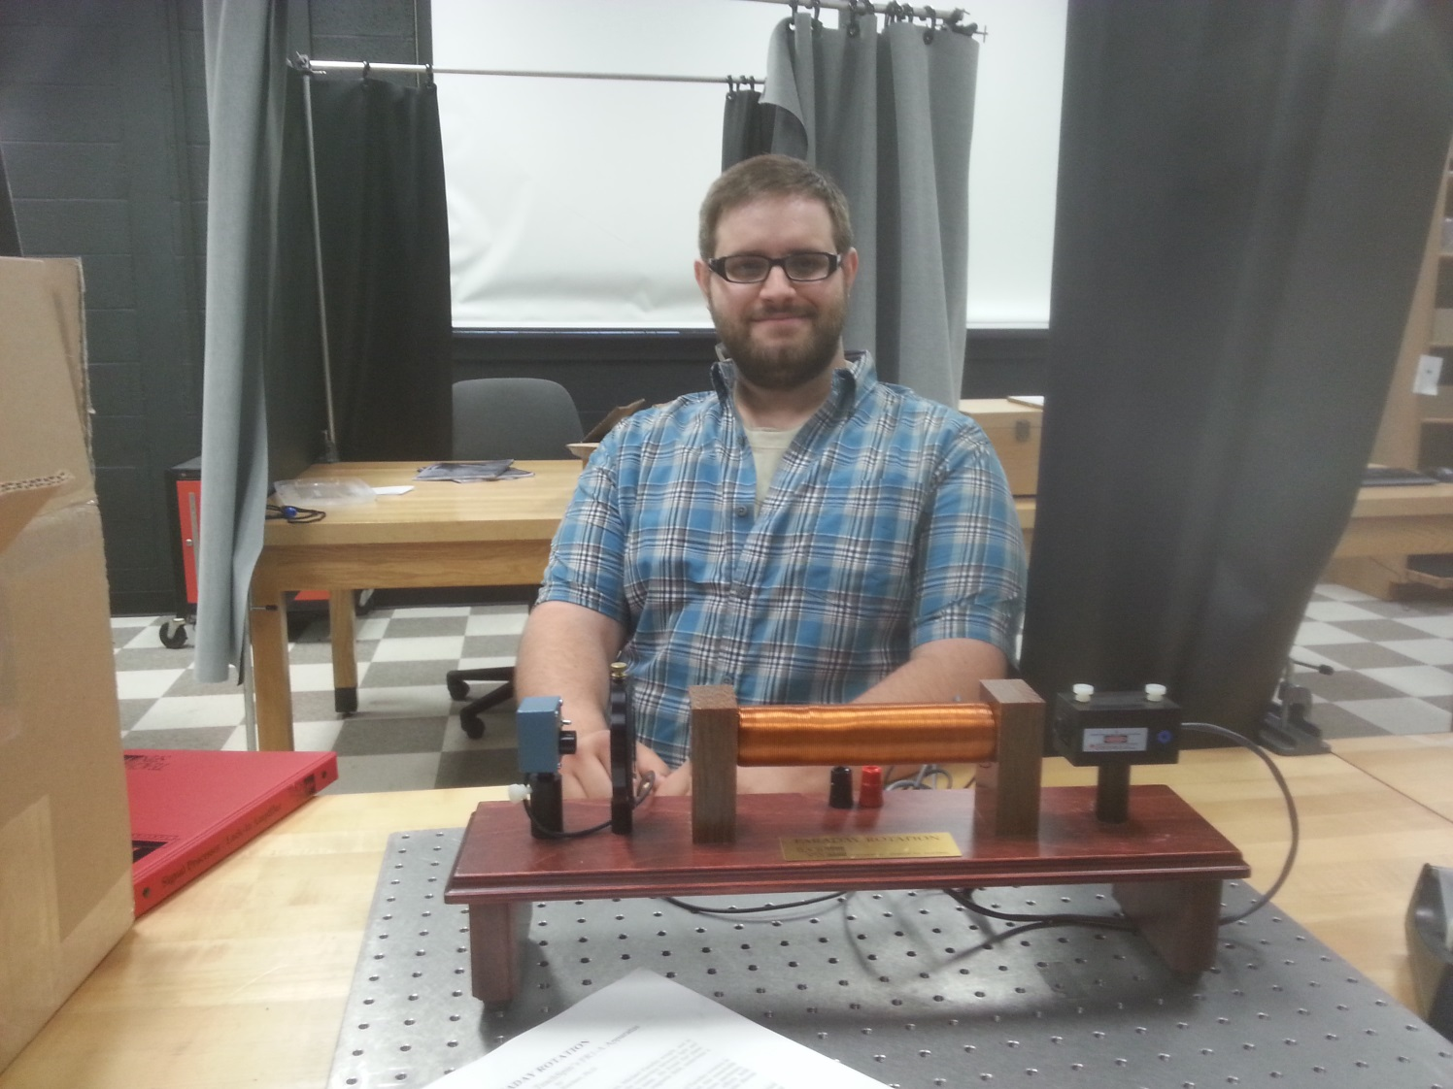

Wavelength Dependence of the Faraday Effect

Seth G. Baker
Advisor: Dr. Tariq Gilani

Using the TeachSpinTM Faraday Rotation apparatus, the Verdet constant of a material can be found for various wavelengths of light. By utilizing lasers of differing wavelengths for a single material sample, in this case SF-57, the wavelength dependence of the Verdet constant can be observed. In addition, it is possible to define a function for the Verdet constant with respect to wavelength. The equation for the wavelength dependence of the Verdet constant was found to be:

$$V= 585.437\frac{rad}{Tm}\left(\frac{(0.014±0.001){nm}^{2}}{λ^{2}}\right)$$

