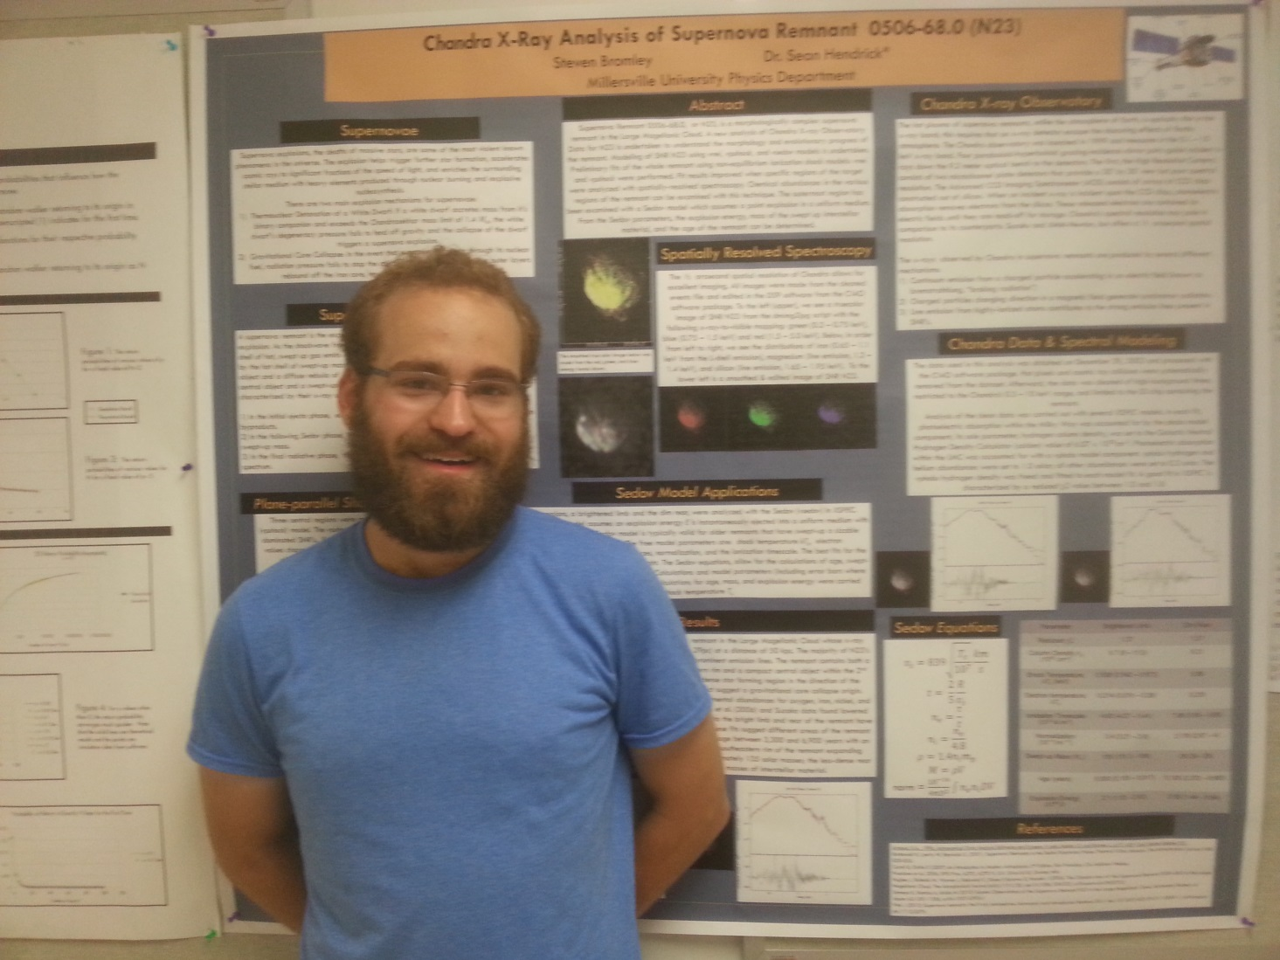

Chandra X-Ray Analysis of Supernova Remnant 0506-68.0

Steven Bromley
Advisor: Dr. Sean P. Hendrick

Supernova Remnant 0506-68.0, also known as N23, is a morphologically complex supernova remnant in the Large Magellanic Cloud. A new analysis of Chandra X-ray Observatory data for N23 is undertaken to understand the morphology and evolutionary progress of the remnant. Modeling of SNR N23 using vnei, vpshock, and vsedov models is undertaken. Preliminary fits of the whole remnant using non-equilibrium ionization shock models: vnei and vpshock were performed. Fit results improved when specific regions of the target were analyzed with spatially-resolved spectroscopy. Chemical abundances in the various region of the remnant can be examined with this technique. The outermost region has been examined with a Sedov model which assumes a point explosion in a uniform medium. From the Sedov parameters, the explosion energy, mass of the swept up interstellar material, and the age of the remnant can be determined.

