Available October-March
Lightbox Therapy

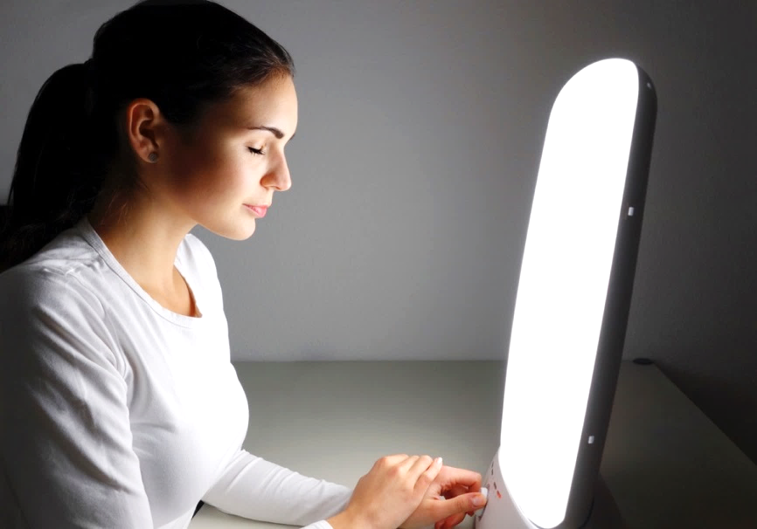
BLUE?

You may be experiencing SAD, or Seasonal Affective Disorder. Seasonal Affective Disorder is quite common during the winter, especially if you are not receiving adequate exposure to sunlight. The Center for Counseling and Human Development is excited to launch our Light Box Therapy Program this semester on October 17th. Students will be able to come to the Center for Counseling and Human Development located on the 3rd floor of Lyle hall and sit in front of our light boxes while completing work for a few times a week. Light box Therapy mimics outdoor sunlight, which can create a chemical change in the brain and lift your mood.
To schedule an appointment for Light Box Therapy call 717-871-7821
For more information contact the Director of Light Box Therapy Dr. Lisa House at Lisa.House@millersville.edu

Are the winter months making you feel
You may be experiencing Seasonal Affective Disorder, also known as SAD. SAD is caused by a reduction of sunlight during the winter months. This decreases the body’s serotonin levels, and as a result, decreases overall mood. SAD is very common during the winter months, but there are ways that we can help:

The Center for Counseling & Human Development
Offers students an opportunity to use lightboxes that mimic outdoor sunlight. This program runs from October 17th until the end of March. Call 717-871-7821 to make your appointment or contact Dr. Lisa House for more information Lisa.House@millersville.edu

