13th Teacher Ed Day

at Millersville University
November 3, 2017 9:30am-2:00pm
Lehr Room, Bolger Conference Center

Participants will:

Learn about being an education major.

Learn about being a college student.

Hear inspiring stories from teachers, administrators, professors and guidance counselors.

Take a tour of campus and eat in the dining hall.

Interact with college students and ask them questions about their majors and college life.

Keynote Speaker---- TBD
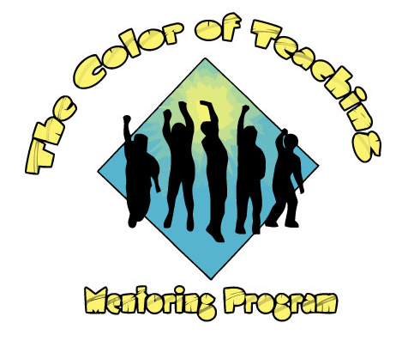

Please submit this registration form by October 27, 2017 to:
Miriam Witmer, Ph.D., Color of Teaching Mentoring Program Advisor
413 Stayer Hall
Millersville, PA 17551
or via email at Miriam.witmer@millersville.edu Phone: 871-4167

13th Teacher Ed Day

November 3, 2017

Stayer Hall Multi-Purpose Room

9:30am-2pm

Registration Form

Deadline: October 27, 2017

This event is hosted by the Color of Teaching Mentoring Program and funded in part by College of Education and Human Services, the Educational Foundations Department, the Admissions Office, and the African-American Studies Program. The mission of the program is to recruit and retain students of color into the field of education. We are looking for students who are interested in learning more about being an education major.

Name of school contact person: ______________________________________________

Email: __________________________________________________________________

Office Phone: Cell phone:

Name of organization/school:

Number of students attending:

Number of chaperones attending:

Will you provide transportation? Yes No
*SDoL students already have transportation covered.

Description of students attending (high school, middle school, specific grade levels, etc.):

**Please submit a list of names of students attending and contact information if possible. This will help us to expedite the registration process at the event.

Please submit this registration form by October 27, 2017 to:
Miriam Witmer, Ph.D.
413 Stayer Hall
Millersville University
Millersville, PA 17551
or via email at Miriam.witmer@millersville.edu
If you have questions, please contact Dr. Witmer at 717-871-4167. Thank you for your interest in this program. We look forward to meeting you and your students.

