Default Report
Employer Survey
December 11th 2019, 1:16 pm MST
Q1 - Millersville’s graduates/teachers know the content they plan to teach.
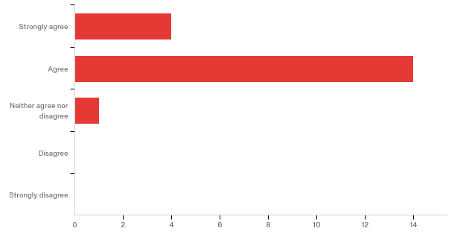

# | Field | Minimum | Maximum | Mean | Std Deviation | Variance | Count
1 | Millersville’s graduates/teachers know the content they plan to teach. | 1.00 | 3.00 | 1.84 | 0.49 | 0.24 | 19

# | Answer | % | Count
1 | Strongly agree | 21.05% | 4
2 | Agree | 73.68% | 14
3 | Neither agree nor disagree | 5.26% | 1
4 | Disagree | 0.00% | 0
5 | Strongly disagree | 0.00% | 0
 | Total | 100% | 19

Q2 - Millersville’ graduates/teachers can explain important concepts required by professional standards at all levels.
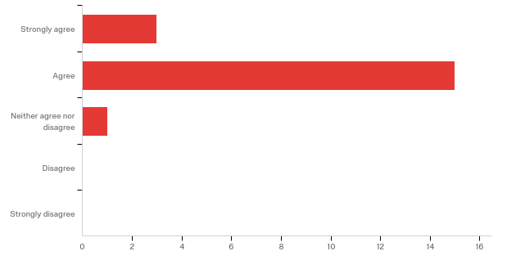

# | Field | Minimum | Maximum | Mean | Std Deviation | Variance | Count
1 | Millersville’ graduates/teachers can explain important concepts required by professional standards at all levels. | 1.00 | 3.00 | 1.89 | 0.45 | 0.20 | 19

# | Answer | % | Count
1 | Strongly agree | 15.79% | 3
2 | Agree | 78.95% | 15
3 | Neither agree nor disagree | 5.26% | 1
4 | Disagree | 0.00% | 0
5 | Strongly disagree | 0.00% | 0
 | Total | 100% | 19

Q3 - Millersville’s graduates/teachers develop instructional plans based on professional standards.
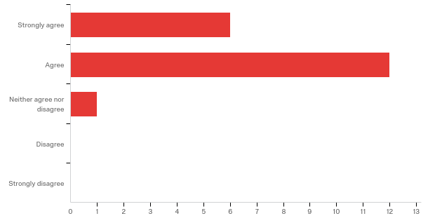

# | Field | Minimum | Maximum | Mean | Std Deviation | Variance | Count
1 | Millersville’s graduates/teachers develop instructional plans based on professional standards. | 1.00 | 3.00 | 1.74 | 0.55 | 0.30 | 19

# | Answer | % | Count
1 | Strongly agree | 31.58% | 6
2 | Agree | 63.16% | 12
3 | Neither agree nor disagree | 5.26% | 1
4 | Disagree | 0.00% | 0
5 | Strongly disagree | 0.00% | 0
 | Total | 100% | 19

Q4 - Millersville’s graduates/teachers facilitate student learning of the content through presentation of the content in meaningful ways.
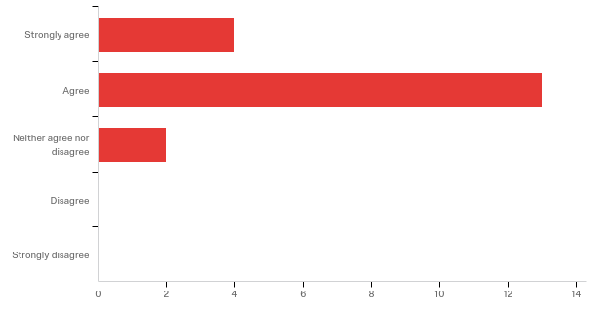

# | Field | Minimum | Maximum | Mean | Std Deviation | Variance | Count
1 | Millersville’s graduates/teachers facilitate student learning of the content through presentation of the content in meaningful ways. | 1.00 | 3.00 | 1.89 | 0.55 | 0.30 | 19

# | Answer | % | Count
1 | Strongly agree | 21.05% | 4
2 | Agree | 68.42% | 13
3 | Neither agree nor disagree | 10.53% | 2
4 | Disagree | 0.00% | 0
5 | Strongly disagree | 0.00% | 0
 | Total | 100% | 19

Q5 - Millersville’s graduates/teachers facilitate student learning of content through the integration of technology.
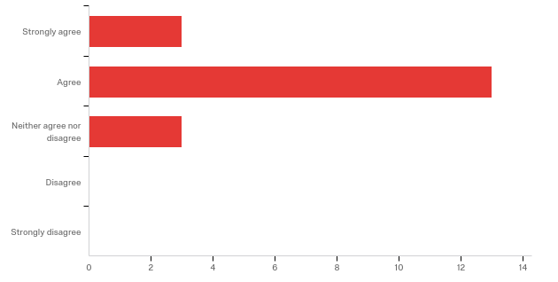

# | Field | Minimum | Maximum | Mean | Std Deviation | Variance | Count
1 | Millersville’s graduates/teachers facilitate student learning of content through the integration of technology. | 1.00 | 3.00 | 2.00 | 0.56 | 0.32 | 19

# | Answer | % | Count
1 | Strongly agree | 15.79% | 3
2 | Agree | 68.42% | 13
3 | Neither agree nor disagree | 15.79% | 3
4 | Disagree | 0.00% | 0
5 | Strongly disagree | 0.00% | 0
 | Total | 100% | 19

Q6 - Millersville’s graduates/teachers present the content to students in challenging, clear ways.
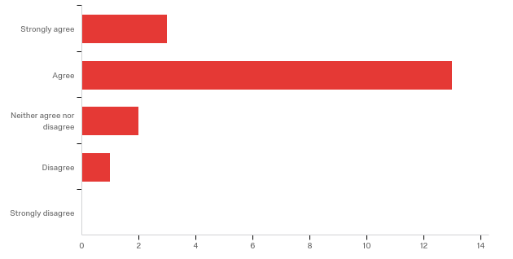

# | Field | Minimum | Maximum | Mean | Std Deviation | Variance | Count
1 | Millersville’s graduates/teachers present the content to students in challenging, clear ways. | 1.00 | 4.00 | 2.05 | 0.69 | 0.47 | 19

# | Answer | % | Count
1 | Strongly agree | 15.79% | 3
2 | Agree | 68.42% | 13
3 | Neither agree nor disagree | 10.53% | 2
4 | Disagree | 5.26% | 1
5 | Strongly disagree | 0.00% | 0
 | Total | 100% | 19

Q7 - When planning instruction, Millersville’s graduates/teachers consider the school, family, and community contexts.
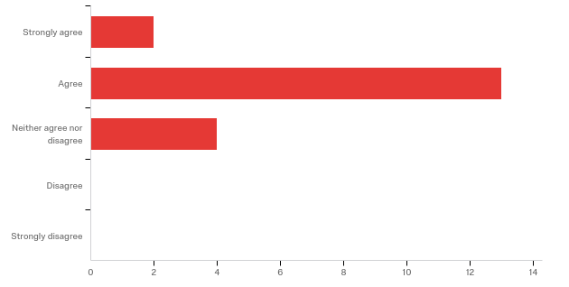

# | Field | Minimum | Maximum | Mean | Std Deviation | Variance | Count
1 | When planning instruction, Millersville’s graduates/teachers consider the school, family, and community contexts. | 1.00 | 3.00 | 2.11 | 0.55 | 0.30 | 19

# | Answer | % | Count
1 | Strongly agree | 10.53% | 2
2 | Agree | 68.42% | 13
3 | Neither agree nor disagree | 21.05% | 4
4 | Disagree | 0.00% | 0
5 | Strongly disagree | 0.00% | 0
 | Total | 100% | 19

Q8 - Millersville’s graduates/teachers consider the prior experience of students to develop meaningful learning experiences.
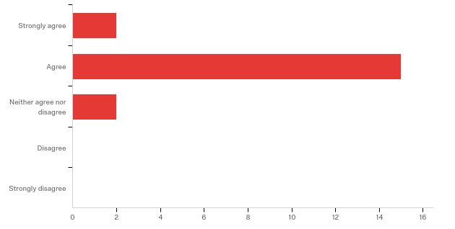

# | Field | Minimum | Maximum | Mean | Std Deviation | Variance | Count
1 | Millersville’s graduates/teachers consider the prior experience of students to develop meaningful learning experiences. | 1.00 | 3.00 | 2.00 | 0.46 | 0.21 | 19

# | Answer | % | Count
1 | Strongly agree | 10.53% | 2
2 | Agree | 78.95% | 15
3 | Neither agree nor disagree | 10.53% | 2
4 | Disagree | 0.00% | 0
5 | Strongly disagree | 0.00% | 0
 | Total | 100% | 19

Q9 - Millersville’s graduates/teachers are able to incorporate new information into their practice as appropriate to meet the needs of all students

# | Field | Minimum | Maximum | Mean | Std Deviation | Variance | Count
1 | Millersville’s graduates/teachers are able to incorporate new information into their practice as appropriate to meet the needs of all students | 1.00 | 3.00 | 1.89 | 0.45 | 0.20 | 19

# | Answer | % | Count
1 | Strongly agree | 15.79% | 3
2 | Agree | 78.95% | 15
3 | Neither agree nor disagree | 5.26% | 1
4 | Disagree | 0.00% | 0
5 | Strongly disagree | 0.00% | 0
 | Total | 100% | 19

Q10 - Millersville’s graduates/teachers assess student learning to gauge their instructional impact on the P12 learner.
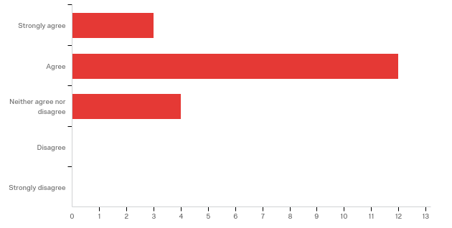

# | Field | Minimum | Maximum | Mean | Std Deviation | Variance | Count
1 | Millersville’s graduates/teachers assess student learning to gauge their instructional impact on the P12 learner. | 1.00 | 3.00 | 2.05 | 0.60 | 0.37 | 19

# | Answer | % | Count
1 | Strongly agree | 15.79% | 3
2 | Agree | 63.16% | 12
3 | Neither agree nor disagree | 21.05% | 4
4 | Disagree | 0.00% | 0
5 | Strongly disagree | 0.00% | 0
 | Total | 100% | 19

Q11 - Millersville’s graduates/teachers make appropriate adjustments to instruction with data driven decisions for instruction by utilizing technology.
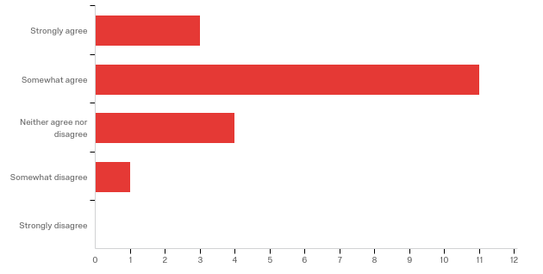

# | Field | Minimum | Maximum | Mean | Std Deviation | Variance | Count
1 | Millersville’s graduates/teachers make appropriate adjustments to instruction with data driven decisions for instruction by utilizing technology. | 1.00 | 4.00 | 2.16 | 0.74 | 0.55 | 19

# | Answer | % | Count
1 | Strongly agree | 15.79% | 3
2 | Somewhat agree | 57.89% | 11
3 | Neither agree nor disagree | 21.05% | 4
4 | Somewhat disagree | 5.26% | 1
5 | Strongly disagree | 0.00% | 0
 | Total | 100% | 19

Q12 - Millersville’s graduates/teachers are familiar with the ethical professional behaviors (dispositions) delineated in professional standards.
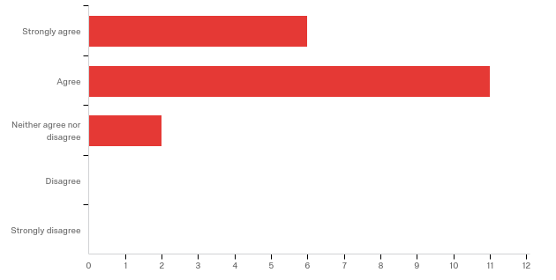

# | Field | Minimum | Maximum | Mean | Std Deviation | Variance | Count
1 | Millersville’s graduates/teachers are familiar with the ethical professional behaviors (dispositions) delineated in professional standards. | 1.00 | 3.00 | 1.79 | 0.61 | 0.38 | 19

# | Answer | % | Count
1 | Strongly agree | 31.58% | 6
2 | Agree | 57.89% | 11
3 | Neither agree nor disagree | 10.53% | 2
4 | Disagree | 0.00% | 0
5 | Strongly disagree | 0.00% | 0
 | Total | 100% | 19

Q13 - Millersville’s graduates/teachers recognize when their own professional behaviors may need to be adjusted to meet their planned goals.
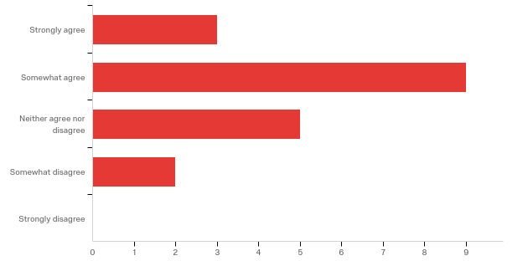

# | Field | Minimum | Maximum | Mean | Std Deviation | Variance | Count
1 | Millersville’s graduates/teachers recognize when their own professional behaviors may need to be adjusted to meet their planned goals. | 1.00 | 4.00 | 2.32 | 0.86 | 0.74 | 19

# | Answer | % | Count
1 | Strongly agree | 15.79% | 3
2 | Somewhat agree | 47.37% | 9
3 | Neither agree nor disagree | 26.32% | 5
4 | Somewhat disagree | 10.53% | 2
5 | Strongly disagree | 0.00% | 0
 | Total | 100% | 19

Q14 - Millersville’s graduates/teachers demonstrate behaviors that encourage self-directed learning.
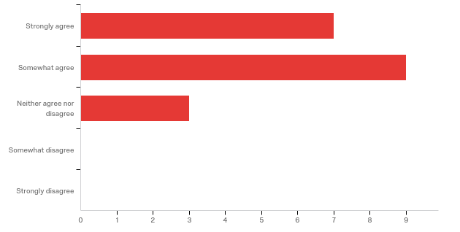

# | Field | Minimum | Maximum | Mean | Std Deviation | Variance | Count
1 | Millersville’s graduates/teachers demonstrate behaviors that encourage self-directed learning. | 1.00 | 3.00 | 1.79 | 0.69 | 0.48 | 19

# | Answer | % | Count
1 | Strongly agree | 36.84% | 7
2 | Somewhat agree | 47.37% | 9
3 | Neither agree nor disagree | 15.79% | 3
4 | Somewhat disagree | 0.00% | 0
5 | Strongly disagree | 0.00% | 0
 | Total | 100% | 19

Q15 - Millersville’s graduates/teachers demonstrate behaviors that create caring, supportive learning environments
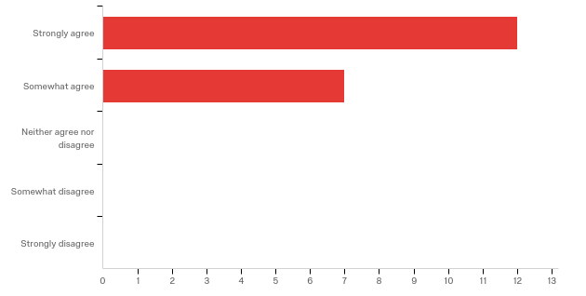

# | Field | Minimum | Maximum | Mean | Std Deviation | Variance | Count
1 | Millersville’s graduates/teachers demonstrate behaviors that create caring, supportive learning environments | 1.00 | 2.00 | 1.37 | 0.48 | 0.23 | 19

# | Answer | % | Count
1 | Strongly agree | 63.16% | 12
2 | Somewhat agree | 36.84% | 7
3 | Neither agree nor disagree | 0.00% | 0
4 | Somewhat disagree | 0.00% | 0
5 | Strongly disagree | 0.00% | 0
 | Total | 100% | 19

Q16 - Millersville’s graduates/teachers demonstrate classroom behaviors that are consistent with the belief that all students can learn.
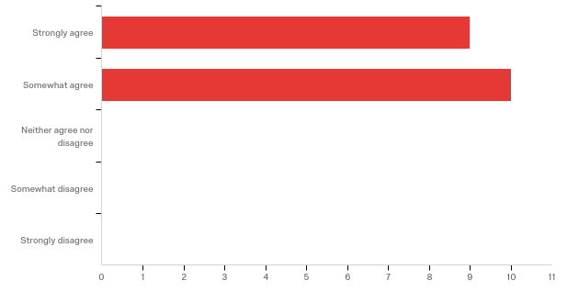

# | Field | Minimum | Maximum | Mean | Std Deviation | Variance | Count
1 | Millersville’s graduates/teachers demonstrate classroom behaviors that are consistent with the belief that all students can learn. | 1.00 | 2.00 | 1.53 | 0.50 | 0.25 | 19

# | Answer | % | Count
1 | Strongly agree | 47.37% | 9
2 | Somewhat agree | 52.63% | 10
3 | Neither agree nor disagree | 0.00% | 0
4 | Somewhat disagree | 0.00% | 0
5 | Strongly disagree | 0.00% | 0
 | Total | 100% | 19

Q17 - Millersville’s graduates/teachers are able to incorporate new information into their practice as appropriate to meet the needs of all students.
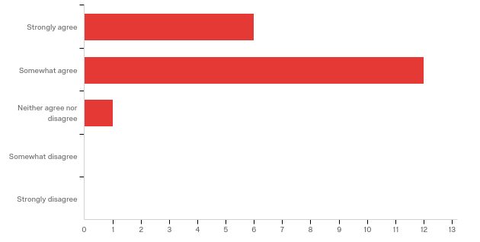

# | Field | Minimum | Maximum | Mean | Std Deviation | Variance | Count
1 | Millersville’s graduates/teachers are able to incorporate new information into their practice as appropriate to meet the needs of all students. | 1.00 | 3.00 | 1.74 | 0.55 | 0.30 | 19

# | Answer | % | Count
1 | Strongly agree | 31.58% | 6
2 | Somewhat agree | 63.16% | 12
3 | Neither agree nor disagree | 5.26% | 1
4 | Somewhat disagree | 0.00% | 0
5 | Strongly disagree | 0.00% | 0
 | Total | 100% | 19

Q18 - Click to write the question text
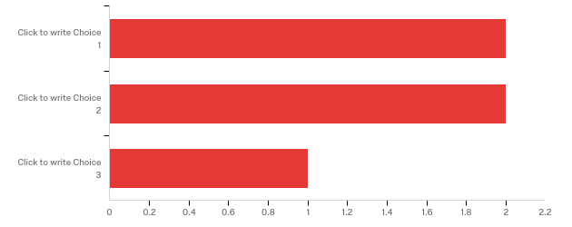

# | Field | Minimum | Maximum | Mean | Std Deviation | Variance | Count
1 | Click to write the question text | 1.00 | 3.00 | 1.80 | 0.75 | 0.56 | 5

# | Answer | % | Count
1 | Click to write Choice 1 | 40.00% | 2
2 | Click to write Choice 2 | 40.00% | 2
3 | Click to write Choice 3 | 20.00% | 1
 | Total | 100% | 5

Q20 - Millersville graduates/teachers actively collaborate with all shareholder groups.
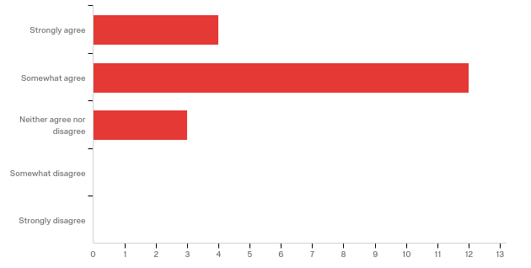

# | Field | Minimum | Maximum | Mean | Std Deviation | Variance | Count
1 | Millersville graduates/teachers actively collaborate with all shareholder groups. | 1.00 | 3.00 | 1.95 | 0.60 | 0.37 | 19

# | Answer | % | Count
1 | Strongly agree | 21.05% | 4
2 | Somewhat agree | 63.16% | 12
3 | Neither agree nor disagree | 15.79% | 3
4 | Somewhat disagree | 0.00% | 0
5 | Strongly disagree | 0.00% | 0
 | Total | 100% | 19

