- Enter your CURRENT email address.
- You will see a screen that says they can’t “find” you and give you these options:
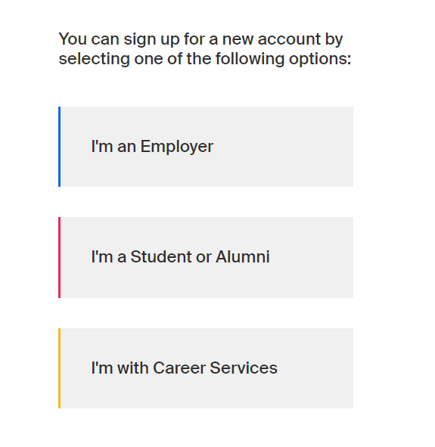
Select “I’m a Student or Alumni”
- The next screen will ask for you to add that CURRENT email address again. It will look like this:
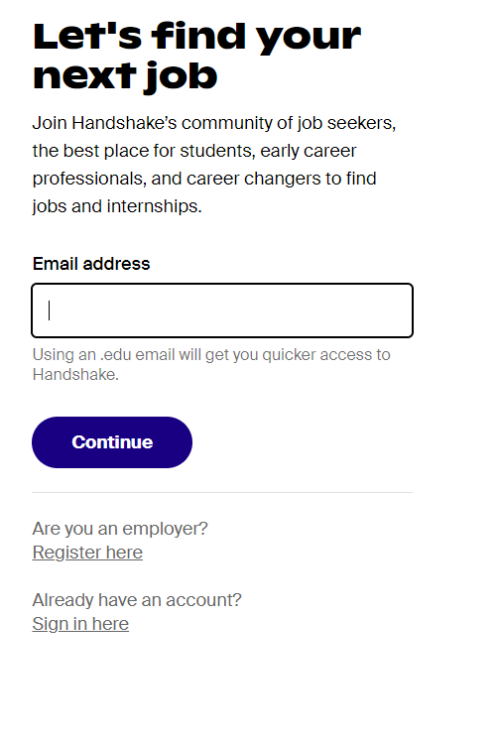
- This next steps asks you to enter the name of your school. Please start typing “Millersville” and the choice should pop up:
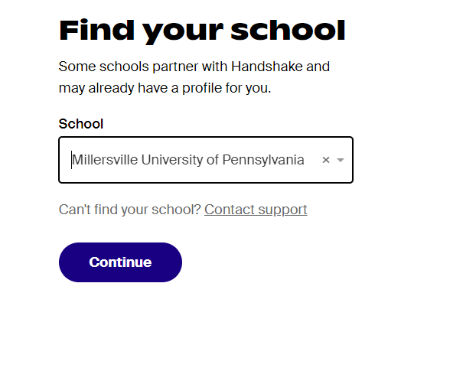
- The next screen asks for a password and then select “Create Account”
- This step is critical. If you do not confirm the email that Handshake sends to your CURRENT EMAIL at this time, the request will not come into The Career Center

Once you confirm, a request will come to The Career Center. We need to verify your status as an alum, so the last thing you need to do is send an email to careers@millersville.edu with the following:

Your Name (please include your Maiden name if it has changed since you were a student)
M# if you remember it or birthday if you do not
Year of graduation
Was your degree undergrad or graduate?

