The Villages Work Orders
*Work Order requests are for the Villages ONLY. If you live in Shenks or Reighard, please see your front desk staff to submit a work order*

Creating a Work Order
- Log into your MyHousing portal by logging into your MAX account
- To submit a work order click “More Tasks” on the top navigation menu, then click “Work Orders”
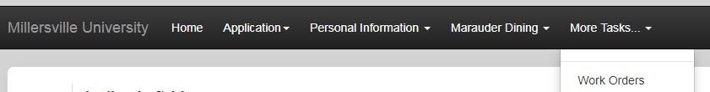

- Your current room will auto-fill. If there is a problem with this feature, contact your hall staff
- Under “Submit a New Maintenance Request” heading, click the drop down box to select the type of category for the problem you are reporting
  - Plumbing: Any sink, toilet, shower, water issue within your room
  - Heating/Cooling: Any heating or cooling issues with your room
  - Electrical: Outlets, lights, switches that are broken in your room
  - Structural: Broken shower racks, toilet paper holders or broken furniture in your room
  - Pest Control: If you notice a significant amount of bugs in your room
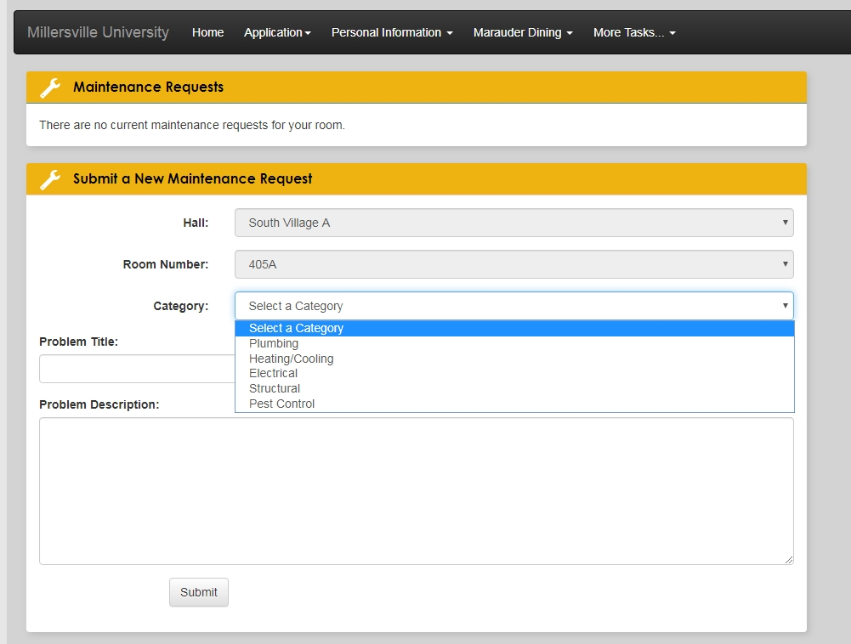

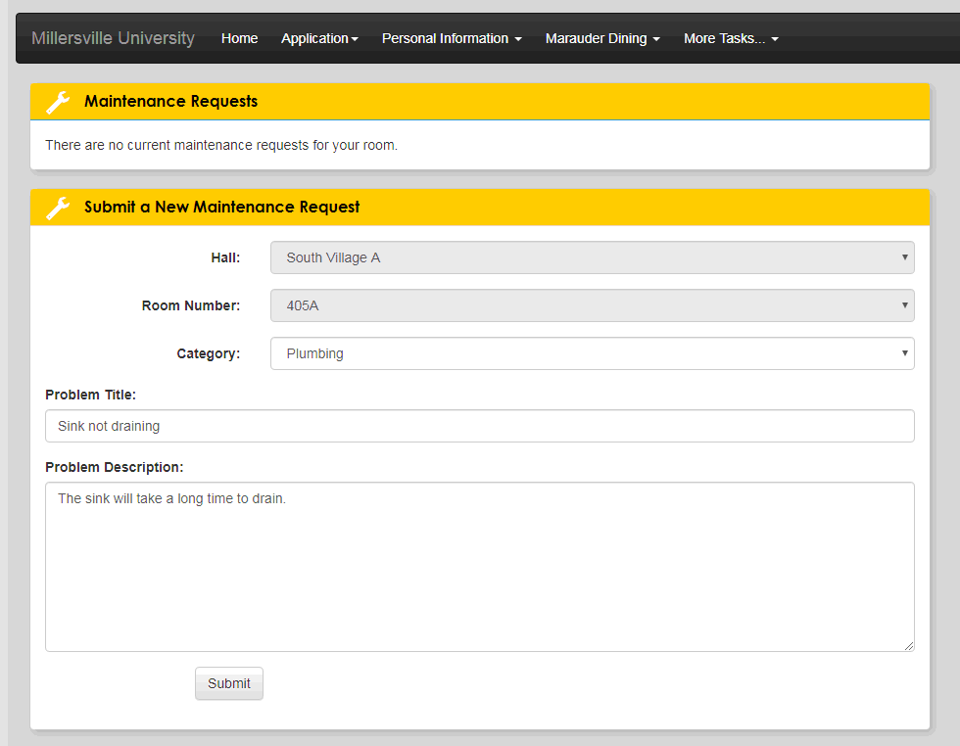
- Type in a Problem Title and Problem Description. Be brief but clear with your Problem Title. Be sure to explain exactly what is happening and where in the Problem Description. The more details you can give, the easier it will be for our Facilities staff to find and correct the issue. When done, click “Submit”

- Your work order has been submitted. You will notice that the work order you just opened will be at the top of the screen under the heading “Maintenance Requests”

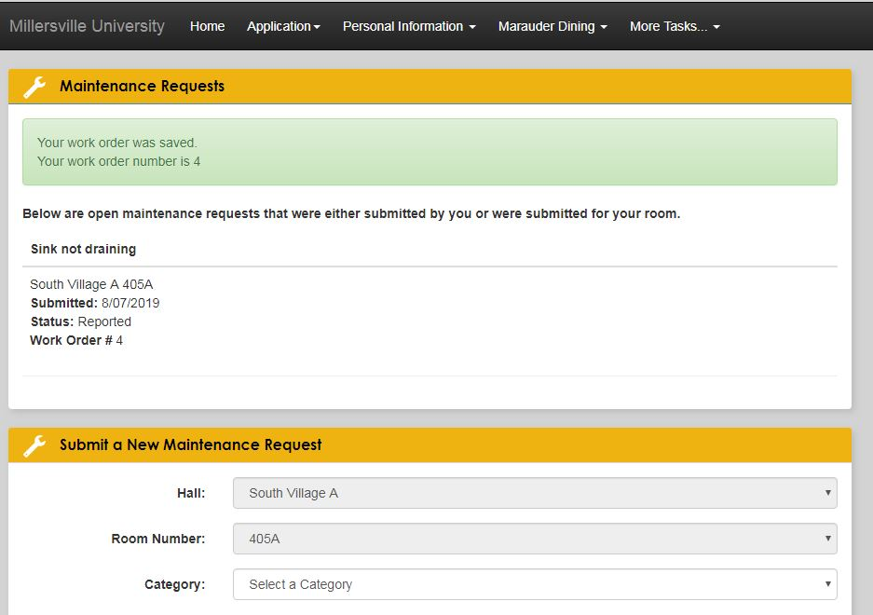

- Facilities staff members will enter your room and fix the issue within 48-72 hours. You do not need to be present in your room when they arrive. Facilities does not enter student rooms until after 9am

