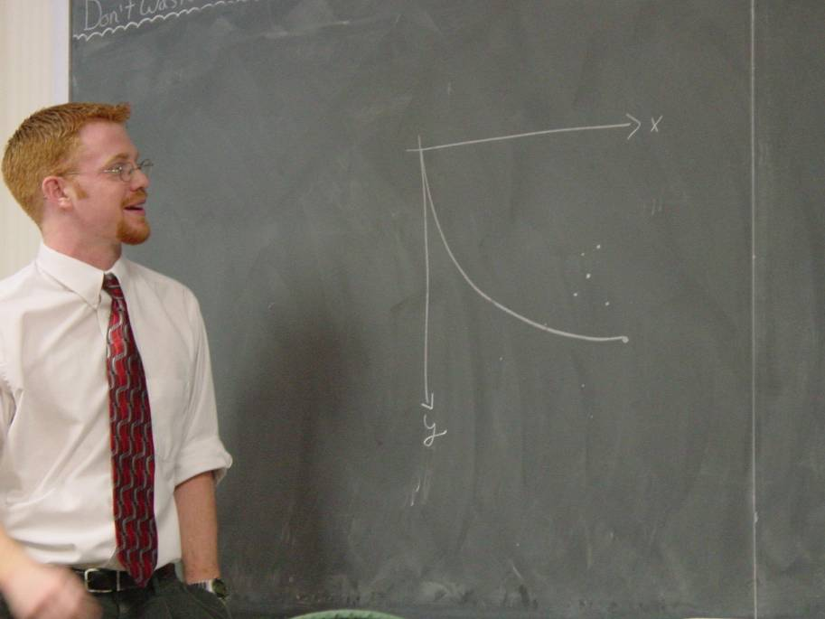

Brachistochrone Problem
Jeff Barrage
Advisor: Dr. M. Nolan

The Brachistochrone Problem is a problem involving the calculus of variations. The physical set up is to connect two points on a plane with a wire and to let a bead slide on the wire without friction. The problem is to find the shape of the wire so that the bead will slide from one point to the other in the shortest amount of time. In the classical case the answer is a cycloid. When the bead travels at relativistic speeds the solution is unknown. The project involves solving the problem so that we can see the evolution of the path from the classical to the relativistic case. I have unitized Mathemeatica to solve the integrals and graph the paths.

