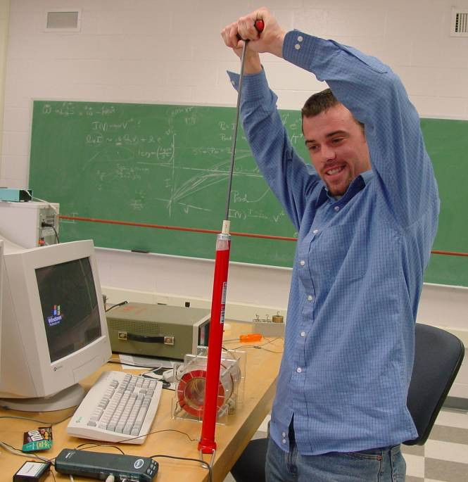

The Thermodynamics of Heat Engines
Joshua Hauser
Advisor: Dr. P. Cooney

This study of the thermodynamics of heat engines consists of two parts. One part is measuring the work done by a heat engine throughout its cycle and comparing it to the net amount of heat absorbed by the engine in its cycle. The second part of the experiment is the measurement of the heat capacity of air. Once the heat capacity is known, by monitoring the temperature of the air in the heat engine, the amount of heat that flows in and out of the engine can be calculated. This heat capacity is found by compressing air with a bicycle pump, then comparing the work done on the gas with the measured temperature change as the gas cools at constant volume. The measured temperature is strongly time dependent due to the heat loss through the walls of the pump. To get a value for the air temperature if the compression had been adiabatic, we can extrapolate the temperature curve back to the time when the air was compressed. This method has yielded a heat capacity of 112 Joules per mole Kelvin, but the method of extrapolation and the measurement of work on the gas is still under study

