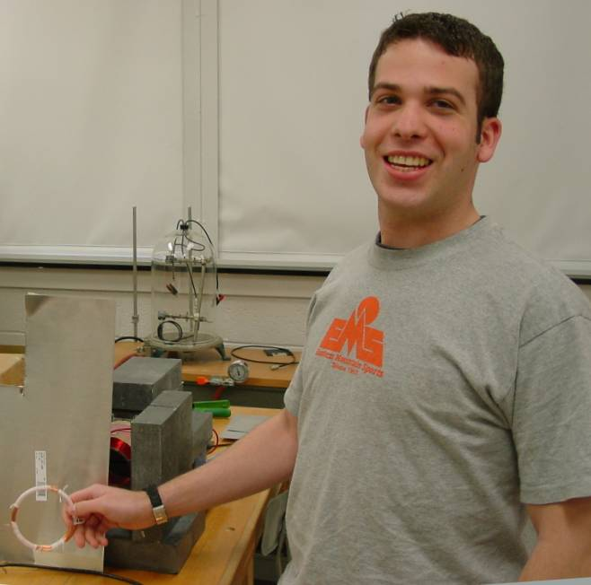

The Skin Depth of Isotropic Materials
James Marek
Advisor: C.W. Price

The skin depth is the distance that an electromagnetic wave penetrates into a material before it is attenuated to 1/e (.367) of its original amplitude. For a wave of angular frequency ω that encounters a sheet of a good conductor, the attenuation of the electromagnetic wave obeys A=A₀ Exp[-d/], where  = (2/)^{1/2} and d is the thickness of the sheet. From this result the slope of ln(amplitude) vs. thickness is inversely proportional to the resistivity (=1/σ) of the material.  can be found by placing a conducting sheet between a source of an electromagnetic plane wave and a detector. So far I have measured the magnetic shielding of mutual inductance between two inductors. This however, at low frequencies (<500 Hz) matches the model for the attenuation of an electromagnetic plane wave, but more analysis is needed to connect the two models. The resistivity at 500 Hz using aluminum as a conductor was similar to published results.

