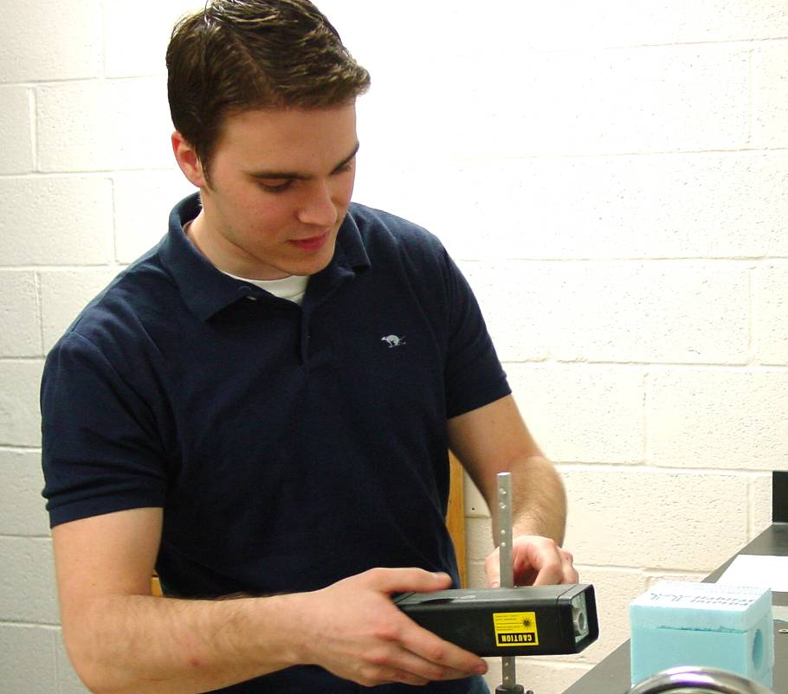

Light Scatterning Phenomena by the Fluid Vapor Interface
Matthew Panas
Advisor: Dr. C. Miziumski

Experimental observations were made of the scattering of n upward-angled laser light beam, in a cell partially filled with liquid Freon 12. The system was heated until the Freon vaporized and was then allowed to cool slowly. As it cooled it passed through the critical point. At this point, a liquid-vapor interface appeared and a transition from transmission of the upward beam to total internal reflection was observed. Interesting results are anticipated when the wavelength of the incident light is compared to a characteristic length associated with density fluctuations near the critical point.

