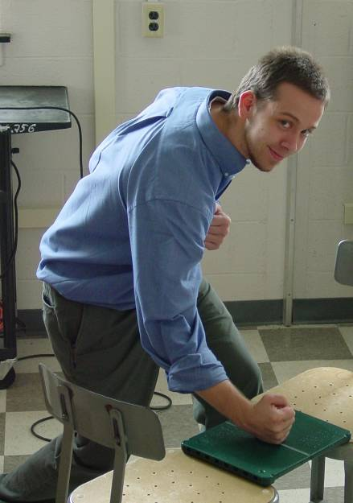

Physics In Karate: Martial Arts Board Breaking

By Jeremy Bigler
Advisor: Dr. Cooney

Abstract

Breaking objects such as wood boards, concrete blocks, slate tiles, etc. using a fist or foot is a standard in many forms of martial arts. It is a way to measure technique and also a way to allow people to set goals and achieve them. Many people that do not participate in martial arts or are just entering the martial arts find breaking a solid object such as a piece of wood or a concrete slab intimidating. The actual event of the break is governed only by the laws of physics. The data were collected by using the Redlake 8000S 1000 frame/sec video camera to capture the collision of a mass and the board. The energy required to break the board appears to be a viable choice for predicting the level of difficulty in a board or target.

