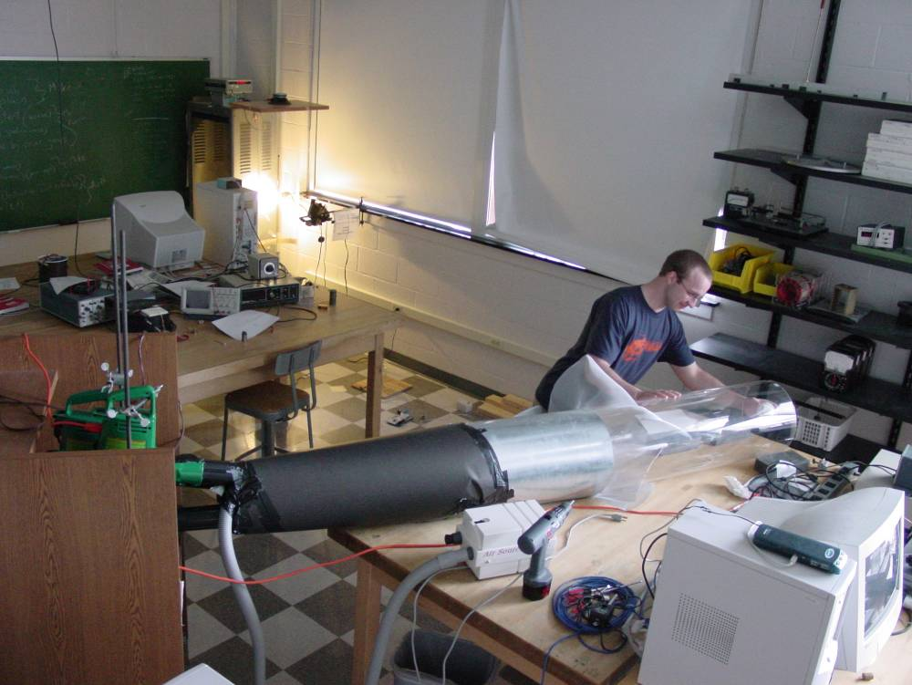

Wind Effects on a Spinning Baseball
Mike Good
Advisor: Dr. Dooley
Fall, 2004

Abstract
The purpose of this experiment is to investigate the effect of air currents on a spinning baseball. By using a wind tunnel I hope to be able to simulate a baseball with a translational velocity of 70 mph or 31.3 m/s and turning at a rate of 1500 rpm. To accomplish this task I used three leaf blowers, each of which is capable of moving air at a speed of 95 mph or 42.5 m/s. Due to the difference between the cross sectional area of the leaf blower pipe to the cross sectional area of the wind tunnel, one leaf blower produces a wind speed of approximately 2.7 m/s. Three leaf blowers produce a wind speed of about 9.0 m/s. Anemometer measurements demonstrated that the wind flow in the tunnel was fairly laminar. The ball was then suspended in the wind tunnel so that I could use Vernier Force Probes to measure the Magnus force generated on the baseball by its rotation about an axis parallel to the ground. I was unable to measure the Magnus force due to low wind speeds. However, I did investigate the Karman vortex street and the forces it produced on the baseball. With these data I was also able to calculate the Strouhal number for the baseball assembly, which was 0.24.

