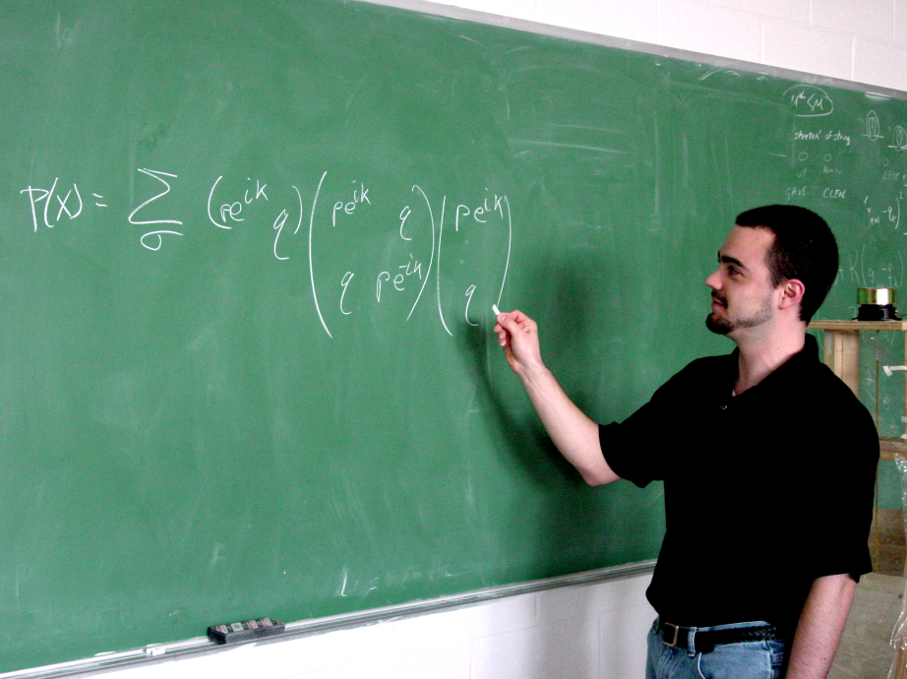

A Study of One-Dimensional Random Walks with Short Range Memory
Christopher Kunkel
Advisor: Dr. Nolan
Fall 2004

Abstract:

Random walks are an important tool in theoretical physics. In this paper we examine three random walk problems. The first is the simple one dimensional problem, the solution of which is well known. The second two involve "memory." That is, the probability distribution for an individual step depends on the previous steps. Here we examine one dimensional discrete and continuous cases with one step memory. We derive distribution functions for distance from the origin in both cases. Also, we compute correlation functions which quantify how much two steps depend on each other. Computer simulations are then run to test the validity of our results. We conclude with a brief discussion on where these results may be applied.

