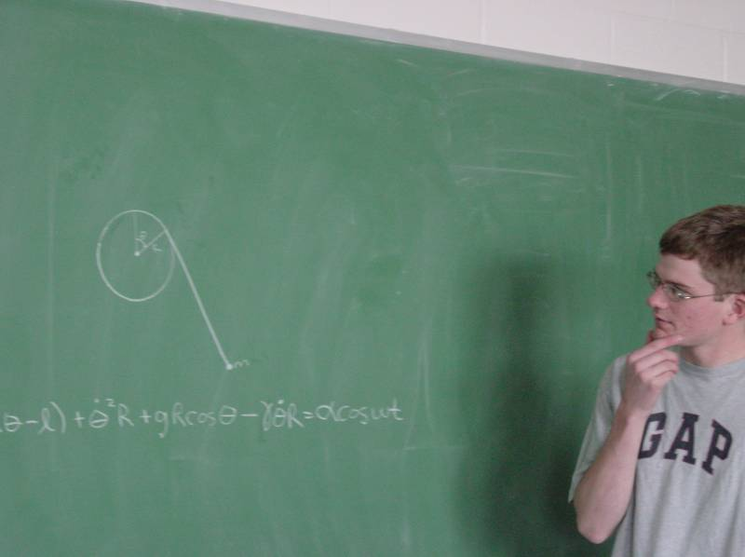

Analyzing Chaos in a String-Around-a-Cylinder System
Nathaniel Phillips, Advisor: Dr. Uy

The purpose of this investigation is to analyze the appearance of chaos in a system comprised of a string of length l that wraps around a cylinder of radius R as a mass m oscillates at the end of the string.

The equation of motion of this system can be found using the methods of Lagrangian mechanics. The equation with damping and driving terms is:
$$\overset{¨}{q}(Rq−l)+{\overset{˙}{q}}^{2}R+g\text{cos}q−gR\overset{˙}{q}−α\text{cos}(wt)=0$$

Mathematica can be used to determine a numerical solution to this equation. Let the cylinder rotate with an angular frequency ω (this will produce the “driving force”). γ is the damping factor.

The parameters α, ω, and γ were changed to produce chaotic motion. Bifurcation diagrams (plots of the end behavior of θ versus ω_{driving}) were created in Mathematica to illustrate values of ω (driving frequency) that result in chaotic behavior. These diagrams were used to investigate the nature of the equilibrium solutions (fixed points) of the system.

Equilibrium points occur for values of (θ, θ’) =$\frac{(n+1)}{2}π$ (that is, half-odd integers of π). The stability of these points is dependent upon the parameters of the system, specifically R, l, γ, g, ω, and the initial conditions: θ₀, and θ’₀.

By writing the equation of motion as a system of equations and linearizing it near the fixed points, the stability of these fixed points was determined. Specifically, the stability is determined by the eigenvalues of the Jacobian matrix, evaluated at each fixed point.

