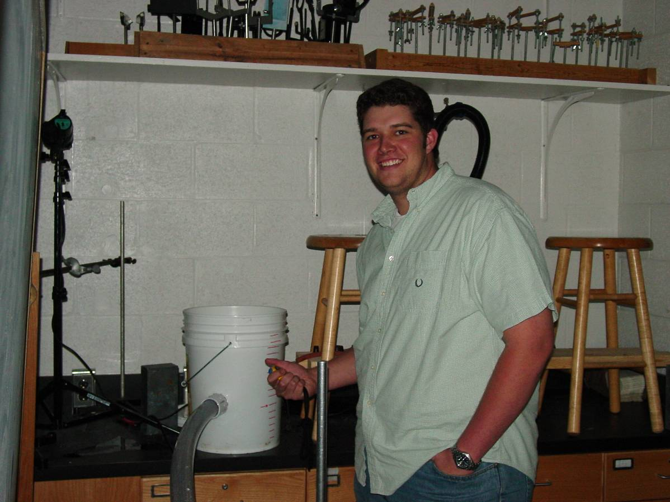

The Flow of Fluid through a Pipe: Entrainment
Ben Shull
Advisor: Dr. Dooley

Entrainment is defined as the process whereby a material diffuses into and is pulled along by another material. Observing and measuring different aspects of a simple water aspirator yielded some properties of entrainment. Using the principle of the conservation of momentum the behavior of the flow of water was predicted and tested. The prediction made was that entrainment would increase the volume measured at the downstream pipe and subsequently, decrease the speed of the water. The prediction was verified by measuring the volume of water at the downstream pipe. The continuity equation was then used to calculate the size of the downstream pipe. This was done by using conservation of momentum to find the velocities, in terms of mass. Masses were converted into volumes (assuming constant density) and the entrance radius (to the aspirator) was used to find a radius of .29cm. Measurement of the downstream pipe yielded a radius of .3 cm. A larger reservoir aspirator apparatus was constructed. In this apparatus the entrainment pipe was able to be moved perpendicular to the main flow pipe. The ideal location of the pipe, in terms of the highest volume of entrainment, was found to be approximately 1.5 cm inside the main flow pipe. Euler’s equation was then used to describe the pressure gradients within the aspirator.

