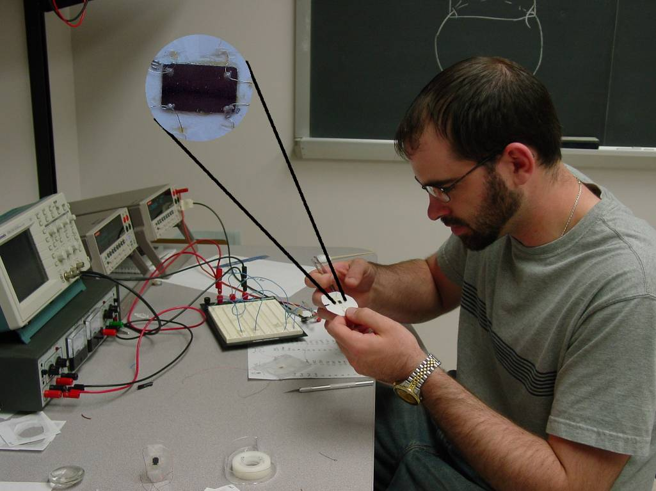

The Anisotropic Electrical Properties of Chiral Sculptured Thin Films
Matt Snyder
Advisor: Dr. Gilani

Chiral sculptured thin films exhibit a property of unidirectional nonhomogeneity which is responsible for a subsequent electrical anisotropy in the films. The H.C. Montgomery method is used to measure two components of the anisotropic resistivity tensor of the films and also is used to map the dimensions of the anisotropic sample to those of an equivalent isotropic sample with a uniform resistivity. Four films were studied, each deposited onto a silicon substrate with thicknesses ranging from 200-3000 nm. Two of the films had ohmic (or nearly ohmic) voltage-current relationships, while two films were decidedly non-ohmic in nature.

